**Project Management Excellence**

Sixth Edition

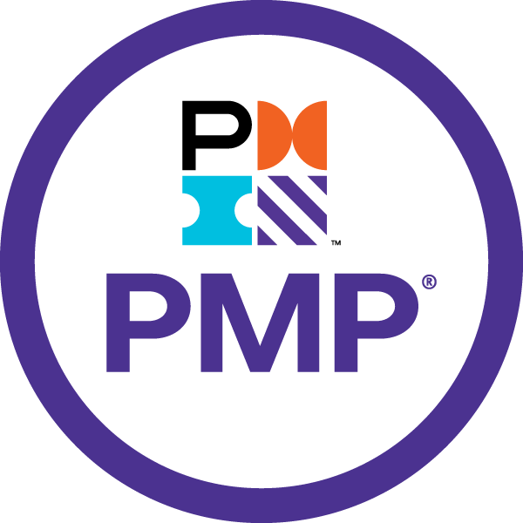

Sriram

# Sriram

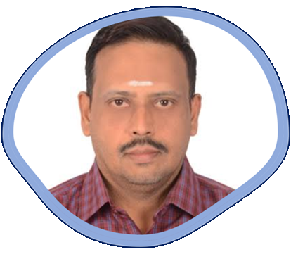

I have been involved in IT Software development since 1997. I have unique combination of process, technical and industrial skills. As a Digital Leader, I have expert level of knowledge in agile and practices with this combination I can help process and technology people, understand the agile world.

The “**Project** **Management Excellence – Sixth Edition”** book comprises of Traditional Project Management. One in All, All in One concept with examples & templates for Key to Success.

My agile journey started in 2011, when I was a part of Tata Consultancy Services. I practiced scrum and agile methods thoroughly over several years and my teams are highly successful in delivering products using agile techniques.

I am proficient in agile engineering, coaching practices and SAFe consulting practices. I have more than 5 years of experience as a senior architect cum senior manager in development. I religiously follow key agile engineering practices like TDD, Refracting, CI and Collective Ownership. Worked in USA, UK for TCS, AtoS, Cognizant & IBM - Agile customers, which creates a global agile experience.

I moved back to India in 2016 and created agile websites and released books related to Scrum Alliance Professional, Agile Coaching and Implementing SAFe 5.0 practices.

Throughout my agile journey, I have been associated the agile professionals, who have helped and mentored me in the journey where sky is the limit.

Place: Dubai, UAE – Middle East Email: digitalcloudguru@gmail.com

# Table of Contents

Contents

Sriram 2

Table of Contents 3

Project Management 6th Edition 4

1.Project Management Framework 7

2.The Environment in Which Projects Operate 38

3. The Role of Project Manager 44

4. Project Integration Management 51

5. Project Scope Management 69

6. Project Schedule Management 80

7. Project Cost Management 99

Formulas to Remember 112

8. Project Quality Management 114

9.Project Resource Management 127

10. Project Communication Management 142

12. Project Procurement Management 151

11. Project Risk Management 161

13. Project Stakeholders Management 174

# Project Management 6th Edition

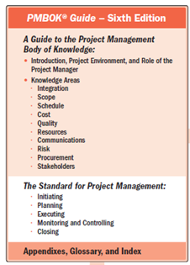

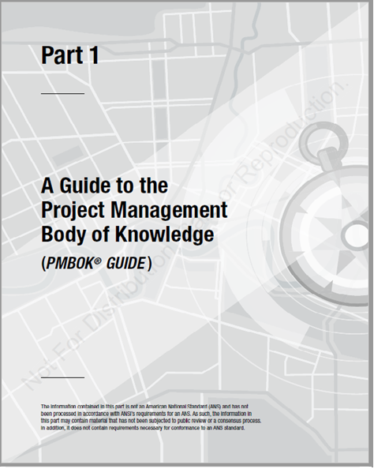

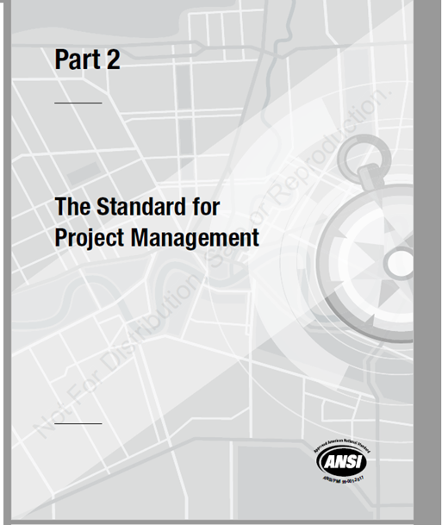

## 1.Project Management Framework

**Objectives**



* Purpose of PMBOK Guide
* Describe values that support the Code of Ethics and Professional Conduct
* Understand Portfolios, Programs, and Projects along with organization structure
* Define a project and distinguish among portfolio, program, and projects
* Describe stakeholders and identify their role in the project
* Recognize the roles of project management office
* Explain the influences on project environment
* Differentiate between project life cycle and product life cycle
* Discuss business documents
* Explain project management process map and framework
* Describe different organization structures
  1. **Introduction**

**Purpose of the Guide**

The term “Project management” is not new. It has been in use for hundreds of years. Examples of project outcomes include:-

* Pyramids of Giza
* Olympic games
* Great Wall of China
* Taj Mahal
* Publication of a children’s book
* Panama Canal
* Development of commercial jet airplanes
* Polio vaccine
* Human beings landing on the moon
* Commercial software applications
* Portable devices to use the global positioning system (GPS)
* Placement of the International Space Station into Earth’s orbit

The outcomes of these projects were the result of leaders and managers applying project management practices, principles, processes, tools, and techniques to their work. The managers of these projects used a set of key skills and applied knowledge to satisfy their customers and other people involved in and affected by the project.

By the mid-20th century, project managers began the work of seeking recognition for project management as a profession. One aspect of this work involved obtaining agreement on the content of the body of knowledge (BOK) called project management. This BOK became known as the Project Management Body of Knowledge (PMBOK). The Project Management Institute (PMI) produced a baseline of charts and glossaries for the PMBOK. Project managers soon realized that no single book

could contain the entire PMBOK. Therefore, PMI developed and published *A Guide to the Project Management Body of Knowledge (PMBOK® Guide).*

PMI defines the project management body of knowledge (PMBOK) as a term that describes the knowledge within the profession of project management. The project management body of knowledge includes proven traditional practices that are widely applied as well as innovative practices that are emerging in the profession.

The project manager works with the project team and other stakeholders to determine and use the appropriate generally recognized good practices for each project. Determining the appropriate combination of processes, inputs, tools, techniques, outputs and life cycle phases to manage a project is referred to as “tailoring” the application of the knowledge described in this guide.

This PMBOK® Guide is a foundation upon which organizations can build methodologies, policies, procedures, rules, tools and techniques, and life cycle phases needed to practice project management.

**Standard for Project Management**

The Standard for Project Management Part I. A standard is a document established by an authority,

custom, or general consent as a model or example. As an American National Standards Institute (ANSI) standard, The Standard for Project Managementwas developed using a process based on the concepts of consensus, openness, due process, and balance.

The Standard for Project Management is a foundational reference for PMI’s project management

professional development programs and the practice of project management. Because project management needs to be tailored to fit the needs of the project, the standard and the guide are both based on descriptive practices, rather than prescriptive practices. Therefore, the standard identifies the processes that are considered good practices on most projects, most of the time. The standard also identifies the inputs and outputs that are usually associated with those processes. The standard does not require that any particular process or practice be performed.

The Standard for Project Management is included as Part II of A Guide to the Project Management Body of Knowledge (PMBOK® Guide). The PMBOK® Guide provides more detail about key concepts, emerging trends, considerations for tailoring the project management processes, and information on how tools and techniques are applied to projects. Project managers may use one or more methodologies to implement the project management processes outlined in the standard.

**Code of Ethics and Professional Conduct**

The PMI® has established a set of guidelines for the Code of Ethics and Professional Conduct for certified PMP professionals. It describes the expectations that the project managers should have of themselves and of their fellow practitioners in the global project management community.



Project managers hold a great deal of responsibility over: -

* The projects they undertake
* The solutions provided
* The management of costs
* The impact of projects on the organization
* Any impacted environments or groups
* Dollars spent
* Vendors/contractors hired

**Values That Support the Code of Ethics**

* PMI has identified four core values across the global project management community that are most important to project managers.
  + Responsibility
  + Respect
  + Fairness
  + Honesty
* Each section of the Code of Ethics and Professional Conduct includes both aspirational and mandatory standards.
* The aspirational standards describe the conduct that the project managers strive to uphold as practitioners.
* Although adherence to the aspirational standards is not easily measured, it is expected that project management professionals adhere to them. These are not optional.
* The mandatory standards establish firm requirements and, in some cases, limit or prohibit practitioner behavior. Practitioners who do not conduct themselves in accordance with these standards will be subject to disciplinary procedures before PMI’s Ethics Review Committee.

**1.2 Foundational Elements**

**1.2.1 Introduction to Projects**

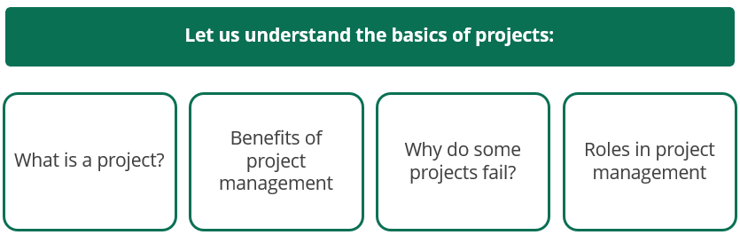

**Project Definition**

According to Project Management Institute (PMI®),a project is a temporary endeavor undertaken to create a unique product, service, or result.

**Project Characteristics**

* Projects are:
  + Performed by people
  + Constrained by limited resources
  + Executed once and completed
  + Planned and controlled
  + Temporary in nature
* Projects differ from operations. Operations are ongoing and repetitive, while projects are temporary and unique endeavors.
* Projects can contain repetitive elements, but the elements do not change its unique characteristics.
* Projects have a definite beginning and end.
* They can have varied durations ranging from very short (less than a month) to very long (more than five years).
* Projects are completed when:-
* The defined objectives are met
* The goals/objectives cannot be met within budget, time, available resources, or chosen technology
* The funding is exhausted
* The need to execute the project has changed or been eliminated (due to competition, regulation, legal, and compliance issues)
* The legal or contractual issues result in project closure

**Examples of a Project**

Each of the following is a temporary endeavor undertaken to create a unique product, service, or result.

|  |  |
| --- | --- |
| * Developing a Software Project application * New Software Product Development * Enhancement in existing Product * Market Research * Feasibility Study * Constructing a building   Events in personal life   * Wedding Event Management * Birthday Party Event * Vaccination Planning & Bookings * Home improvement   Events in Operations   * Manufacturing unit’s assembly line * Cleaning a building every day * Regular maintenance of servers & other electrical equipment’s | * Developing a new charger for cell phones * Expanding the service offering at a consulting firm * Merging two organizations * Implementing a new accounting system and the corresponding process changes * Renovating corporate office space * Developing research around a political issue * Performing a study on the environmental impact of a new bridge in a rural area * Building a new parking garage |

**Project Drivers**

The main motives of projects are: -

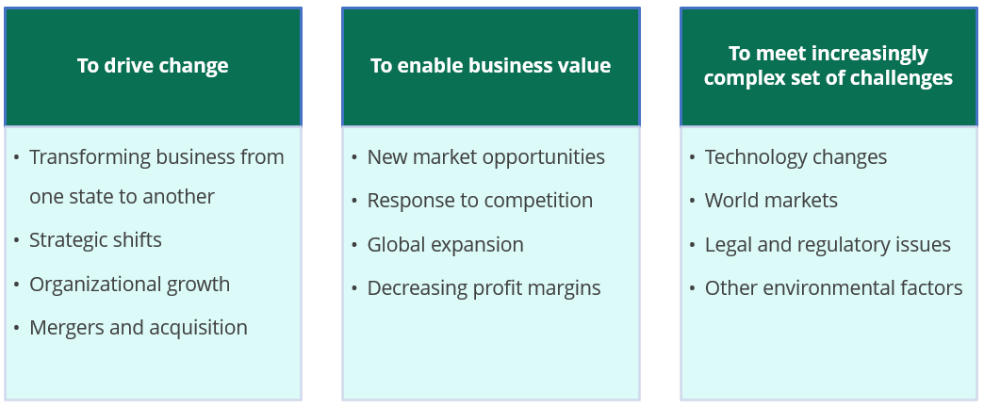

**Project Management Value**

* Project management contributes to organizational success
* It helps by completing the project:
  + Within the allotted time
  + Within the budgeted cost
  + At the proper performance or specification level
  + With acceptance by the customer, sponsor, or user
  + With minimally agreed upon scope changes
  + Without disturbing the main work flow of the organization
  + Without changing the corporate culture
* The unique efforts of project management require innovative thinking and planning in advance
* While similar efforts may have taken place in the past, the situational, environmental, legal, regulatory, and technical changes require a unique approach

**Factors that Lead to the Creation of a Project**

Projects are started for one or more reasons; each project has certain objectives or goals to achieve. These goals have to be linked with organizational strategic goals and generally provide a boost to the company’s top line revenue’s or help in the reduction of costs and hence, in increasing the bottom-line profit. Some projects may also be required due to mandatory regulations, or due to corporate social responsibility activity that every company undertakes these days.

The reason for starting projects is: -

|  |  |
| --- | --- |
| * Market /Consumer Demand * Technology change | * Statutory / Legal / Social Mandate * Internal Organizational needs |

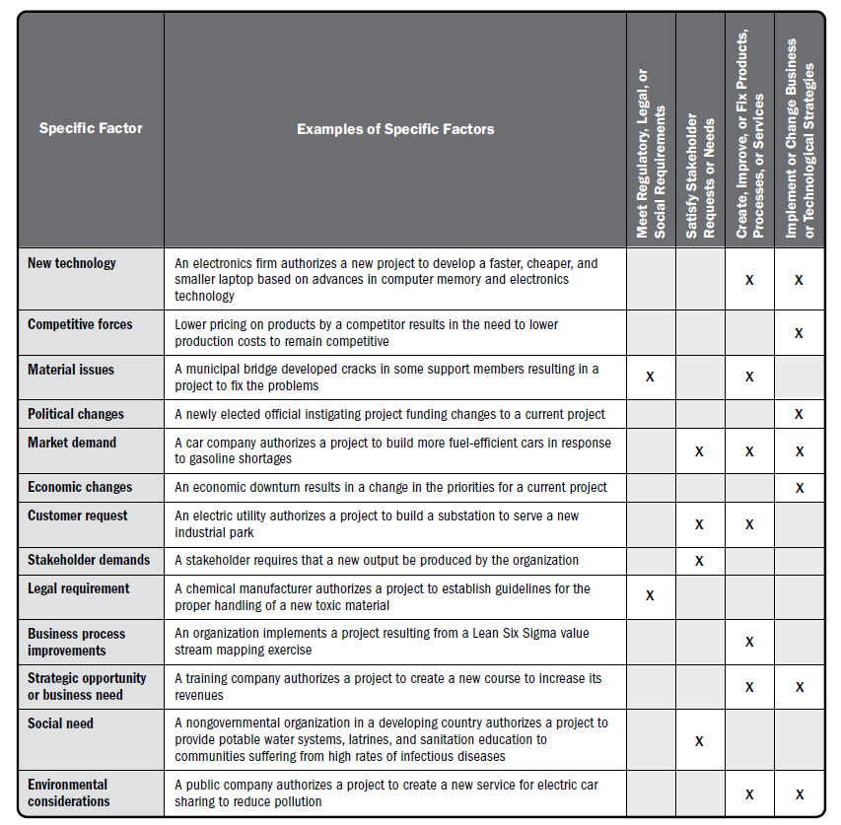

**12.2 The Importance of the Project**

Project management is the application of knowledge, skills, tools, and techniques to project activities to meet the project requirements. Project management is accomplished through the appropriate application and integration of the project management processes identified for the project. Project management enables organizations to execute projects effectively and efficiently.

Effective project management helps individuals, groups, and public and private organizations to:

* Meet business objectives
* Satisfy stakeholder expectations
* Be more predictable
* Increase chances of success
* Deliver the right products at the right time
* Resolve problems and issues
* Respond to risks in a timely manner
* Optimize the use of organizational resources
* Identify, recover, or terminate failing projects
* Manage constraints (e.g., scope, quality, schedule, costs, resources)
* Balance the influence of constraints on the project (e.g., increased scope may increase cost or schedule)
* Manage change in a better manner

Poorly managed projects or the absence of project management may result in:

* Missed deadlines
* Cost overruns
* Poor quality
* Rework
* Uncontrolled expansion of the project
* Loss of reputation for the organization
* Unsatisfied stakeholders
* Failure in achieving the objectives for which the project was undertaken

Projects are a key way to create value and benefits in organizations. In today’s business environment, organizational leaders need to be able to manage with tighter budgets, shorter timelines, scarcity of resources, and rapidly changing technology. The business environment is dynamic with an accelerating rate of change. To remain competitive in the world economy, companies are embracing project management to consistently deliver business value.

Effective and efficient project management should be considered a strategic competency within organizations. It enables organizations to:

* Tie project results to business goals,
* Compete more effectively in their markets,
* Sustain the organization, and
* Respond to the impact of business environment changes on projects by appropriately adjusting project management plans

**Reasons for Failure of Projects**

**Research has identified the following top reasons for project failures:**

1. Requirements that are ambiguous, misunderstood, or incorrect
2. Controlling cost and schedule
3. Scope creep
4. Sponsor not actively involved in the project strategy and direction
5. Project plan that is nonexistent, out of date, incomplete, or poorly constructed
6. Frequent changes of assigned PM
7. Project teams (external and in-house resources) whose responsibilities and relationships are not clearly defined in writing
8. No clear definition of the benefits and the deliverables that will produce them
9. Poor or no change control
10. Inappropriate or insufficient skills

**1.2.3 Relationship of Project, Program, Portfolio, and Operations**

**First Understand the Portfolios, Programs, Projects**

Portfolios, programs, and projects operate together to deliver benefits to the business

* **Program** management is the centralized, coordinated management of a program to achieve the program’s strategic objectives and benefits. It involves aligning multiple projects to achieve the program goals and allows for optimized or integrated cost, schedule, and effort.
* **Projects** in a program have a common deliverable or capability. Projects that are interlinked are called a portfolio of projects.
* A **portfolio** may consist of other portfolios, projects, and programs. The components may or may not be interdependent.

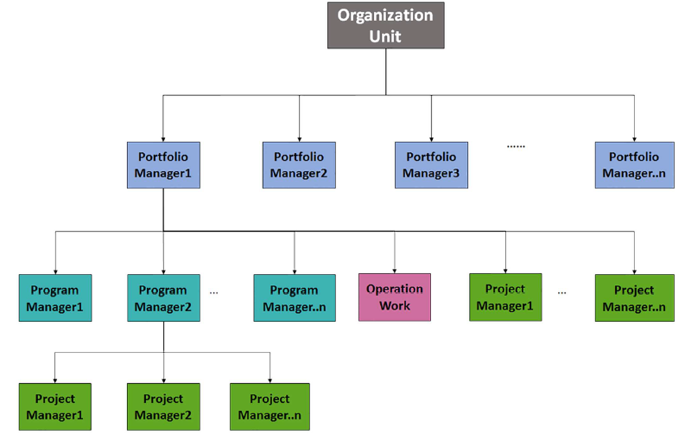

**PMO, PgMO, PfMO**

Project Management Office (PMO)

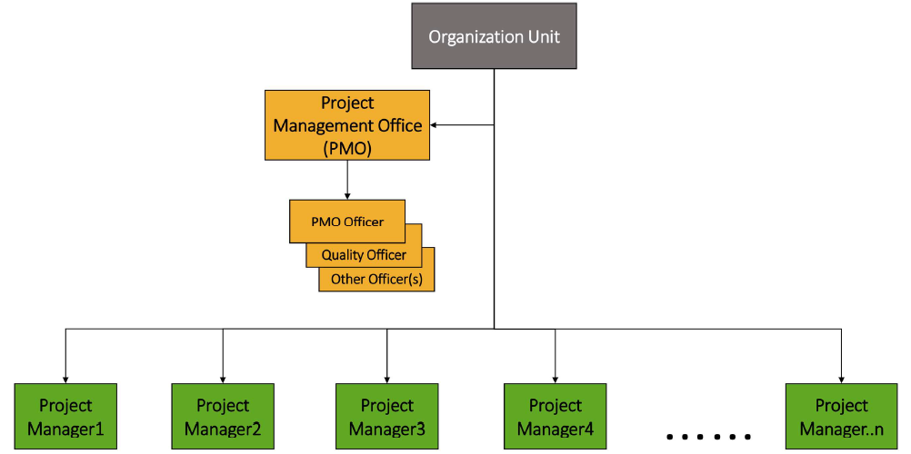

PMO Structure Types are Supportive, Controlling & Directive

**Program Management Office (PgMO)**

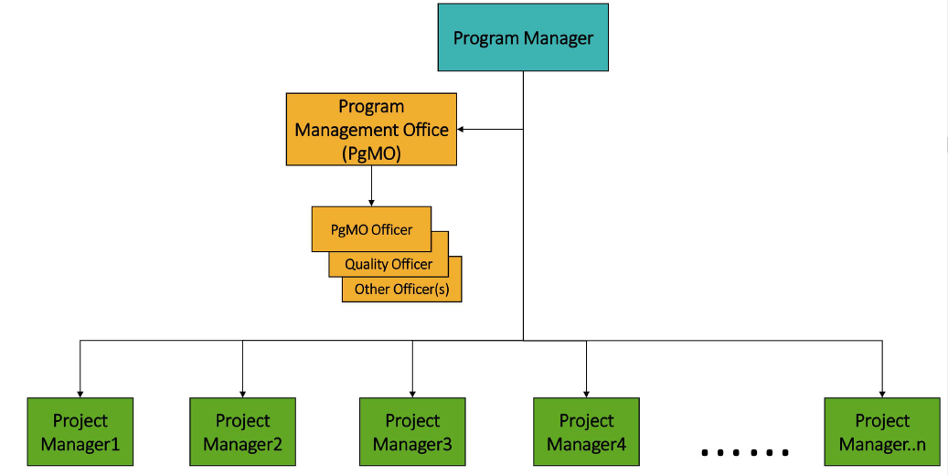

**Portfolio Management Office (PfMO)**

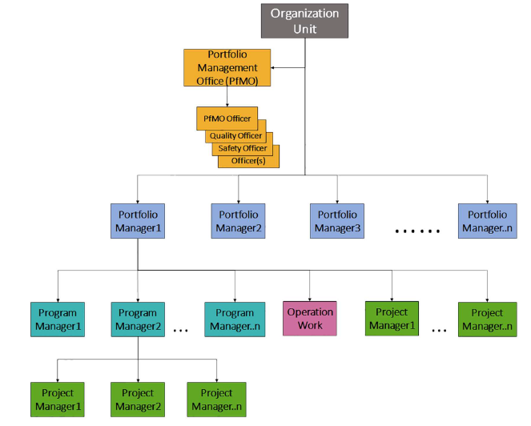

**Definition of Project Management**

**PMI® definition of *project management:**

“Project management is the application of knowledge, skills, tools, and techniques to project activities to meet project requirements. It is accomplished through the appropriate application and integration of the project management processes identified for the project. It enables organizations to execute projects effectively and efficiently.”

**Common misconception:** Project management is an art of creating an illusion that any outcome is the result of a series of predetermined, deliberate acts when, in fact, it was dumb luck.

**Project Management Methodology**

Project management is a formalized approach to manage a unique product, service, or result.

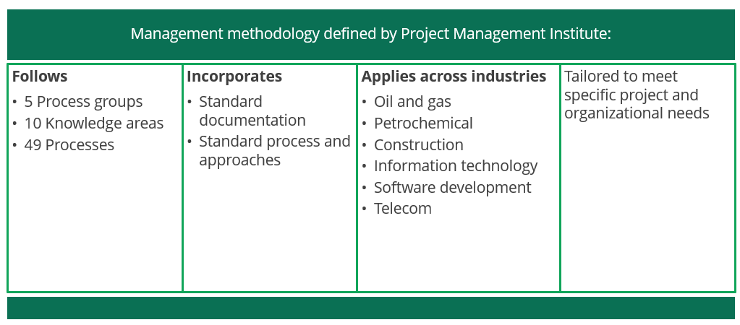

**Definition of Program Management**

**PMI® Definition of *Program Management:**

“The application of knowledge, skills, and principles to a program to achieve the program objectives to obtain benefits and control not available by managing components individually”

**PMI® Definition of *Program:**

A program is defined as a group of related projects, subprograms, and program activities managed in a coordinated way to obtain benefits not available from managing them individually.

**Features of Program Management**

* For a group of projects to be classified as a program, there must be some value added in managing them together as a program.
* A project need not belong to a program; a program will always have projects.
* A program is designed to deliver some strategic benefits to the organization; the benefits could be tangible (for example, growing the operating margin) or intangible (for example, improving the morale of the team).
* A project manager focuses on fulfilling the requirements of a project, whereas a program manager focuses on delivery of benefits to the organization.

**Portfolio**

The definition of *portfolio is as follows: - A collection of projects, programs, subsidiary portfolios, and operations managed as a group to achieve strategic objectives.

Projects and programs of a portfolio may not be necessarily interdependent or directly related.

A portfolio can be based on the business objectives.

“Japanese Projects” can be a portfolio where an IT company puts all its projects from Japan to give more focus and attention to its Japanese projects and grow its Japanese business. Similar projects can be managed as a program within this portfolio; all banking projects will be managed as a “banking program.”

**Portfolio Management**

The definition of *portfolio management is as follows: -

“Portfolio management refers to the centralized management of one or more portfolios to achieve strategic objectives.”

Portfolio management includes identifying, prioritizing, authorizing, managing, and controlling projects, programs, and other related work to achieve strategic business objectives.

**Relationship among Portfolios, Programs, and Projects**

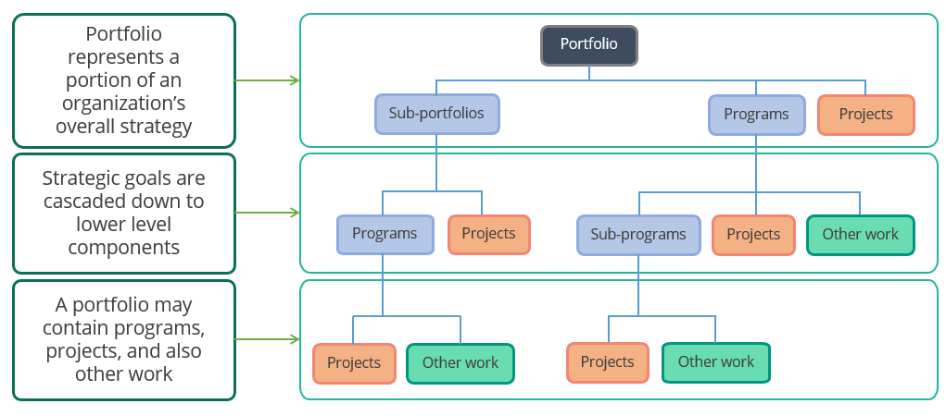

**Project Constraints**

Every project is managed within certain limitations. The project manager has to keep these factors in mind while planning and executing the project. These factors are called Constraints. Every project has six constraints given below: -

* Scope
* Time
* Cost | Budget
* Resources
* Quality
* Risk

The above constraints complete against each other and a project manager needs to juggle between them or perform a trade-off. For example, if the scope of the project is increased, it could affect the time, cost, resources, quality, and risk of the project.

Based on the evaluation of the impacts, a decision will be made on whether the additional scope should be included or not. Similarly, if the customer wants an early delivery, then it could have an impact on scope, cost resources, quality, and risk of the project.

**Project Management Office (PMO)**

“A Project Management Office (PMO) is an organizational structure that standardizes project-related governance processes and facilitates the sharing of resources, methodologies, tools, and techniques”

The roles of PMO are as follows: -

**Primary Roles**

PMO usually has one or a combination of the following primary roles: -

* It provides the policies, methodologies, and tools and templates for managing projects within the organization
* It provides support and training in the organization on how to manage projects
* It provides project managers for ongoing projects in the organization
* It ensures compliance (governance) with all policies, procedures, methodologies, and tools and templates within the organization

**Other Roles**

PMO may also help in the following areas: -

* Managing interdependencies between projects
* Selecting, managing, and deploying shared or dedicated project resources
* Terminating projects
* Organizing “lessons learned” sessions
* Maintaining the project management knowledge base for an organization
* Supporting projects through knowledge repositories, training, and mentoring

**Types of Project Management Offices**

Types of PMO structures in organizations: -

* Supportive (Low control)
* Controlling (Medium control)
* Directive (High control)

**Stakeholder**

The definition of *stakeholder is as follows: -

“An individual, group, or organization who may affect, be affected by, or perceive itself to be affected by a decision, activity, or outcome of a project, program, or portfolio is known as a stakeholder.”

**Examples of Stakeholders: -**

**Project Manager:** One who manages the project and follows the process

**Project Team:** One who develop & implement the project

**Project Sponsor:** One who gives the go-ahead for a project and provides the necessary resources to execute the project. In short, one who pays for the project.

**Customer:** One who takes delivery of the project’s product

**End User:** One who uses the product of the project

**Performing Organization:** Company executing the project

**Government | Statutory bodies:** In case any approvals are to be taken

**Environmental / Social / Political groups:** If the project infringes on the group’s objectives

**Society as a whole:** Companies and Projects are performed within our society and hence, have responsibility towards the society

Stakeholder Management is extremely important for success of a project. It includes the following:-

* Identifying stakeholder’s
* Capturing stakeholder’s requirements and expectations
* Managing stakeholder’s influence
* Communicating with stakeholder’s

All the above responsibilities finally rest with the project managers.

**1.2.4 Project Life**

|  |  |
| --- | --- |
| Project Life Cycle | Product Life Cycle |
| A project life cycle is the series of phases that a project passes through from the beginning to the end.  A project life cycle depends upon the control needs of the performing organization or the organization’s preference, which is defined in the project execution methodology. | A typical product life cycle starts with the conception of the product and goes on until its withdrawal from the market or when it becomes obsolete.  A product life cycle is long.  A product life cycle includes multiple projects throughout its life. |

**Comparison of Project Life Cycle vs. Product Life Cycle**

**Example**

The Apple iPod is an example of a product. Over the course of its product life there were many projects that enhanced its functionalities and added features. These projects and their life cycles were determined by the control needs of Apple, which typically emphasized time-to-market (TTM) and high quality. The iPod as a product exhibited its own life cycle of “Conception – Introduction – Maturity – Decline – Withdrawal” and new products have replaced it now.

**Types of Project Development Life Cycle**

**Predictive:** Project scope, time, and cost are determined as early as possible. The changes to project scope are carefully managed. It is also referred to as waterfall life cycle.

**Iterative:** The scope is determined earlier, but time and cost estimates are regularly modified as the understanding of the product increases.

**Incremental:** The deliverable is produced through a series of iterations that successively add functionality.

**Adaptive:** Projects can be agile, iterative, or incremental. The scope is defined and approved before the start of an iteration. It is also referred to as agile or change-driven life cycle. The iterations are very rapid and are fixed in duration and cost.

**Hybrid:** A hybrid life cycle is a combination of a predictive and an adaptive life cycle.

**1.2.5 Components of PMBOK Guide**

**Project phases:** A collection of logically related project activities that culminates in the completion of one or more deliverables

**Phase gate:**  A review at the end of a phase in which a decision is made to continue to the next phase

**Process group:** A logical grouping of project management inputs, tools and techniques, and outputs

**Knowledge area**: An identified area of project management defined by its knowledge requirements and described in terms of its processes and practices

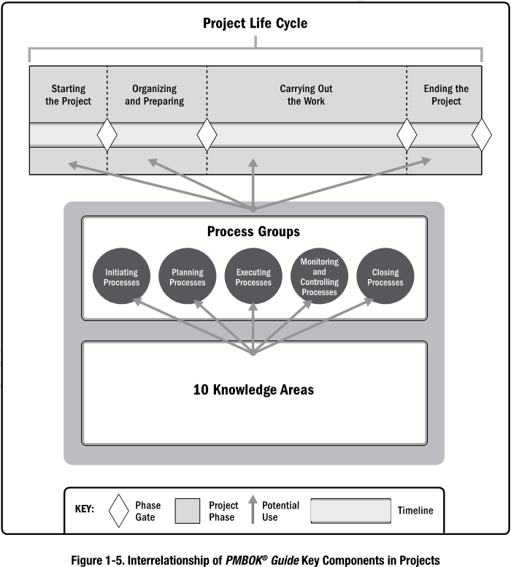

**Project Management Process Groups**

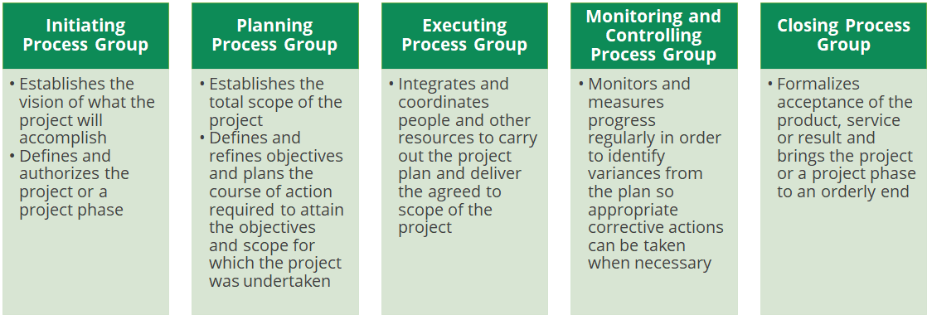

**Initiating Process Group.** Those processes performed to define a new project or a new phase of an existing project by obtaining authorization to start the project or phase.

**Planning Process Group.** Those processes required to establish the scope of the project, refine the objectives, and define the course of action required to attain the objectives that the project was undertaken to achieve.

**Executing Process Group.** Those processes performed to complete the work defined in the project management plan to satisfy the project requirements.

**Monitoring and Controlling Process Group.** Those processes required to track, review, and regulate the

progress and performance of the project; identify any areas in which changes to the plan are required; and initiate the corresponding changes.

**Closing Process Group.** Those processes performed to formally complete or close the project, phase, or contract.

**Project Management Knowledge Areas**

The ten knowledge areas are:-

**Project Integration Management -** Includes the processes and activities to identify, define, combine, unify, and coordinate the various processes and project management activities within the Project Management Process Groups.

**Project Scope Management -** Includes the processes required to ensure the project includes all the work required, and only the work required, to complete the project successfully.

**Project Schedule Management -** Includes the processes required to manage the timely completion of the project.

**Project Cost Management** - Includes the processes involved in planning, estimating, budgeting, financing, funding, managing, and controlling costs so the project can be completed within the approved budget.

**Project Quality Management** - Includes the processes for incorporating the organization’s quality policy regarding planning, managing, and controlling project and product quality requirements, in order to meet stakeholders’ expectations.

**Project Resource Management** - Includes the processes to identify, acquire, and manage the resources needed for the successful completion of the project.

**Project Communications Management** - Includes the processes required to ensure timely and appropriate planning, collection, creation, distribution, storage, retrieval, management, control, monitoring, and ultimate disposition of project information.

**Project Risk Management** - Includes the processes of conducting risk management planning, identification, analysis, response planning, response implementation, and monitoring risk on a project.

**Project Procurement Management** - Includes the processes necessary to purchase or acquire products, services, or results needed from outside the project team.

**Project Stakeholder Management** - Includes the processes required to identify the people, groups, or organizations that could impact or be impacted by the project, to analyze stakeholder expectations and their impact on the project, and to develop appropriate management strategies for effectively engaging stakeholders in project decisions and execution.

**Project Management Process**

**Project Management Institute provides formalized project management process:-**

*A Guide to Project Management Body of Knowledge (PMBOK® Guide)* incorporates 5 process groups, 10 knowledge areas, and 49 processes.

Planning is a priority as:-

* + Plans permeate every activity
  + Plans can be executed when developed in advance
  + Planning ensures that process is well thought out
  + Planning makes sure that project participants know their roles and responsibilities
  + Eliminates confusion, rework, redundancy and conflict
  + Ensures that “greater good” drives project decisions
* Plans are done at the level of detail sufficient to determine strategy, approach, and potential risks
* Planning establishes how quality and success are measured – “When are we done”
* Planning provides strategies for handling risks when realized

**PMI’s Process Framework**

**Inputs, Outputs, and Tools**

* All project management work can be described by one of the 49 processes.​
* A process is defined by inputs, tools and techniques, and outputs.​
* Every exam question will tie back to a process, knowledge area, or process group or to Professional and Social Responsibility.

**A process is characterized by three elements:**

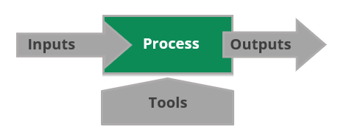

**Common Inputs and Outputs**

**Enterprise environmental factors**

* Anything that affects your project—examples include the culture, the organization, the PM’s power, risk tolerance, and the market
* Used heavily in Initiating, Planning, and Monitoring and Controlling process groups

**Organizational process assets**

* Anything that helps projects and planning—examples include previous plans, documents, analytical data, policies, and systems
* Used heavily in all process groups

**Project management plan**

* Primary project document that directs execution, control, and closure—discussed in the next segment
* Used in all Executing, Monitoring and Controlling, and Closing process groups

**Work performance data**

* The raw observations and measurements identified during activities performed to carry out the project work

**Work performance information**

* Data collected from various controlling processes analysed in context
* Used in Monitoring and Controlling process group

**Maps the Project Management Process Groups and Knowledge Areas**

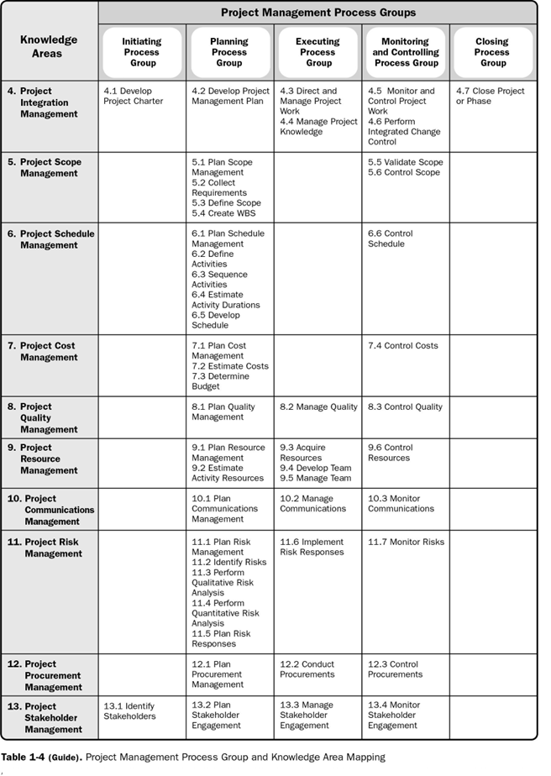

**1.2.6 Process Tailoring**

Tailoring is necessary because each project is unique; not every process, tool, technique, input, or output identified in the PMBOK® Guide is required on every project. Tailoring should address the competing constraints of scope, schedule, cost, resources, quality, and risk. The importance of each constraint is different for each project, and the project manager tailors the approach for managing these constraints based on the project environment, organizational culture, stakeholder needs, and other variables.

**1.2.7 Project Management Data Information**

The Project life cycle flow shows the order of events that occur during a project’s duration. During the project, data is collected and analyzed to assist in project decision making.

**Work performance data**

The raw observations and measurements identified during activities performed to carry out the project work. Examples include reported percent of work physically completed, quality and technical performance measures, start and finish dates of schedule activities, number of change requests, number of defects, actual costs, actual durations, etc. Project data are usually recorded in a Project Management Information System (PMIS) and in project documents.

**Work performance information**

The performance data collected from various controlling processes, analyzed in context and integrated based on relationships across areas. Examples of performance information are status of deliverables, implementation status for change requests, and forecast estimates to complete.

**Work performance reports**

The physical or electronic representation of work performance information compiled in project documents, which is intended to generate decisions or raise issues, actions, or awareness. Examples include status reports, memos, justifications, information notes, electronic dashboards, recommendations, and updates.

Figure shows the flow of project information across the various processes used in managing the project

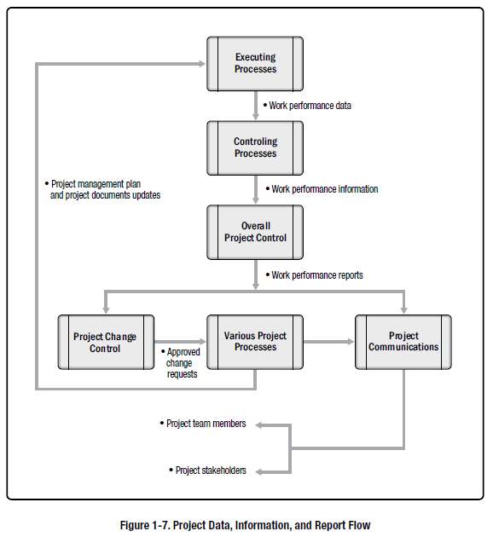

**12.8 Project Management Business Documents**

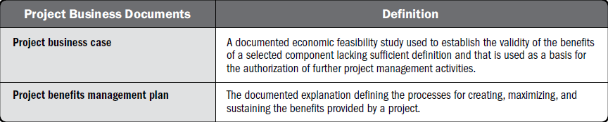

A **Projects** **business case** may include but is not limited to documenting the following: -

* Business need
* Analysis of the situation
* Options available:
* Do nothing
* Do the minimum work possible
* Do more than the minimum work possible
* Recommendation
* Evaluation

The **Projects** **benefits management plan** describes key elements of the benefits and may include but is not limited to documenting the following:-

* Target benefits
* Strategic alignment
* Timeframe
* List of benefits owners
* Metrics
* Assumptions
* Risks

**1.2.9 Project Success Measures**

Project success may include additional criteria linked to the organizational strategy and to the delivery of business results.

These project objectives may include but are not limited to:-

* Completing the project benefits management plan;
* Meeting the agreed-upon financial measures documented in the business case. These financial measures may include but are not limited to:-
* Net present value (NPV),
* Return on investment (ROI),
* Internal rate of return (IRR),
* Payback period (PBP), and
* Benefit-cost ratio (BCR)
* Meeting business case nonfinancial objectives;
* Completing movement of an organization from its current state to the desired future state;
* Fulfilling contract terms and conditions;
* Meeting organizational strategy, goals, and objectives;
* Achieving stakeholder satisfaction;
* Acceptable customer/end-user adoption;
* Integration of deliverables into the organization’s operating environment;
* Achieving agreed-upon quality of delivery;
* Meeting governance criteria; and
* Achieving other agreed-upon success measures or criteria (e.g., process throughput).

The project team needs to be able to assess the project situation, balance the demands, and maintain proactive communication with stakeholders in order to deliver a successful project.

**Project Management Framework Summary**



* Project management is the application of knowledge, skills, and tools and techniques to project activities to meet the project requirements
* Project manager has to integrate various project aspects, like the people, stakeholders, risks, communication, and procurements with the project constraints (**T**ime, **S**cope, **C**ost, and **Q**uality).
* Projects differ from operations in that they are temporary and not repetitive in nature
* Programs encapsulate multiple projects to achieve objectives that are not possible by managing projects individually
* Portfolios are strategically aligned efforts combining programs, projects, and operational efforts in the pursuit of organizational objectives
* PMO provides the policies, methodologies, and tools and templates for managing projects within the organization
* Identifying internal and external stakeholders, determining their requirements, and communicating with them regularly is an important role of a project manager
* Functional, projectized, and matrix are the three types of organization structures, based on the level of authority given to the project manager
* Project life cycle begins at the initiation of a project and lasts until the closure, while product life cycle encompasses the operational and maintenance phases
* Project life cycle follows 5 process groups: Initiating, Planning, Executing, Monitoring and Controlling, and Closing
* Project life cycle can be iterative in nature and may go through the 5 process groups multiple times
* PMI provides **10** Knowledge Areas, **5** Process Groups, and **49** processes

## 2.The Environment in Which Projects Operate

**Objectives**



* Influence on Project Management
  + Organizational Process Assets
  + Enterprise Environmental Factors
  + Organizational System
* Organizational Structure Types

**2.1 Influence on Project Management**

Factors influence on Project Management

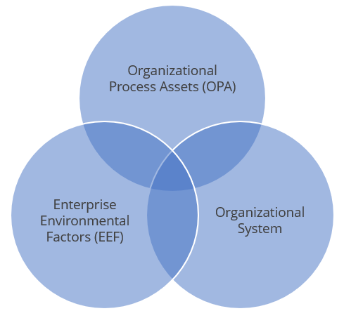

**2.2 Enterprise Environmental Factors (EEF)**

Enterprise environmental factors (EEFs) refer to conditions, not under the control of the project team, that influence, constrain, or direct the project. These conditions can be internal and/or external to the organization. EEFs are considered as inputs to many projects management processes, specifically for most planning processes. These factors may enhance or constrain project management options. In addition, these factors may have a positive or negative influence on the outcome.

The Enterprise Environmental Factors are: -

**Internal**

* Organizational culture, structure, and governance
* Geographic distribution of facilities and resource
* Infrastructure
* IT software
* Resource availability
* Employee capability

**External**

* Market conditions
* Social and cultural influence, and issues
* Legal restrictions
* Commercial databases
* Academic research
* Government or industry standards
* Financial considerations
* Physical environmental elements

**2.3 Organizational Process Assets (OPA)**

Organizational process assets (OPAs) are the plans, processes, policies, procedures, and knowledge bases specific to and used by the performing organization. These assets influence the management of the project.

OPAs include any artifact, practice, or knowledge from any or all of the performing organizations involved in the project that can be used to execute or govern the project. The OPAs also include the organization’s lessons learned from previous projects and historical information. OPAs may include completed schedules, risk data, and earned value data.

OPAs are inputs to many project management processes. Since OPAs are internal to the organization, the project team members may be able to update and add to the organizational process assets as necessary throughout the project.

They may be grouped into two categories:

* Processes, policies, and procedures
* Organizational knowledge bases.

**The processes, policies, and procedures of a project include:-**

* Standards
* Quality policies and procedures, templates, guidelines, and tailoring
* Proposal evaluation criteria
* Performance measurement criteria
* Communication guidelines
* Project closure guidelines
* Financial control procedures
* Issue and defect management
* Change control, risk management, and work authorization

**The corporate knowledge base of the project includes:-**

* Process measurement database
* Project files and historical information
* Issue and defect database
* Lessons learned
* Configuration management databases
* Financial databases

**2.4 Organizational System**

* Organizational system is a result of interaction of various factors in an organization.
* It determines power, competence, interests, and political capabilities of people.
* The three components of organizational systems are:
  + - Management elements
    - Governance frameworks
* Organizational structure types

**2.5 Organizational Structure Types**

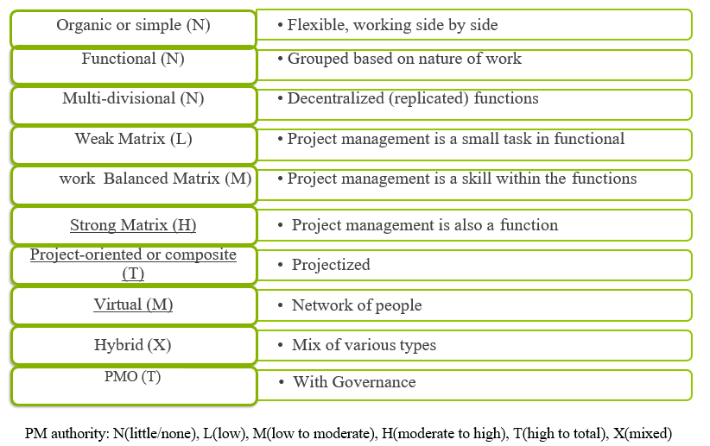

**The Environment in which Projects Operate Summary**



* Factors that influence on Project Management
* Organizational Process Assets
* Enterprise Environmental Factors
* Organizational System
* Enterprise environmental factors (EEFs) refer to conditions, not under the control of the project team, that influence, constrain, or direct the project. These conditions can be internal and/or external to the organization.
* Organizational process assets (OPAs) are the plans, processes, policies, procedures, and knowledge bases specific to and used by the performing organization. These assets influence the management of the project.
* Organizational system is a result of interaction of various factors in an organization, It determines power, competence, interests, and political capabilities of people.

## 3. The Role of Project Manager

**Objectives**



* Discuss the definitions of project, functional, and operations manager
* Identify the role of project managers and their sphere of influence
* Explain project manager competences
* Compare team management and leadership
* Describe different leadership styles
* Discuss how project managers can perform integration on the projects

**Definition of Project Manager**

A project manager leads the team that is responsible for achieving the project objectives.

**Definition of Functional Manager**

A functional manager focuses on providing management oversight for a functional or business unit.

**Definition of Operations Manager**

An operations manager ensures that business operations are efficient.

**Project Manager’s Sphere of Influence**

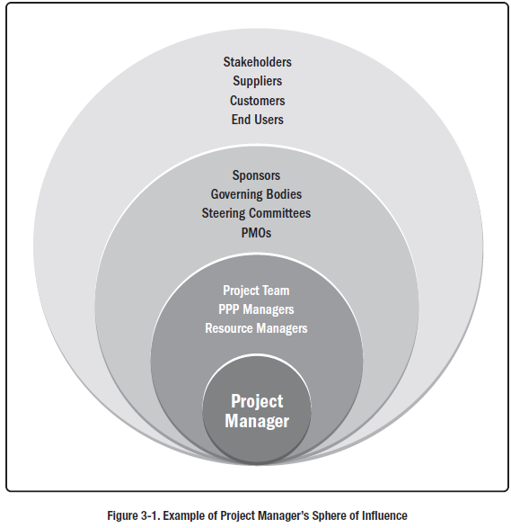

**The Role of a Project Manager**

A project manager: -

* Is responsible and accountable for the project
* Applies lessons learned from recent projects
* Defines project roles and responsibilities
* Leads the project planning activities
* Performs project tracking and communicates project status
* Adopts project management best practices
* Manages the project priorities
* Performs risk and issue management
* Drives decision-making
* Promotes client involvement
* Encourages and supports escalations
* Enforces effective change control
* Mentors project members
* Has the most essential position and authority on a project

**Forms of Power of a Project Manager**

Relationships enable project managers to get things done on the project. Various forms of power at the disposal of project managers:

* Positional (also called formal/legitimate/authoritative)
* Informational
* Referent
* Situational
* Personal or charismatic
* Relational
* Expert
* Reward-oriented
* Punitive or coercive
* Ingratiating
* Pressure-based
* Guilt-based
* Persuasive
* Avoiding

**Project Manager Competences**

The three main competences for a project manager are shown with the help of PMI Talent Triangle *®.*

Technical project management

Leadership

Strategic and business management

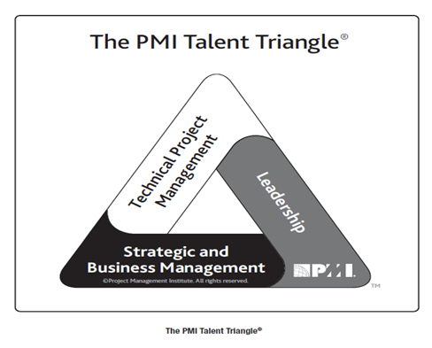

**Technical Project Management**

* This includes the knowledge, skills, and behavior related to specific domains of project, program, and portfolio management
* It is the technical aspect of the project manager’s role

**Leadership**

* This includes the knowledge, skills, and behavior needed to guide, motivate, and direct a team to help an organization achieve its business goals

**Strategic and business**

* This includes project manager’s knowledge and information about the organization
* It enhances performance and delivers the business outcomes

**Management vs. Leadership**

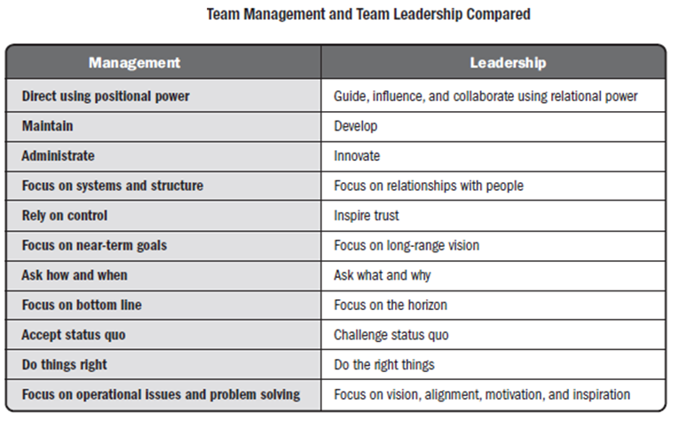

**Leadership Styles**

* **Laissez-faire:** The leader allows the team to make their own decisions and establish their own goals. It is also referred to as taking a hands-off style.
* **Transactional:** The leader focuses on goals, feedback, and accomplishment to determine rewards.
* **Servant leader:** The leader demonstrates commitment to serve and puts others first. The leader focuses on other’s growth, learning, development, autonomy, and well-being. The leader also concentrates on relationships, community, and collaboration. Leadership is secondary and emerges after service.
* **Transformational:** The leader empowers followers through idealized attributes and behavior, inspirational motivation, encouragement for innovation and creativity, and individual consideration.
* **Charismatic:** The leader inspires the team and possesses high energy, enthusiasm, confidence, and strong convictions.
* **Interactional:** This style is a combination of transactional, transformational, and charismatic leadership styles.

**Performing Integration**

* Integration is a critical skill for project managers
* It must be performed at three different levels:
* **Process Level:** The project manager understands process interactions
* **Cognitive Level:** The processes are then integrated into knowledge areas
* **Context Level:** New environmental elements are added at this level

**The Role of Project Manager Summary**



* A project manager leads the team that is responsible for achieving the project objectives.
* A functional manager focuses on providing management oversight for a functional or business unit.
* An operations manager ensures that business operations are efficient.
* Relationships enable project managers to get things done on the project. Various forms of power are at the disposal of project managers.
* The three main competences for a project manager are shown with the help of PMI Talent Triangle*®*. They are technical project management, leadership, and strategic and business management.
* The different types of leadership styles are laissez-faire, transactional, servant leader, transformational, charismatic, and interactional.

## 4. Project Integration Management

**Objectives**



* Define Project Integration Management
* Identify the key role of the project manager, project team, and project sponsor
* Explain various project selection methods
* Describe the Project Integration Management processes
* Identify key terminologies used in Project Integration Management

**Project Integration Management**

The Project Integration Management includes: -

Processes and activities to identify, define, combine, unify, and coordinate the various processes and project management activities within the Project Management Process Groups.

Project Integration Management is high-level work that requires the project manager to manage interdependencies among the other knowledge areas. It deals with:

* Resource allocation
* Balancing competing demands
* Examining alternative approaches
* Tailoring the processes to meet the project objectives
* Managing the interdependencies among Project Management Knowledge Areas

**Key Concepts of Project Integration Management**

Project Integration Management is specific to project managers, whereas the rest of the knowledge areas can be managed by others.

The links among the processes in Project Management Process Groups are iterative in nature. Integration is required to:

* Ensure deliverables and due dates are achieved
* Provide a plan for managing the project
* Ensure use of appropriate knowledge when needed
* Manage performance in project management plan
* Integrate decision-making across knowledge and process groups
* Monitor and control work performance
* Implement risk strategies across efforts when indicated by events or performance
* Manage communications and engagements
* Effectively manage phase transitions

**Trends and Emerging Trends in Project Integration Management**

Some of the evolving trends in integrated processes include: -

* Use of automated tools such as PMIS (Project Management Information System)
* Use of visual management tools instead of written plans and other documents
* Implementing project knowledge management to secure knowledge
* Expanding the project managers’ responsibility by involving them in development of business case and benefits management plan
* Applying hybrid methodologies such as use of agile and other iterative practices

**Tailoring and Consideration** **in Project Integration Management**

Considerations for tailoring the way Project Integration Management Processes are applied: -

* Project life cycle—What is an appropriate project life cycle?
* Development life cycle—Is predictive, adaptive, or hybrid approach appropriate for product, service, or result?
* Management approaches—What management processes are effective based on organizational culture?
* Knowledge management—How will knowledge be managed to foster collaborative working environment?
* Change—How will changes be managed?
* Governance—What control board and committees are part of the project?
* Lessons learned—What information should be collected throughout and at the end of the project? How will historical information and lessons learned be made available to future projects?
* Benefits—When and how should the benefits be reported?

**Agile | Adaptive Environments in Project Integration Management**

* Control of the detailed product planning and delivery is delegated to the team members.
* PM’s focus is on building a collaborative decision-making environment.

**Role of Project Manager, Team, and Sponsor**

Given below are the key roles of the project manager, project team, and the project sponsor:

**Project Manager**: -The key role of a project manager is to integrate various activities of the project.

**Project Team**: - The key role of a project team is to concentrate on completing the project activities

**Project Sponsor**: - The key role of a project sponsor is to protect the project team from unnecessary   
changes and loss of resources.

**Project Selection Methods**

An organization can undertake a project as a contract or driven by business needs. There should be a formal process for selecting projects to ensure that the limited corporate resources are optimized.

The two broad project selection methods are as follows:

**Benefit measurement methods**

These methods ascertain the costs and benefits of undertaking the project.

Examples:

* Murder board
* Peer review
* Scoring models
* Economic models
* Benefit compared to cost

**Constrained optimization methods**

These methods rely on mathematical modeling techniques to determine the selection of the best projects to achieve certain business objectives.

Examples:

* Linear programming
* Goal Programming
* Integer Programming

**Type of project selection technique is peer review:** Peer review is a **benefit measurement method**

**Present Value (PV)**

Present Value (PV) is the current value of a future cash flow. The amount of money received today is worth more than the same amount in the future. A discount factor has to be applied to reflect future cash flows in present values.

A sum of $250 being paid right now will be more valuable than $250 being paid 3 years from now.

PV analysis is important to ensure that an organization maximizes its profit, particularly when value will be delivered a long time in the future. Farther the timing of the cash flow (future value), lower is the present value.

**Net Present Value (NPV)**

Net Present Value (NPV) is the difference between value of the total benefits (income or revenue) and the costs over a period of time. Present values of different items combined gives the NPV.

Project X will take 2 years to complete and has an NPV of $35,000. Project Y will take 5 years to complete and has an NPV of $95,000. Which project would you select?

Project Y, because it has a higher NPV.

Note: The project with the higher NPV is better.

Problems where a project has to be selected over other projects on the basis of its net present value can be expected in the exam.

**Internal Rate of Return (IRR)**

Internal Rate of Return (IRR) is the rate of discounting (used to reduce future cash flows to their present value) at which the present value of costs matches the present value of benefits. In other words, it is the rate of return internal to the project.

Project A has an IRR of 25% and project B has an IRR of 15%. which project would you choose?

Project A, because it has a higher IRR. The project with the higher IRR is better.

**Payback Period**

Payback Period is the number of time periods it takes to recover the investment from the project before profits start accumulating.

Project A has a payback period of 5 months and project B has a payback period of 12 months. Which project would you select?

Project A, because it has a lesser payback period. The project with the lesser payback period is better.

**Benefit Cost Ratio (BCR)**

Benefit Cost Ratio (BCR) compares the present value of benefits to the present value of costs. A benefit cost ratio of more than 1 means that the benefits are greater than the costs.

Which project would you select if the BCR of Project A is 2.5 and BCR of Project B is 1.5?

Project A, as it has higher BCR.

Accept a project with a BCR greater than 1. The project with the higher BCR is better.

**Return on Investment (ROI)**

Return on Investment (ROI) is the rate of return on the project normalized by the initial investment. It indicates the profitability of the project.

If a project involves an initial investment of $100,000 and generates an average return of $20,000 per year, ROI is 20,000/100,000 or 20%. Higher the ROI, the more profitable the project is.

**Opportunity Cost**

Opportunity cost is the cost related to the next best choice available after choosing from among several mutually exclusive choices. It is therefore the opportunity given up by selecting one project over another.

What is the opportunity cost of selecting Project B if Project A has an NPV of $55,000 and Project B has an NPV of $85,000?

Opportunity cost is $55,000. This is the NPV of Project A.

**Project Integration Management Knowledge Areas**

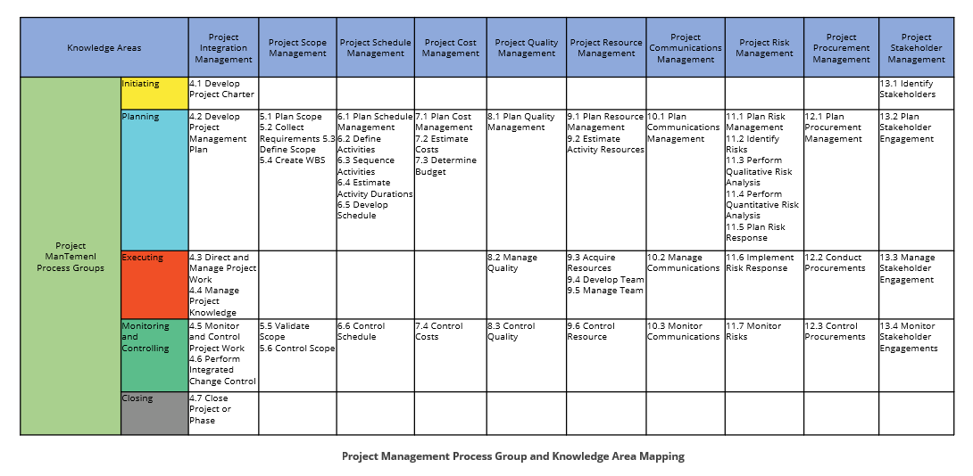

**Develop Project Charter**

“Develop Project Charter is a process of developing a document that formally authorizes the existence of a project and provides the project manager with the authority to apply organizational resources to the project activities.”[1] It belongs to the Initiating Process Group.

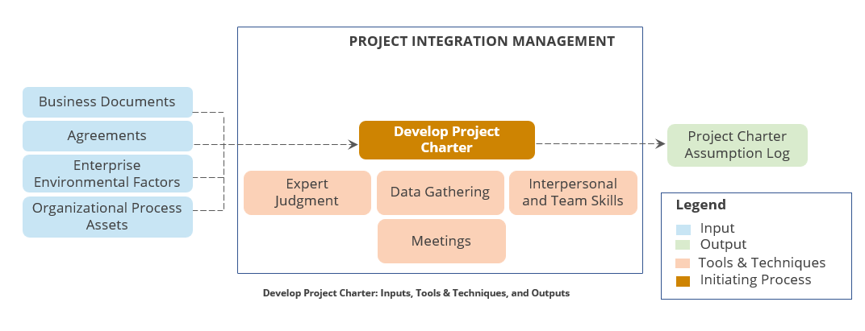

This process is the first opportunity for Project Manager to understand the vision and goals of the project as agreed to by the sponsor and stakeholders.

* Describes project purpose, vision, and initial scope
* Formally authorizes project and project manager
* Contains
  + Business problem to be solved
  + Measurable project objectives/requirements
  + Project boundaries and key deliverables
  + Risks
  + Critical success factors
  + Stakeholder list and roles/responsibilities
  + Constraints and assumptions
  + Project exit criteria
* Approved by project sponsor

**Develop Project Management Plan**

“Develop Project Management Plan is the process of defining, preparing, integrating, and coordinating all subsidiary plans and integrating them into a comprehensive project management plan.”

* Project management plan is a detailed document that describes how the project would be executed, monitored and controlled, and closed.
* Project management plan contains all the subsidiary management plans and their baseline values.
* Subsidiary plans can be separate documents, particularly on very large projects.

The various inputs, outputs, and tools and techniques of developing the project plan are given below.

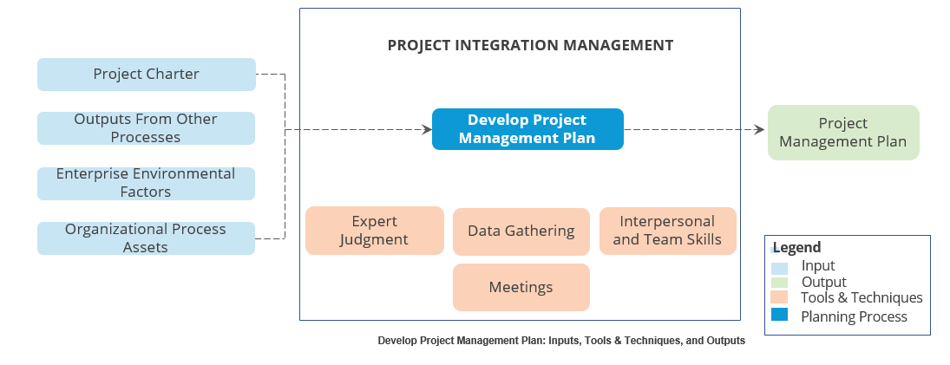

**Contents of Project Management Plan**

Regardless of how the plan is organized, it should contain a section referencing or covering:

|  |  |
| --- | --- |
| * Scope Management Plan * Requirements Management Plan * Schedule Management Plan * Cost Management Plan * Quality Management Plan * Resource Management Plan * Communications Management Plan * Risk Management Plan * Procurement Management Plan * Stakeholder Engagement Plan * Change Management Plan | * Configuration Management Plan * Scope Baseline * Schedule Baseline * Cost Baseline * Performance Measurement Baseline * Project Life cycle * Development Approach * Management Reviews |

**Project Documents**

The following is a list of project documents.

|  |  |  |
| --- | --- | --- |
| * Activity Attributes * Activity List * Assumption Log * Basis of Estimates * Change Log * Cost Estimates * Cost Forecasts * Duration Estimates * Issue Log * Lessons Learned Register * Milestone List * Physical Resource Assignments * Project Calendars * Project Communications | * Project Schedule * Project Schedule Network Diagram * Project Scope Statement * Project Team Assignments * Quality Control Measurements * Quality Metrics * Quality Report * Requirements Documentation * Requirements Traceability Matrix * Resource Breakdown Structure * Resource Calendars * Resource Requirements * Risk Register * Risk Report | * Schedule Data * Schedule Forecasts * Stakeholder Register * Team Charter * Test and Evaluation Documents |

**What is Change Control System?**

A set of procedures that describes how modifications to the project deliverables and documentation are managed and controlled.

**What is Configuration Management System?**

A collection of procedures used to track project artifacts and monitor and control changes to these artifacts.

**Direct and Manage Project Work**

“Direct and Manage Project Work is the process of leading and performing the work defined in the project management plan and implementing approved changes to achieve the project objectives.” It belongs to the Executing Process Group.

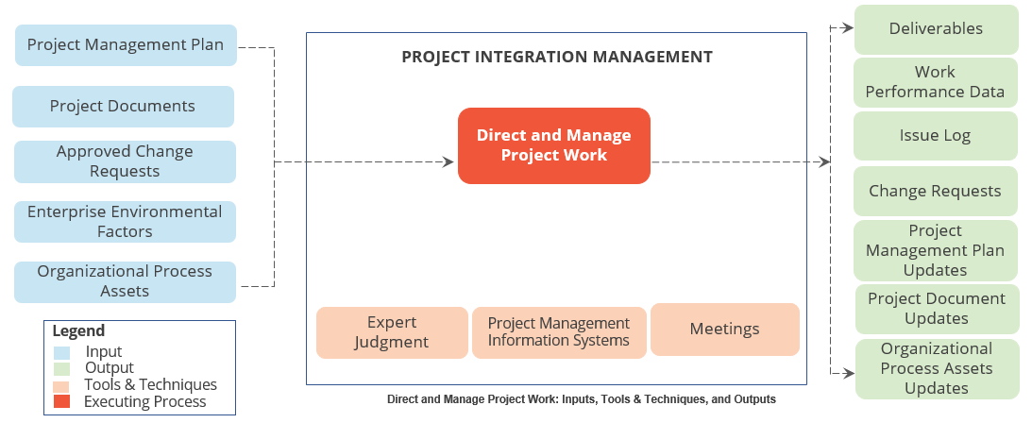

During Direct and Manage, the Project Manager focuses on:

* Project Team development and coordination
  + Ensure appropriate training, reference material, availability of experts
  + Coordinate efforts within team
  + Resolve conflicts and issues with internal/external groups or contractors
  + 5 minute meetings
* Interfacing with all stakeholders
  + Following Communication plan
  + Following Stakeholder Engagement plan
  + Reporting metrics
  + Reporting progress
  + Additional reporting requirements as defined in the Communication plan
* Project Plan Monitoring (actual vs. planned)
  + Gathering actual completion dates
  + Determining task completion status
* Overall quality management
  + Quality in all deliverables
  + Compliance with process
* Risk management
  + Identifying risks
  + Implementing mitigation strategies
  + Communicating risks
* Scope and product change management
  + Implement the process
  + Look for unauthorized changes
  + Ensure scheduled changes are incorporated and completed
* Facilitating project meetings and performance reviews (communications management)
  + Follow Communication plan
  + Execute Stakeholder Engagement Management Plan
  + Document inputs from meetings and communications with stakeholders and team members
* Documenting progress and work performance
* Updating project records, reports (communications management), and deliverables management

**Execution**

During Execution, Project Leadership is a critical success factor.

The PM must lead the Project Team and stakeholders with respect to the project.

* Essential prerequisite for project success is the PM’s ability to lead the Project Team in what can be an unstructured environment.
* Provide leadership throughout each phase of the project to motivate team members, ensure consistent interpretation of the requirements, keep the project on schedule and within budget, and make sure all milestones (e.g., deliverables submissions) are met.

**Manage Project Knowledge**

“Manage Project Knowledge is the process of using existing knowledge and creating new knowledge to achieve project objectives and contribute to organizational learning.” It belongs to the Executing Process Group.

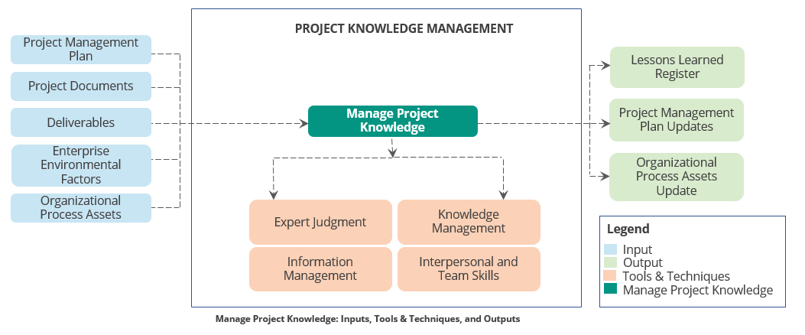

Project knowledge is broken into explicit and tacit knowledge and is intended to increase organizational success factors as well as achieve project objectives.

* Explicit knowledge is information that can be easily documented and communicated
* Tacit knowledge is personal and difficult to communicate (expertise, experience, insights, etc.)
* Both types of knowledge are required for Project Knowledge
* Ensure that tacit and explicit knowledge are used before, during, and after project development
* Knowledge Management is more than lessons learned, change requests, and risks

**Monitor and Control Project Work**

“Monitor and Control Project Work is the process of tracking, reviewing, and regulating the progress to meet the performance objectives defined in the project management plan.” It belongs to the Monitoring and Controlling Process Group.

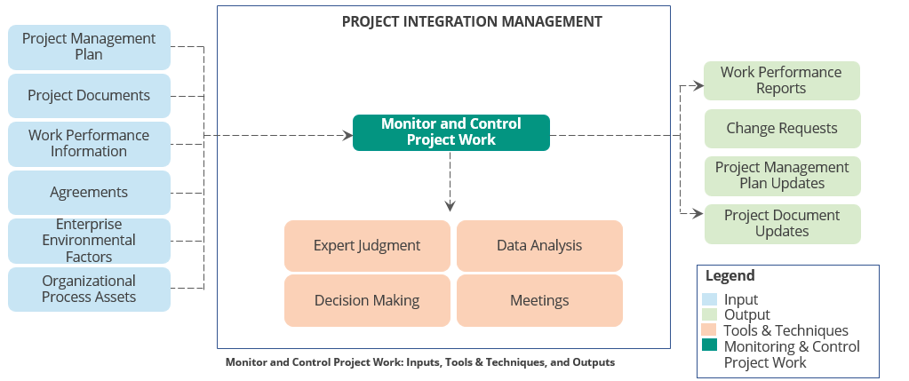

During Monitor and Control Project Work, the Project Manager focuses on:

* Evaluating work performance
* Developing Variance analysis
  + Monitor metrics and evaluate and report on variance
  + Evaluate for impact and correct if necessary
  + Evaluate trending work performance and project status and look for indicators in project variables
* Earned value management
  + Overlap with Control and Monitoring process
  + Collect information to develop analysis model
  + Communicate results of model throughout the team
  + Make decisions to improve performance, burn-rate, or both
  + Evaluate staffing decisions for performance

**Challenges**

Project Managers must manage both cost and schedule

* “Poor cost variance combined with good schedule variance does not mean everything is alright.” – Humphreys 2002
* Spend more and make up time (SV decrease)
* Spend less and lose time (CV decrease)

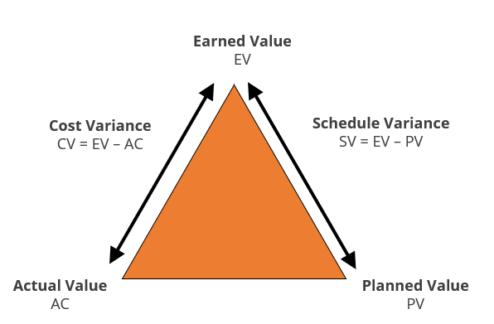

**Monitor and Control**

The monitor and control project work is an opportunity to adjust and adapt the work to ensure project success. It is also an opportunity to learn new approaches and techniques that other projects can benefit from. This process:

* Generates real-time lessons learned for current and future efforts
* Defines additional approaches for future efforts
* May result in schedule modifications
  + Corrective / Preventative Actions
  + Fast-track schedule
  + Schedule Optimization
  + Implementation of mitigation plans

**Perform Integrated Change Control**

“Perform Integrated Change Control is the process of reviewing all change requests; approving and managing changes to deliverables, project documents, and the project management plan; and communicating the decisions.” It belongs to the Monitoring and Controlling Process Group.

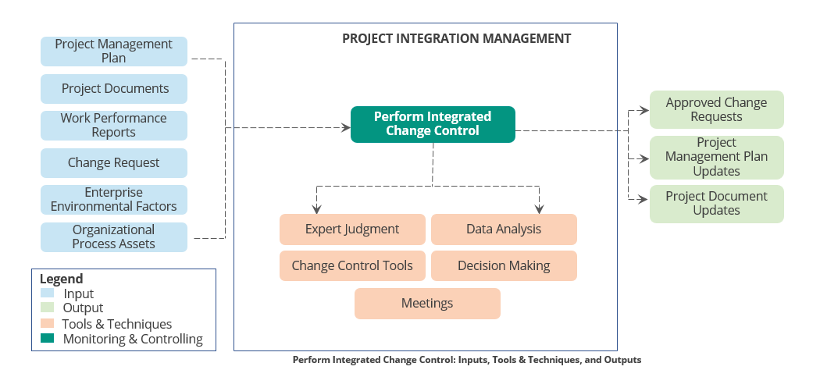

**Projects seldom run according to plan.**

* The only constant is change
* Identify that a change needs to occur or has occurred
* Influence the factors that circumvent change control
* Review and approve changes
* Manage approved changes
  + Monitor when and how changes occur
  + Analyze risk impact
  + Socialize and seek change approval (Change Control Board (CCB), Sponsor, Stakeholders)
  + Schedule change
  + Release only approved changes
* Update project documents (schedule, cost, risk, quality plan, change log)

**Change Management Process**

The process of change management is as follows: -

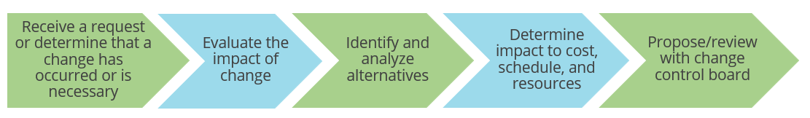

**Close Project or Phase**

“Close Project or Phase is the process of finalizing all activities for the project, phase, or contract.” It belongs to the Closing Process Group.

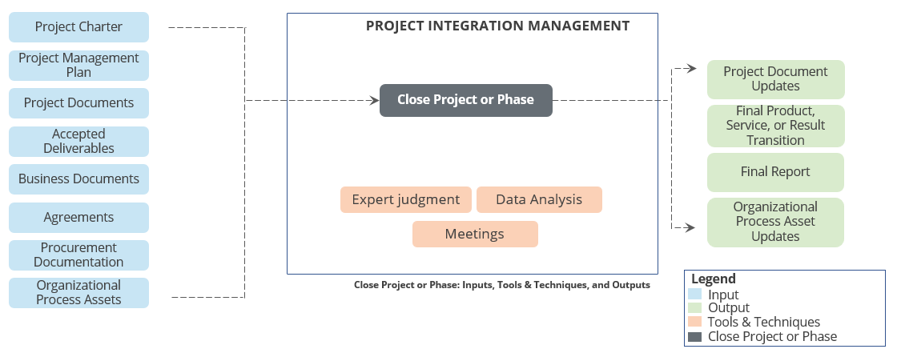

**Project Integration Management Summary**



* Project Integration Management involves unification, consolidation, articulation, and integrative actions that are crucial for successfully completing the project.
* Integrating the project activities is the key role of a project manager; the project team focuses on completing the project activities, and the project sponsor protects the team against unsolicited changes.
* Benefit measurement methods ascertain the costs and benefits of undertaking the project, while constrained optimization methods rely on mathematical modeling to select the best projects that achieve business objectives.
* Various Project Integration Management processes are Develop Project Charter, Develop Project Management Plan, Direct and Manage Project Work, Manage Project Work, Monitor and Control Project Work, Perform Integrated Change Control, and Close Project or Phase.

## 5. Project Scope Management

**Objectives**



* Define Project Scope Management
* Differentiate between project scope and product scope
* Identify the key terms used in Project Scope Management
* Explain work breakdown structure
* Describe the Project Scope Management processes

**Define Project Scope Management?**

Project Scope Management includes the processes required to ensure that a project includes all the work required, and only the work required, to complete the project successfully.

Managing the project scope is primarily concerned with defining and controlling what should be included in the project.

**Project Scope Management Activities**

The key activities of Project Scope Management are as follows:-

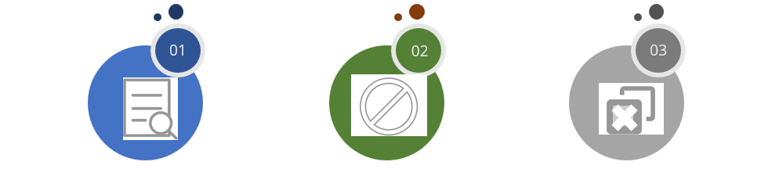

**1. Ensure Constant Monitoring**

Ensure all the project work is being completed

**2. Avoid Scope Creep**

Define project boundaries and avoid unnecessary addition of scope

**3. Prevent Gold Plating**

Restrict the project work only to the defined activities and avoid doing more work than required for the project.

**Product Scope vs. Project Scope**

Project Scope Management deals with managing both the product scope as well as the project scope.

The difference between project scope and product scope is as follows:-

**Product Scope**

Product scope refers to the features and functions that characterize a product, service, or result.

Example: In the banking sector, services like savings accounts and mutual funds are called products.

**Project Scope**

Project scope refers to the work performed to deliver a product, service, or result with the specified features and functions. Project Scope is often inclusive of Product Scope.

Example: To deliver a product, requirement and design documents have to be produced. This is a part of project scope and not product scope.

**Trends and Emerging Practices**

* A business analyst is responsible for requirement-related activities
* Collaborate with business analyst to:
  + Determine problems and identify business needs
  + Identify and recommend viable solutions
  + Elicit, document, and manage stakeholder requirements to meet business and project objectives
  + Facilitate successful implementation of the product, service, or end result of the project
* Project manager and business analyst should have a collaborative partnership

**Tailoring Considerations**

Considerations for tailoring the way Project Scope Management Processes are applied in an organization:

* Knowledge and requirements management
* Validation and control
* Development approach
* Stability of requirements
* Governance

**Considerations for Agile/Adaptive environment**

* In the beginning of the project, agile methods spend less time to define and agree on scope. These methods spend more time to establish the process for its ongoing discovery and refinement.
* Agile methods build prototypes to understand customer feedback and refine requirements.
* Scope is defined and refined throughout the project.
* Requirements constitute the backlog in agile approaches.

**Definition of Work Breakdown Structure (WBS)**

A deliverable-oriented, functional decomposition of the project scope of work into hierarchically grouped work elements.



* A WBS defines the total project work.
* If a deliverable is not in the WBS, it is not in the project.
* Each descending level of a WBS represents an increasingly detailed definition of the project work to be performed.
* The WBS is the foundation for project task definition, resource and performance planning, cost estimating, budget control, progress tracking, and status reporting.
* Work packages are considered decomposed at their lowest level when decomposing them offers no further value or when the work packages can be realistically estimated and they have a meaningful conclusion.
* For a completely decomposed project, each work package should:
  + Have a single purpose
  + Be decomposed until it does not make sense to decompose further
  + Be estimable with a high degree of accuracy
  + Contain clearly understood deliverable(s) or work product(s)

Work Breakdown Structure (WBS) reflects the scope baseline of the entire project. Deliverables not incorporated in WBS will not be a part of the project.

* WBS is prepared with the team’s buy-in.
* During decomposition, each level should be complete; it should include all the work in the project before decomposing further.
* Decomposition should be done until the lowest work unit cannot be logically subdivided further (and/or it can be estimated with reasonable accuracy).
* WBS is a deliverable-oriented decomposition and should contain only deliverables and not activities.
* WBS is part of Project Scope Baseline along with Project Scope Statement and WBS Dictionary.

**Key Terms**

**Work Breakdown Structure**

A hierarchical decomposition of the total scope of work to be carried out by the project team to accomplish the project objectives and create the required deliverables

**WBS Dictionary**

A document that provides detailed deliverable, activity, and schedule information about each component in the Work Breakdown Structure

**Project Scope Statement**

The project scope statement is the description of the project scope, major deliverables, assumptions, and constraints. It describes the project’s deliverables in detail.

**Control Account**

A management control point where scope, budget, actual cost, and schedule are integrated and compared to earned value for performance measurement

**Example: WBS**

Given below is the WBS of a core banking software development project:-

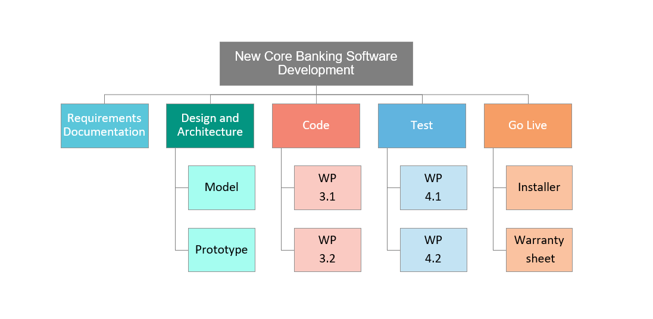

**Project Scope Management Processes**

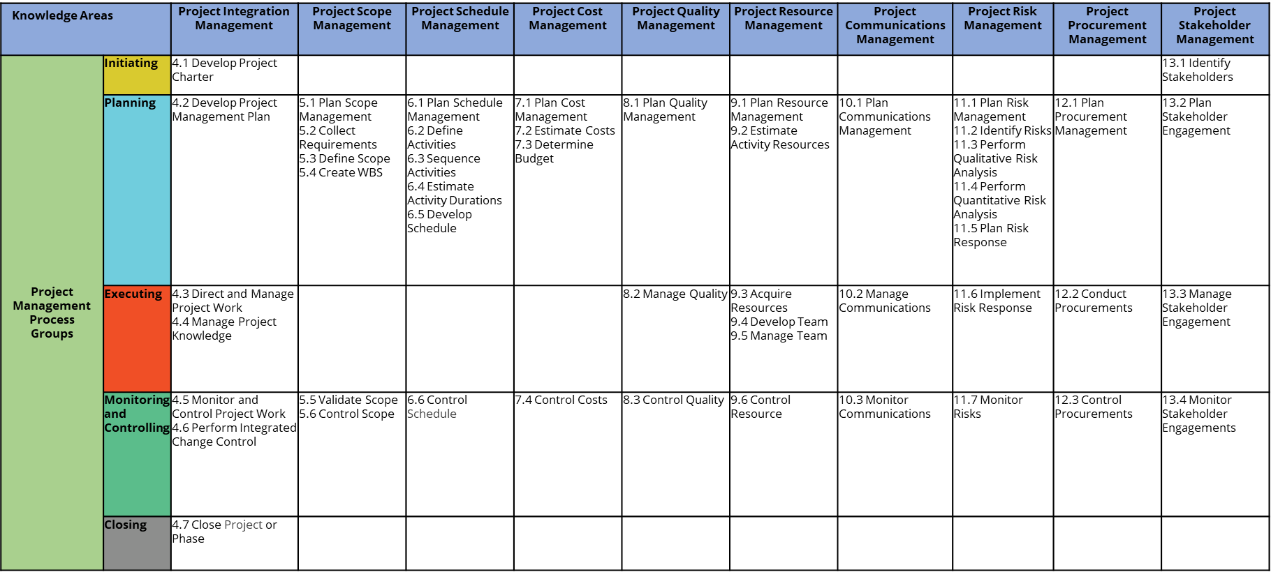

**Plan Scope Management**

“Plan Scope Management is the process of creating a scope management plan that documents how the project and product scope will be defined, validated, and controlled.” It belongs to the Planning Process Group.

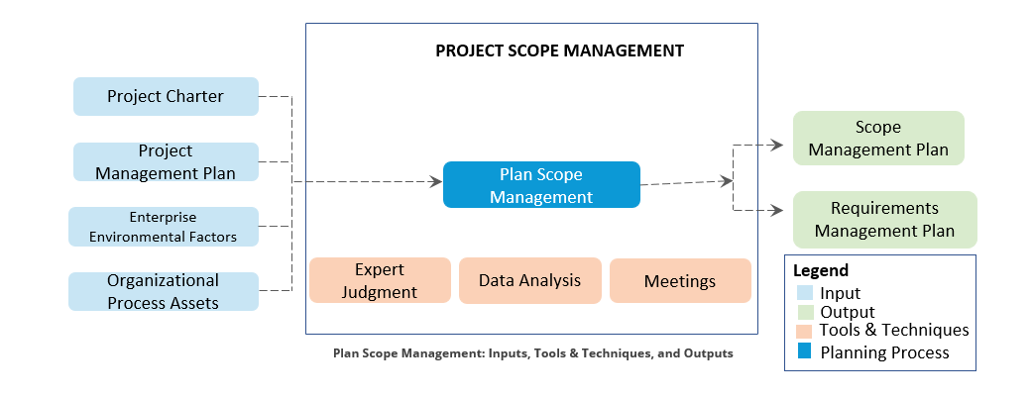

**Collect Requirements**

“Collect Requirements is the process of determining, documenting, and managing stakeholder needs and requirements to meet objectives.” It belongs to the Planning Process Group.

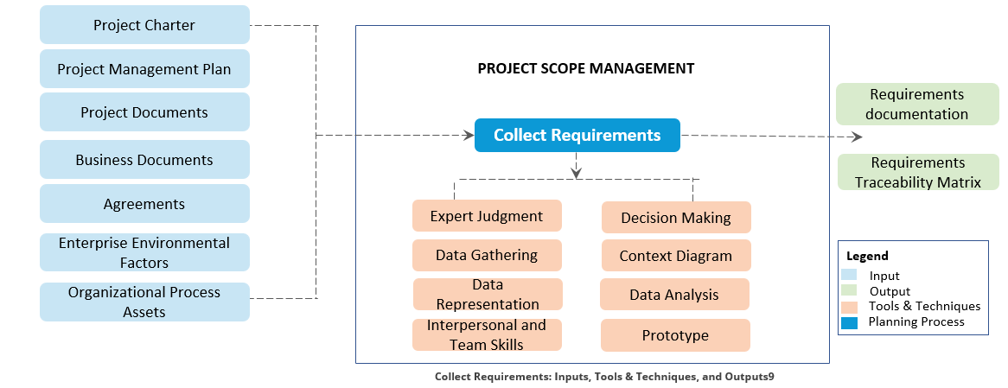

**Requirement Traceability Matrix**

**A sample requirements traceability matrix is given below:**

Requirements Traceability is a technique used to verify that the work packages of a WBS are delivered and tested. Typically, this is supported through tooling like Microsoft Team Foundation Server or similar products.

|  |  |  |  |  |
| --- | --- | --- | --- | --- |
| Requirement Number | Design | Coding | System Testing | Acceptance Testing |
| 3.1.1.1 (Multi-user access) | SDD Section 3.1 | RBACprocessing.cpp  SchemaCreation.sql | Tests 111-120 | Tests 51-55 |
| … |  |  |  |  |
| … |  |  |  |  |
| … |  |  |  |  |
| … |  |  |  |  |

**Define Scope**

“Define Scope is the process of developing a detailed description of the project and product.” It belongs to the Planning Process Group.

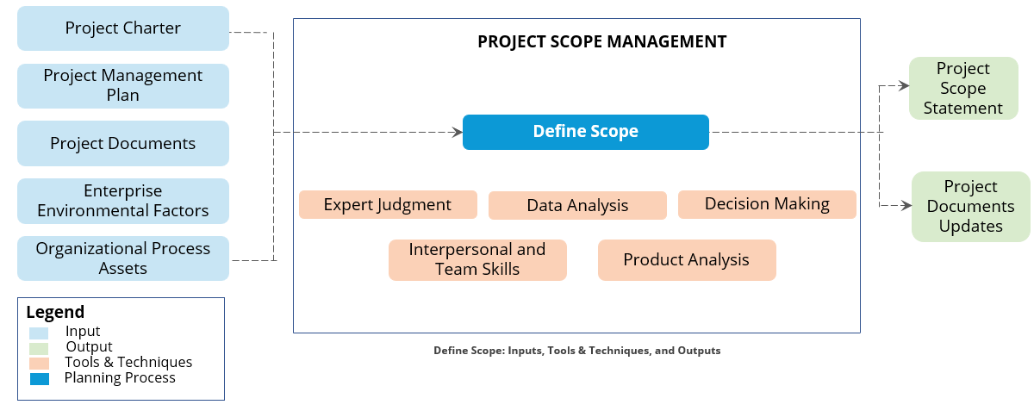

**Create WBS**

“Create WBS is the process of subdividing project deliverables and project work into smaller, more manageable components.” It belongs to the Planning Process Group.

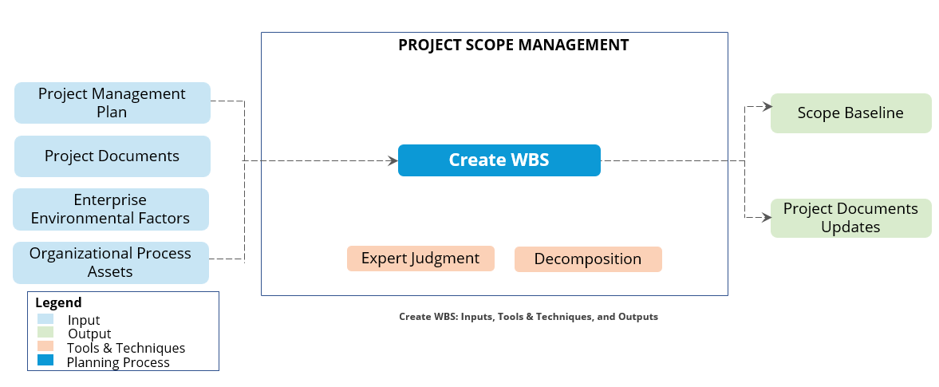

**Validate Scope**

“Validate Scope is the process of formalizing acceptance of the completed project deliverables.” It belongs to the Monitoring and Controlling Process Group.

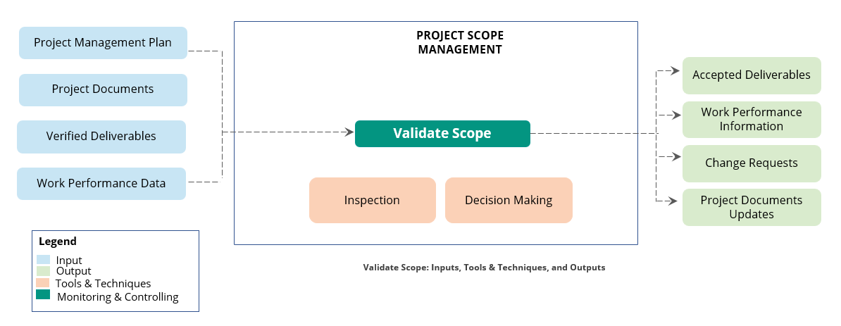

**Control Scope**

“Control Scope is the process of monitoring the status of the project and product scope and managing changes to the scope baseline.” It belongs to the Monitoring and Controlling Process Group.

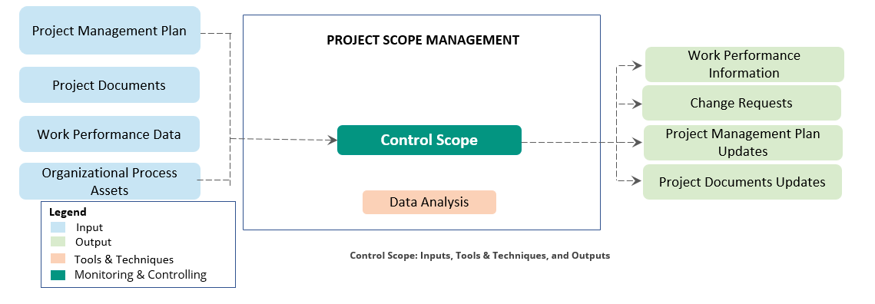

**Important Outputs**

**Work Performance Information**

The performance data collected from controlling processes, analysed in comparison with project management plan components, project documents and other work performance information. Work performance data becomes work performance information after the tools and techniques of a process have been applied.

**Accepted Deliverables**

These are deliverables that have been verified and are ready for validation against the project scope at which point they are accepted.

**Change Requests**

When validating project scope, new requirements might be discovered, for example, adding an email notification when a password is changed. These requirements should be documented as change requests.

**Project Scope Management Summary**



* Project Scope Management includes the processes required to ensure that a project includes all and only the work essential to complete the project successfully.
* Product scope refers to the features and functions that characterize a product, service, or result, while project scope refers to the work that must be performed to deliver a product, service, or result with the specified features and functions.
* WBS breaks the project scope into smaller and more manageable pieces called work packages
* WBS dictionary contains the explanation of the terms used in WBS.
* The six Project Scope Management processes are Plan Scope, Collect Requirements, Define Scope, Create WBS, Validate Scope, and Control Scope.

## 6. Project Schedule Management

**Objectives**



* Define Project Schedule Management
* Explain project schedule, Gantt charts, and network diagrams
* Identify the key terms used in Project Schedule Management
* Describe the Project Schedule Management processes
* Explain various schedule network analysis techniques

**Project Schedule Management**

**The definition of *Project Schedule Management is as follows:**

Project Schedule Management includes processes required to manage timely completion of the project.

Project scheduling provides a detailed plan that represents how and when the project will deliver the products, services, and results defined in the project scope. It serves as a tool for communication, managing stakeholders’ expectations, and as a basis for performance reporting.

Schedule management plan defines how schedule contingencies will be reported and assessed.

**Project Schedule Management Processes**

**The key processes of Project Schedule Management are as follows: -**

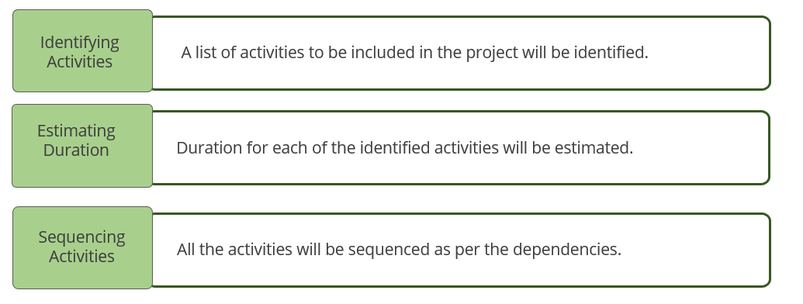

**Key Concepts for Project Schedule Management**

* Project scheduling provides how and when the delivery happens and acts as communication tool.
* Project management team selects the scheduling method, such as critical path or Agile approach.
* For small projects, the planning processes can be combined as one process.
* When possible, the detailed project schedule should remain flexible throughout the project to adjust for knowledge gained, increased understanding of risk, and value-added activities.

**Trends and Emerging Practices in Project Schedule Management**

**Iterative Scheduling with a Backlog**

It is a form of Rolling Wave Planning technique that is based on adaptive life cycles. Benefit of this approach is it welcomes changes throughout the development life cycle.

**On-demand Scheduling**

This does not rely on a schedule that was developed previously for development of the product but rather pulls work from backlog as resources become available. This approach, typically used in a Kanban system, is based on the theory-of-constraints and pull-based scheduling concepts.

**Tailoring Considerations**

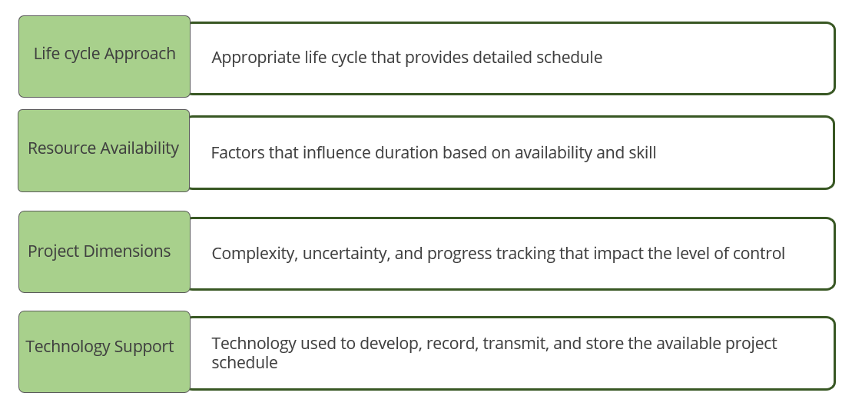

**Considerations for Agile/Adaptive Environments**

Role of project manager will not change regardless of whether the environment is predictive or adaptive.

Project manager should be familiar with tools and techniques under agile/adaptive environments.

Project Schedule

Project schedule assigns a duration to the project activities, and the activities are sequenced in a logical order.

* Project schedule defines the start and end dates of the project and its activities.
* Each task is assigned a resource, duration, and, when appropriate, a predecessor task.
* Scheduling software is used to develop the project schedule. Microsoft Project is the most popular tool used for project schedule development.

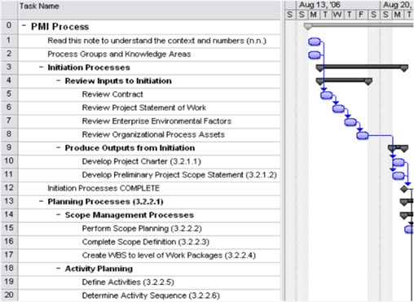

**Gantt Chart**

Gantt chart is a type of bar chart that displays the start and end dates for project activities and the overall project schedule. They can also show logical task relationships and indicate the task completion percentage.

Create tasks and work with the Gantt chart. Each task has a duration, and the Gantt chart facilitates a graphical representation of the overall project schedule, with path to completion.

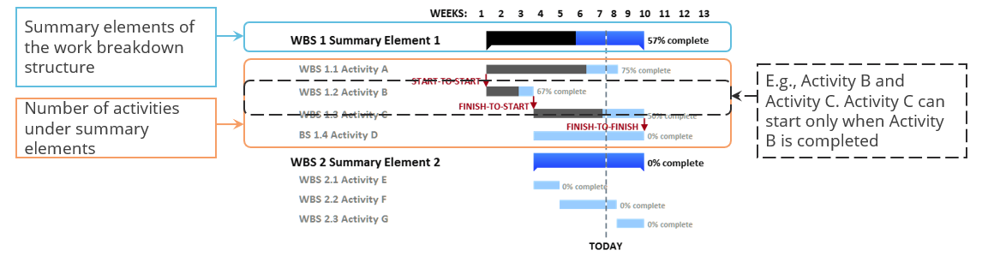

**Gantt Chart: Relationships**

Project activities are related to each other. The relationships among project activities can be classified as follows: -

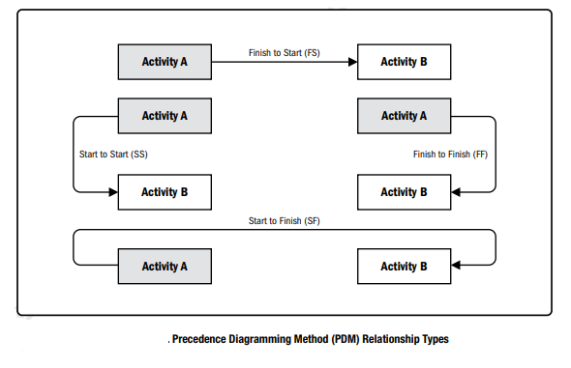

Charts are generally laid out with finish-start and then time/resource adjusted by changing the relationship of tasks (start-start, finish-finish, start-finish)

**Finish to Start (FS)**

An activity must finish before the next activity can start.

An activity that cannot be started until its predecessor is completed. For example, the foundation for a building cannot be poured until it has been excavated.

**Finish to Finish (FF)**

An activity must finish before the next activity can finish.

An activity must finish before the next activity can finish. For example, an old system must be retired before a new system can go into production.

**Start to Start (SS)**

An activity must start before the next activity can start.

An activity must start before the next activity can start. For example, the project request must be submitted before work can start on the project charter.

**Start to Finish (SF)**

An activity must start before the next activity can finish.

An activity must start before the next activity can finish. For example, billing for a service must be started until the service task can be finished.

**Gantt Chart: Dependencies**

Dependency suggests that the project activities are interdependent. Dependencies can be classified as follows: -

**Classification 1**

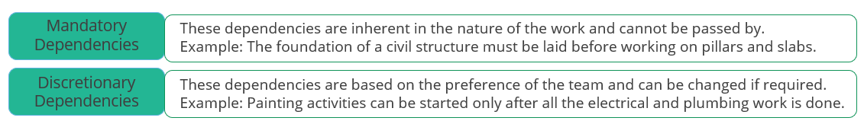

**Classification 2**

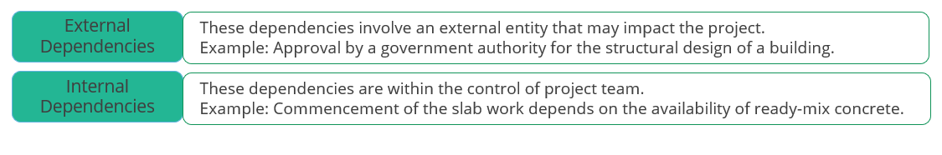

**Network Diagram**

Network diagram is used to plot the activity dependencies. Project activities are represented in the form of a network. Network diagrams can be drawn in one of the following two ways: -

**Precedence Diagramming Model (PDM) or Activity on Node (AON)**

In precedence diagramming model:

* Boxes represent activities
* Arrows indicate dependencies
* Relationships can be of four types:
  + Finish to Start
  + Start to Start
  + Finish to Finish
  + Start to Finish

**Arrow Diagramming Model (ADM) or Activity on Arrow (AOA)**

In arrow diagramming model:

* Arrows are used to represent activities
* Direction of the arrows indicates the relationships and sequences
* Only Finish to Start relationships can be shown
* Dummy activities may be required to show a dependency

**Example: - Node diagram**

Given below is an Activity on Node diagram: -

Hammock activities are used to show a comprehensive summary activity, which can be used for control and reporting purposes.

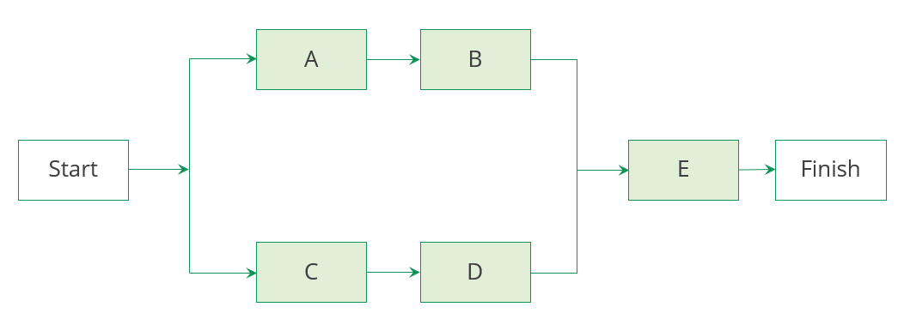

**Key Terms in Project Schedule Management**

Given below are the key terms used in Project Schedule Management:

**Leads and Lags**

A successor activity is said to have a lead when it can start before the predecessor.

Example: Activity B can start 2 days before the completion of activity A.

A successor activity is said to have a lag when it needs to be delayed with respect to the predecessor.

Example: Activity B can start 2 days AFTER activity A is completed.

**\*Rolling Wave Planning**

Rolling wave planning is an iterative planning technique in which the work to be accomplished in the near term is planned in detail while the work in the future is planned at a higher level. It is a form of progressive elaboration applicable to work packages and release planning when using an agile or waterfall approach.

**Analogous Estimating**

Analogous estimating is a technique for estimating the duration or cost of an activity or a project using historical data from a similar activity or project. Analogous estimating uses parameters from a previous, similar project. For example, if the last 5 similar projects took 6 months, this one will also take 6 months.

**Project Schedule Management Processes**

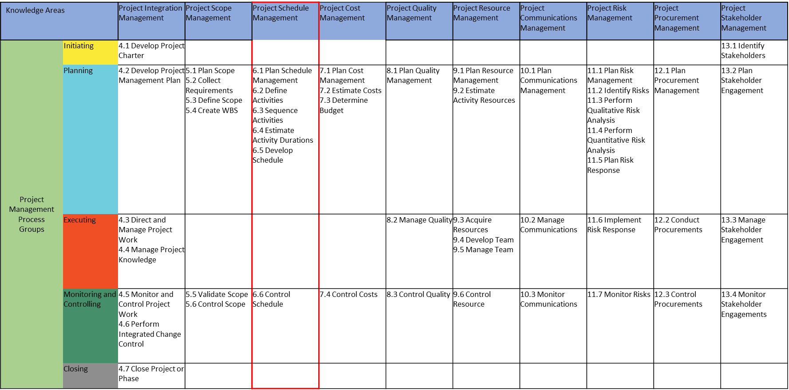

**Plan Schedule Management**

“Plan Schedule Management is the process of establishing the policies, procedures, and documentation for planning, developing, managing, executing, and controlling the project schedule.” It belongs to the Planning Process Group.

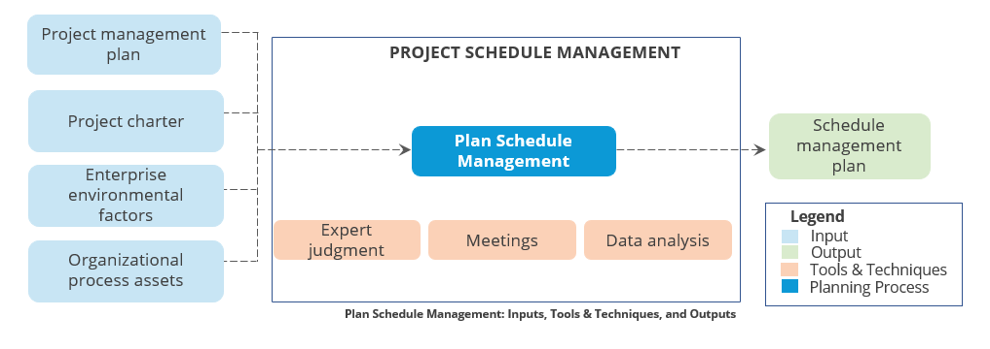

**Define Activities**

“Define Activities is the process of identifying and documenting the specific actions to be performed to produce the project deliverables.” It belongs to the Planning Process Group.

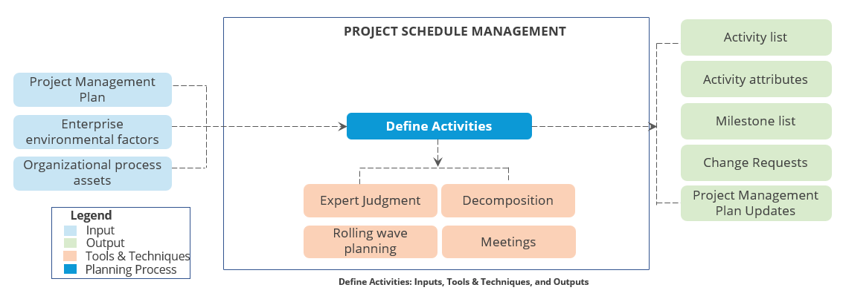

**Sequence Activities**

“Sequence Activities is the process of identifying and documenting relationships among the project activities.” It belongs to the Planning Process Group.

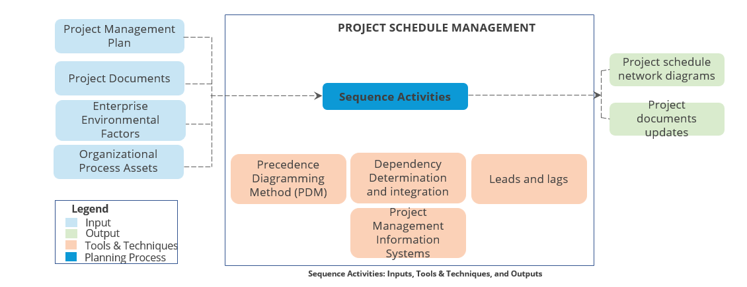

**Estimate Activity Durations**

“Estimate Activity Durations is the process of estimating the number of work periods needed to complete individual activities with estimated resources. The key benefit of this process is that it provides the amount of time each activity will take to complete, which is a major input into the Develop Schedule process.” It belongs to the Planning Process Group.

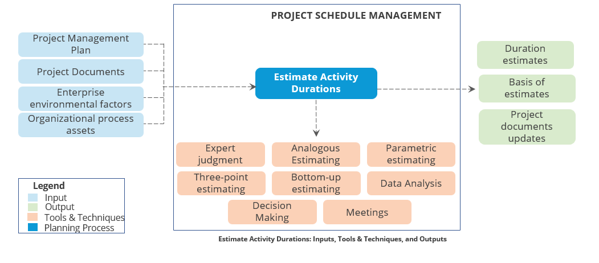

**Develop Schedule**

Develop Schedule is the process of analyzing activity sequences, durations, resource requirements, and schedule constraints to create the project schedule model for project execution and monitoring and controlling.” It belongs to the Planning Process Group.’’

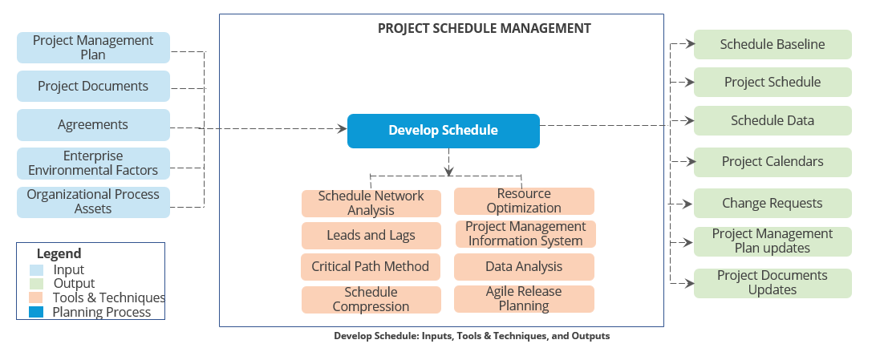

**Schedule Network Analysis**

Along with the time estimate, it is necessary to know if the required resources are available at a given time.

Schedule network analysis technique generates project schedule. Various schedule network techniques are as follows:

**Critical Path Method**

It determines a critical path on a project schedule.

**Monte Carlo Analysis**

In this method, a computer modeling program is used to simulate the outcomes of a project by making use of input values selected at random from probability distributions.

**What-If Scenario Analysis**

It varies a certain parameter and observes the impact on the schedule.

**Resource Optimization Techniques**

They arrive at the optimal utilization of the resources on a project.

**Program Evaluation and Review Technique (PERT)**

Program Evaluation and Review Technique (PERT) uses three-point estimates for an activity.

* Pessimistic (P) estimate refers to the duration an activity would take in the worst-case scenario.
* Most likely (M) estimate refers to the duration an activity would take in a realistic scenario.
* Optimistic (O) estimate represents the duration an activity would take in the best-case scenario.

**Given below are the key formulae used in PERT:**

To calculate the expected duration of the estimate, based on the three estimates

(μ) = (P+4M+O)/6

To calculate the standard deviation of an activity

(σ) = (P-O)/6

To calculate the variance of the activity

σ ^ 2

**Example: PERT**

The values of expected deviation and standard deviation can be applied to derive useful information about the likely range for values.

PERT allows you to plan based on the intended level of confidence in the outcome and determine buffers accordingly.

**Given:** O = 20; P = 70; M = 30

Now, μ = (70 + 30 * 4 + 20)/6 = 35

And σ = (70 – 20)/6 = 8 (approx.)

**Using the normal curve**:

Likelihood of actual time lying between:

1 σ, i.e., 27 and 43 is 68.2%

2 σ, i.e., 19 and 51 is 95.4%

3 σ, i.e., 11 and 59 is 99.7%

**Six Sigma:**

Six Sigma is reaching a level of confidence where 3.4 times out of a million would fall outside the stated range

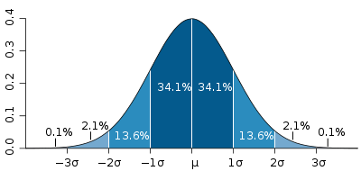

**Critical Path Method**

Critical path is the longest duration path through a network diagram, which determines the shortest time to complete the project. Float, also called slack, is calculated in a network diagram.

The three types of floats are as follows:

**Total Float (Slack)**

The amount of time that a schedule activity can be delayed or extended from its early start date without delaying the project finish date or violating a schedule constraint

**Free Float (Slack)**

The amount of time that a schedule activity can be delayed without delaying the early start date of any successor or violating a schedule constraint

The slack of activities on the critical path is zero (0) as the activities on critical path cannot be delayed.

**Calculation of Float**

Steps to calculate float are as follows: -

Total Float = **Late Start – Early Start** or **Late Finish – Early Finish**

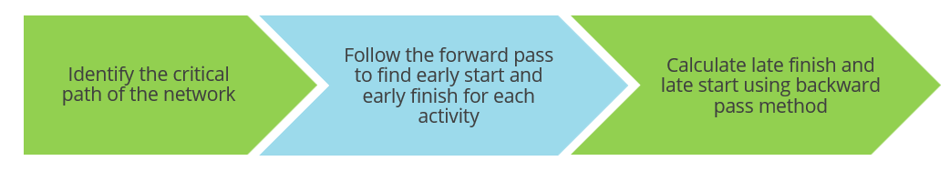

**Critical Path: Example**

Given below is the calculation of a critical path:

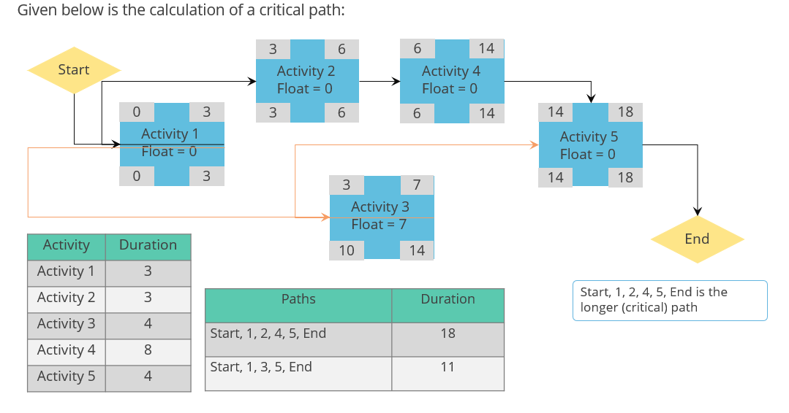

**Schedule Compression**

Schedule compression is done to see if the desired completion date can be met and what will have to change to meet that date. The two techniques of schedule compression are as follows: -

**Fast Tracking**

Linear activities are checked if they can happen in parallel, thereby reducing the project cycle time

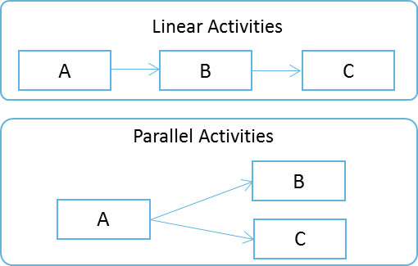

**Crashing**

This involves increasing resources on critical path activities while making cost and schedule tradeoffs. You must determine how to obtain the greatest amount of schedule compression for the least incremental cost while maintaining project scope.

**Example**

The table summarizes the project activity details. Which activity would you crash to reduce the project time by 1 day? Activity A, as it has the minimum crash cost per day.

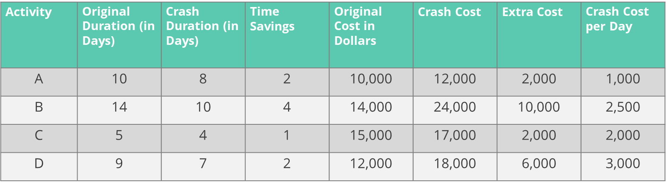

**Impact of Schedule Compression**

Impact of schedule compression on projects are as follows:

|  |  |
| --- | --- |
| Schedule Compression Technique | General Impact to the Project |
| Fast track | * Adds risks * Increases management time for the project manager |
| Crash | * Adds costs * Increases management time for the project manager |
| Reduce scope | * Saves time and cost * Increases customer dissatisfaction |
| Cut quality | * Saves cost and resources * Increases risks |
| Resource reallocation | * Does not add cost or increase risks |

**Control Schedule**

“Control Schedule is the process of monitoring the status of project to update project schedule and managing changes to the schedule baseline.” It is part of the Monitoring and Controlling Process Group.

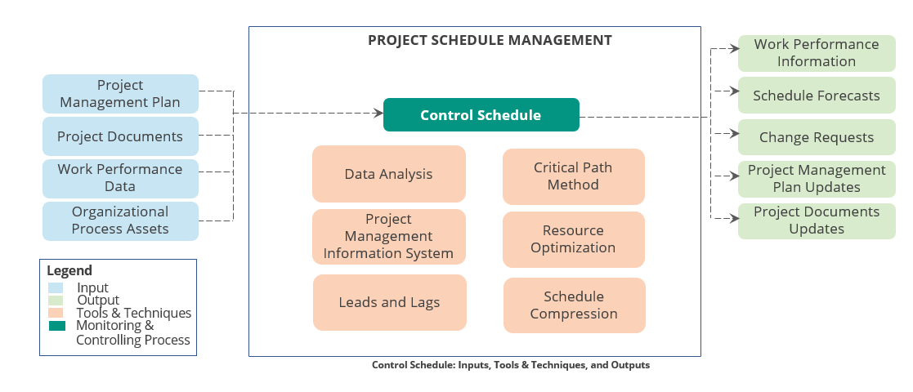

**Project Schedule Management Summary**



* Project Schedule Management includes the processes required to manage the timely completion of the project.
* A project schedule defines the start and end dates of the project and the project activities. These activities are assigned a duration and sequenced in a logical order.
* Gantt charts and network diagrams are used to identify project activities and determine the relationships and dependencies between them.
* Gantt chart displays the start and end dates of project activities, the overall project schedule, and the logical task relationships, while network diagram is used to plot the activity dependencies.
* Plan Schedule Management, Define Activities, Sequence Activities, Estimate Activity Durations, Develop Schedule, and Control Schedule are the six processes under Project Schedule Management.
* Schedule network analysis technique generates project schedule based on the estimates of time and resource requirements.

## 7. Project Cost Management

**Objectives**



* Define Project Cost Management
* Differentiate between cost estimation and cost budgeting
* Explain control accounts
* Describe the Project Cost Management processes
* Apply earned value management technique to track project performance
* Identify key terminologies used in Project Cost Management

**Define Project Cost Management?**

Project Cost Management includes the processes involved in planning, estimating, budgeting, financing, funding, managing, and controlling costs so that project can be completed within the approved budget.

**What are the Key Concepts of Cost Management?**

* Project cost management is primarily concerned with the cost of the resources needed to complete the project activities. Project cost management should consider the effect of project decisions on the subsequent recurring cost of using, maintaining, and supporting the product, service, or result of the project.
* Another aspect involves recognizing that different stakeholders measure project costs in different ways and at different times.

**Explain Cost Management Plan?**

* The Cost Management Plan is concerned with the costs of the resources needed to complete project activities.
* It provides details on how to plan, manage, and control the project cost in relation to the cost baseline and manage the cost variances.
* The project cost management plan is a subsidiary of the project management plan.
* The techniques involved in estimating the cost of each project activity is similar to the ones used in estimating project time.
* Expert judgment, analogous estimating, bottom-up estimating, and reserve analysis are some of the techniques used in cost management.



**Trends and Emerging Practices in Project Cost Management**

* Within the practice of project cost management, trends include expansion of earned value management (EVM) to include the concept of earned schedule (ES).
* ES theory replaces the schedule variance measures used in traditional EVM (Earned value - Planned value) with ES and Actual Time (AT).
* Schedule Variance (SV) is ES-AT.
* Schedule performance index (SPI) using earned schedule metrics is ES/AT.

**Tailoring Considerations**

**Knowledge Management:**

Does the organization have a formal knowledge management and financial database repository that a project manager is required to use and that is readily accessible?

**Estimating and Budgeting:**

Does the organization have existing formal or informal cost estimating and budgeting-related policies, procedures, and guidelines?

**Earned Value Management:**

Does the organization use EVM in managing projects?

**Use of Agile Approach:**

Does the organization use agile methodologies in managing projects? How does this impact cost estimating?

**Governance:**

Does the organization have formal or informal audit and governance policies, procedures, and guidelines?

**Considerations for Agile/Adaptive Environments**

* Projects with high degrees of uncertainty or those where the scope is not yet fully defined may not benefit from detailed cost calculations due to frequent changes.
* Lightweight estimation methods can be used to generate a fast, high-level forecast of project labor costs, which can then be easily adjusted as changes arise.
* In cases where high-variability projects are also subject to strict budgets, the scope and schedule are more often adjusted to stay within cost constraints.

**Control Account**

In larger projects, costs are managed at a higher level rather than at an individual activity level. Under control account technique, related activities are grouped and their costs are managed as one unit.

The scope of a project is decomposed through a Work Breakdown Structure (WBS). The lowest level deliverable in the WBS is called a work package.

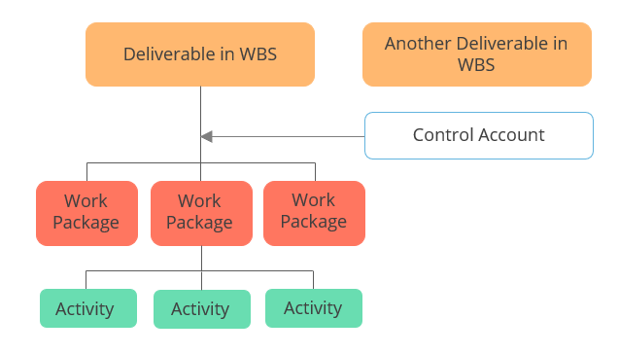

**Project Cost Management Processes**

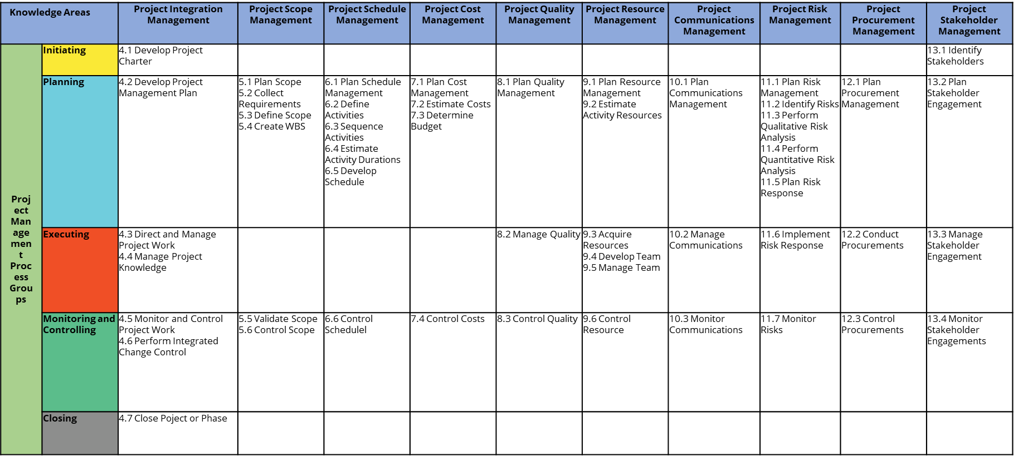

**Plan Cost Management**

“Plan Cost Management is the process of defining how the project costs will be estimated, budgeted, managed, monitored, and controlled.” It is part of the Planning Process Group.

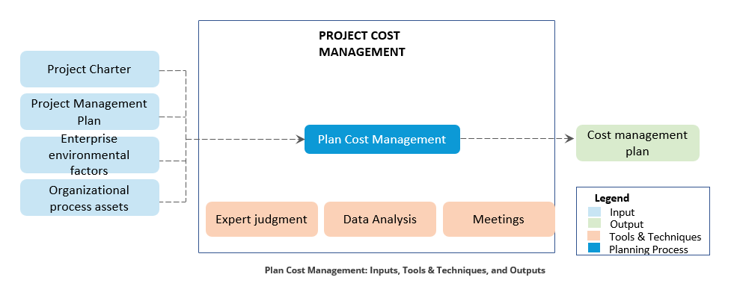

**Estimate Costs**

“Estimate Costs is the process of developing an approximation of the cost of resources needed to complete project work.” It belongs to the Planning Process Group.

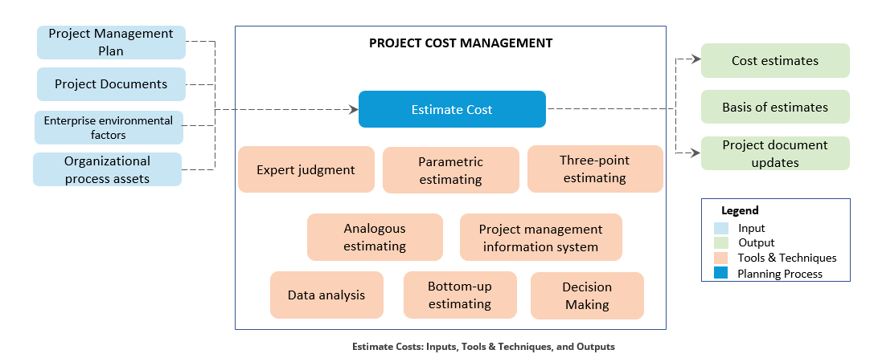

**Determine Budget**

“Determine Budget is the process of aggregating the estimated costs of individual activities or work packages to establish an authorized cost baseline.” It is part of the Planning Process Group.

The cost baseline includes all authorized budgets but excludes management reserves.

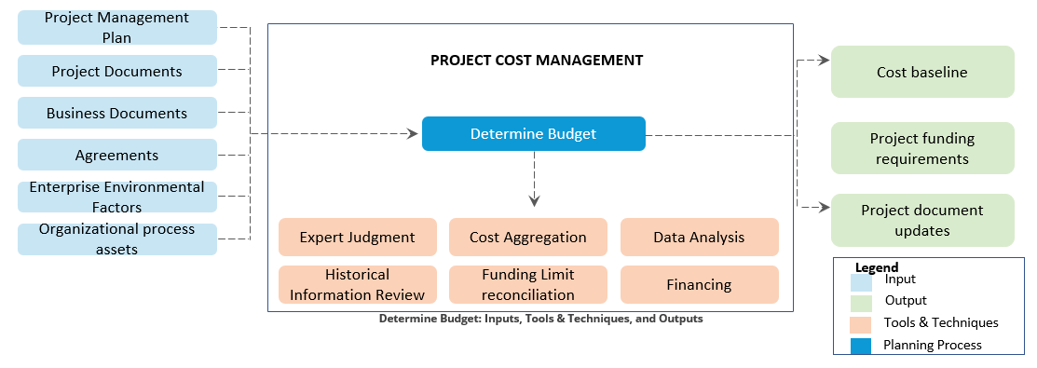

**Control Costs**

“Control Costs is the process of monitoring the status of the project to update the project costs and managing changes to the cost baseline.” It belongs to the Monitoring and Controlling Process Group.

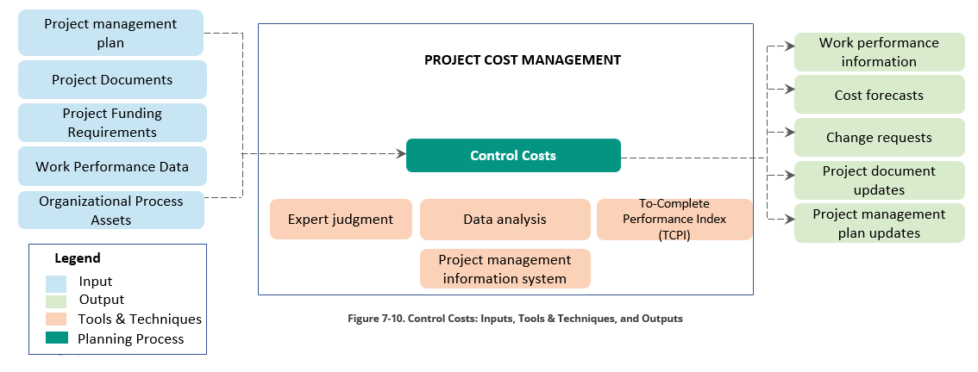

**Difference Between Planned Value and Earned Value**

* Earned value is the total of budget allocated to each of the activities that have been completed at that point of time.
* We can compare the earned value (budget allocated for a specific period of time) to the planned value (the total of all work planned) to determine if the project is on track.

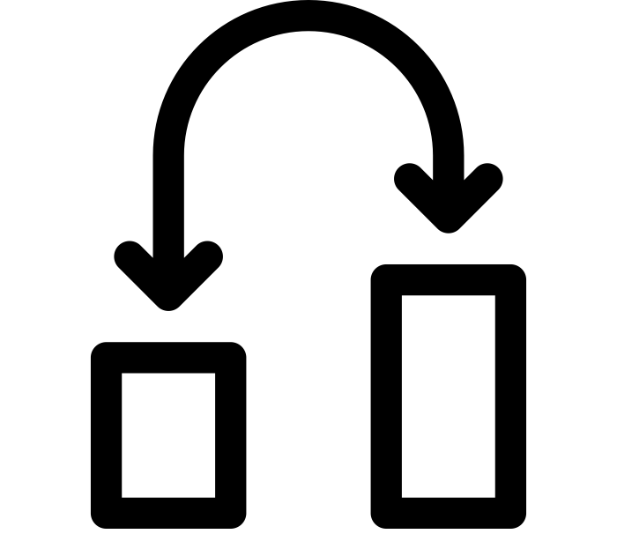

If the planned value of a project is $340, then the total of all the work packages planned for the project is $340.

**Earned Value Management**

Earned Value Management (EVM) is a method to measure project performance against the project baselines. It results from an earned value analysis and indicates potential deviation of the project from the cost and/or schedule baselines.

**The various terms used in earned value are as follows:-**

|  |  |  |
| --- | --- | --- |
| Acronym | Term | Explanation |
| PV | Planned Value | Authorized budget assigned to scheduled work |
| EV | Earned Value | Work performed in terms of budget authorized for that work |
| AC | Actual Cost | Actual cost incurred in work performed |
| BAC | Budget at Completion | Budgeted amount for the total work |
| EAC | Estimate at Completion | Expected total cost for the project |
| ETC | Estimate to Complete | Expected cost to finish all the remaining project work |
| VAC | Variance at Completion | Projected budget surplus or deficit at the end of the project |

**Earned Value Management: Example 1**

A software development project has four phases. Each phase takes a month to complete and is estimated to cost $10,000 per phase. The phases are planned to be completed one after the other. Given the project status at the end of three months, calculate the CV, SV, CPI, and SPI.

|  |  |  |  |  |  |
| --- | --- | --- | --- | --- | --- |
| Project Phases | Month 1 | Month 2 | Month 3 | Month 4 | Status at the End of Month 3 |
| Requirement Definition | S---------F |  |  |  | Complete, spent $10,000 |
| Architecture & Design |  | S-------PF | ---F |  | Complete, spent $12,000 |
| Development & Unit Testing |  |  | S----PF |  | 50% done, spent $9,000 |
| System Testing & Go Live |  |  |  |  | Not yet started |

**Legend**

S – Start time F – Finish time PF – Partly finished

**Earned Value Management: Example 1**

**Calculation of project cost related attributes are as follows: -**

|  |  |  |  |
| --- | --- | --- | --- |
| Term | Calculation | Value | Interpretation of the Answer |
| Planned Value (PV) | $10,000+$10,000+$10,000 | $30,000 | By third month, $30,000 worth of work should have been completed. |
| Earned Value (EV) | $10,000+$10,000+$5,000 | $25,000 | The accomplished work is worth $25,000. |
| Actual Cost (AC) | $10,000+$12,000+$9,000 | $31,000 | The amount actually spent is $31,000. |
| Cost Variance (CV) | $25,000-$31,000 | -$6,000 | The project is over budget by $6,000. |
| Schedule Variance (SV) | $25,000-$30,000 | -$5,000 | The project is behind schedule. |
| Cost Performance Index (CPI) | $25,000/$31,000 | 0.80 | $0.80 worth is got out of every dollar spent. |
| Schedule Performance Index (SPI) | $25,000/$30,000 | 0.83 | The project is progressing at 83% of the originally planned rate. |

**Earned Value Management: Example 2**

John is managing a three-month project to enhance a financial system. He is working on his EVM analysis to report to management on status of project. Calculate the following based on the information given below:-

**Q1**. John is comparing his actuals to the Earned Value of his project. He has finished the first month of his project schedule, and the earned value for his project is $65,000. The actuals from the financial system are $57,850. What is the CPI for his project?

CPI is calculated as EV/AC. CPI = $65,000/$57,850 = **1.12**

John is managing a three- month project to enhance a financial system. He is working on his EVM analysis to report to management on status of project. Calculate the following based on the information given below:

Q2. Based on the CPI and a Budget at Completion (BAC) of $200,000, what is the Estimate at Completion (EAC)?

EAC is calculated as BAC/CPI. EAC = $200,000/1.12 = **$178,571**

John is managing a three-month project to enhance a financial system. He is working on his EVM analysis to report to management on status of project. Calculate the following based on the information given below:

**Q4**. John also needs to understand how his project is tracking against its schedule. After the first month of work effort, his Planned Value (PV) was $60,000. What is the SPI for his project?

SPI is calculated as EV/PV. From our previous calculations, EV was $65,000.

SPI = $65,000/$60,000 = **1.08**

John is managing a three-month project to enhance a financial system. He is working on his EVM analysis to report to management on status of project. Calculate the following based on the information given below:-

**Q5**. John wants to see if the positive SPI of the project will offset the CPI. He decides to rerun his EAC calculations. How can he incorporate both CPI and SPI?

EAC can also be calculated as AC + [(BAC – EV)/(CPI * SPI)]. Based on our previous answers we can determine: $57,850 + ($200,000 - $65,000)/(1.12 * 1.08) = **$169,457.14**

**Key Terms in Project Cost Management**

**Given below are the key terms related to the cost concept:**

**Law of diminishing returns**

The more you put into something, the less you get out of it

For example: doubling the number of resources working on a project will not necessarily halve the time

**Working Capital**

The amount of money the company has to invest on the project and the day-to-day company operations

**Funding limit reconciliation**

The process of comparing the planned expenditure in a given period with the available funding for that period

**Project Cost Management Summary**



* Project cost management includes the processes involved in estimating, budgeting, and controlling costs so that the project can be completed within the approved budget.
* Cost management plan contains details on how to plan, manage, and control the project cost in relation to the cost baseline and manage the cost variances.
* Cost estimate is an educated guess of how much an activity or a project will cost. Budget considers the cost estimate and accordingly sets aside funds for the completion of the project.
* Under control account technique, related activities are clubbed and their costs are managed as one unit.
* The four Project Cost Management processes are Plan Cost Management, Estimate Costs, Determine Budget, and Control Costs.
* Earned Value Management technique indicates potential deviation of the project from the cost and/or schedule baselines.

## Formulas to Remember

**Earned Value Management (EVM)**

CV = EV – AC (Positive: Under planned cost, Negative: Over planned cost)

SV = EV – PV (Positive: Ahead of Schedule, Negative: Behind Schedule)

CPI = EV/AC ( > 1 : Under planned cost, < 1 : Over planned cost)

SPI = EV/PV ( > 1 : Ahead of schedule, < 1: Behind schedule)

Please remember:

Positive SV or CV is good and Negative is Bad

CPI/SPI > 1 is good and CPI/SPI <1 is bad

**Activity duration estimation**

PERT uses three estimates to define an approximate range for an activity’s duration:

Most likely (Tm), Optimistic (To) and Pessimistic (Tp).

Two commonly used formulas to calculate the expected duration, Te:

Beta Distribution (traditional PERT technique): Te = (To + 4 X Tm + Tp) / 6

Triangular Distribution: Te = (To + Tm + Tp) / 3

**Present Value (PV):**

Present Value (PV) = Future Value (FV) / [ (1+r)n ], where r is the interest rate, and n is the number of years.

**(EMV)**:

It is a technique used for quantitative risk analysis and modelling

EMV = Probability * Impact

**Payback (PB):**

It is normally expressed as the number of years it takes to recover the investment of the total program cost

**Return on Investment (ROI):**

It has many formulas that can be used; some are mentioned below:

ROI % = [(Financial value – Program cost) / Program cost] x 100

ROI = (Financial value – Program cost) / Program cost

ROI = Financial value – Program cost

The drawback here it that ROI does not tell the duration to have this value as return on investment

## 8. Project Quality Management

**Objectives**



* Define quality and quality management
* Differentiate among quality planning, quality assurance, and quality control
* Explain cost of quality and its categories
* Describe the Project Quality Management processes
* Explain the quality tools
* Explain Six Sigma

**Define Quality?**

Quality is the degree to which a set of inherent characteristics fulfills requirements (ISO 9000).

A project is said to meet quality expectations when all the project requirements agreed in the beginning of the project are met and the resulting product is usable.

**What is the Optimal Level of Quality?**

Achieving quality involves cost. Increased efforts and costs can increase the quality of output, but a ceiling on investment on quality has to be fixed.

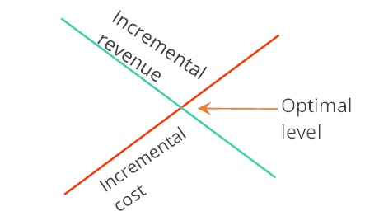

The investment on quality is determined by identifying the optimal level of quality of a project.

Optimal level of quality is achieved when the incremental cost of achieving the quality is equal to the incremental revenue from such improvements.

**Quality Management**

Quality management includes creating and following policies and procedures that meet the project’s defined quality needs. This is to ensure that the specified approach to quality is implemented on the project. The three key activities of quality management are as follows:

Quality Planning: Quality-related activities of the project are planned

Quality Assurance/ Manage Quality: Manage Quality/Quality Assurance is carried out to ensure that a process is followed per the quality management plan

Quality Control: Periodic checks are conducted to ensure quality improvements

Some of the key concepts of Quality are:

**Prevention over inspection**—Prevention is keeping errors out of the process, and inspection is keeping errors out of the hands of the customer

**Attribute sampling vs. variable sampling** —In attribute sampling, the result either conforms or does not conform. In variable sampling, the result is rated on a continuous scale that measures the degree of conformity

**Tolerances and control limits**—Tolerance is the specified range of acceptable results, and control limits identify the boundaries of common variation in a statistically stable process

**Five levels of effective quality management**

* Let the customer find the defects, which can lead to warranty issues, recalls, loss of reputation, and rework costs
* Detect and correct defects during the control quality process
* Use quality assurance to ensure the correct process is followed
* Incorporate quality into planning and designing of the project and product
* Create a culture that helps the organization to be committed to quality in processes and products

**Trends and Emerging Practices**

Some of the trends in Project Quality Management are:

* **Customer satisfaction—**A combination of conformance to requirements and fitness for use ensures that the customer requirements are met
* **Continual improvement—**PDCA (Plan-Do-Check-Act) cycle, TQM (Total Quality Management), Six Sigma, Lean Six Sigma, and Kaizen improve both the quality of project management and the quality of the end product, service, or result
* **Management responsibility—**Management should provide suitable resources at adequate capacities
* **Mutually beneficial partnership with suppliers—**Organization should prefer long-term relationships over short-term gains

|  |  |
| --- | --- |
| **Kaizen (change for better)**  A philosophy that looks for small and continuous improvements in a process |  |

**Tailoring Considerations**

Some of the considerations for tailoring are:

* **Policy compliance and auditing—**Whatquality policies, procedures, tools, techniques, and templates does the organization follow?
* **Standards and regulatory compliance—**What industry quality standards and specific governmental, legal, or regulatory constraints need to be taken into consideration?
* **Continuous improvement—**Is quality improvement managed at the organizational level or at the level of each project?
* **Stakeholder engagement—**Is there a collaborative environment for stakeholders and suppliers?

**Considerations for Agile/Adaptive Environments**

* Agile methods involve frequent quality and review steps built in throughout the project rather than toward the end of the project.
* Recurring retrospectives help in finding root causes of issues and suggest approaches for further improvements.
* Agile methods focus on small batches of work to uncover inconsistencies and quality issues earlier in the project life cycle.

**Quality Planning vs. Quality Assurance vs. Quality Control**

|  |  |  |  |
| --- | --- | --- | --- |
| Basis of Comparison | Scope | Activities | Focus Area |
| **Quality Planning** | Determines a plan for quality, defining the standards, templates, policies, and procedures | Involves preparation of the quality management plan | Focuses on information on the level of quality and the methods of achieving it |
| **Quality Assurance/ Manage Quality** | Determines if the project is complying with the organizational (as well as project) policies and procedures | Involves conducting regular process audits to identify deviations from the quality plan and undertake corrective and preventive actions | Focuses on processes and not products |
| **Quality Control** | Measures specific project results (product) against standards | Involves inspecting and verifying the project’s product, defect repair, and measuring whether the quality indicators are improving | Focuses on product and data |

**Quality Planning vs. Quality Assurance vs. Quality Control**

A project was planned to be completed within plus or minus 10 percent of the budget. Three months ago, the project was over budget by 20 percent. The most recent measurement done one day ago shows budget overrun by 15 percent.

Since there is an improvement of 5 percent, it is quite likely that over the next 3 months the cost would reduce and the project could get completed within the planned limit. If the cost increases further, corrective and preventive actions have to be taken to bring the project within the agreed limits. This is quality control.

**Cost of Quality**

“Cost of quality includes all costs incurred over the life of the product by investment in preventing nonconformance to requirements, appraising the product or service for conformance to requirements, and failing to meet requirements (rework).” Cost of quality can be categorized as follows:-

**Cost of Conformance**

It is the money spent during the project to avoid failures. This can be divided as follows:

* Prevention Costs: Costs to prevent errors and produce quality products Example: training, documentation, equipment, time to do it right
* Appraisal Costs: Costs to assess the quality Example: testing, destructive testing loss, and inspections

**Cost of Nonconformance**

It is the money spent during and after the project because of failures. This can be divided as follows:

* Internal Failure Costs: Costs that occur before the product is released Example: rework, scrap
* External Failure Costs: Costs incurred after the product is released to the customer. Example: liabilities, warranty, and lost business

**Project Quality Management Processes**

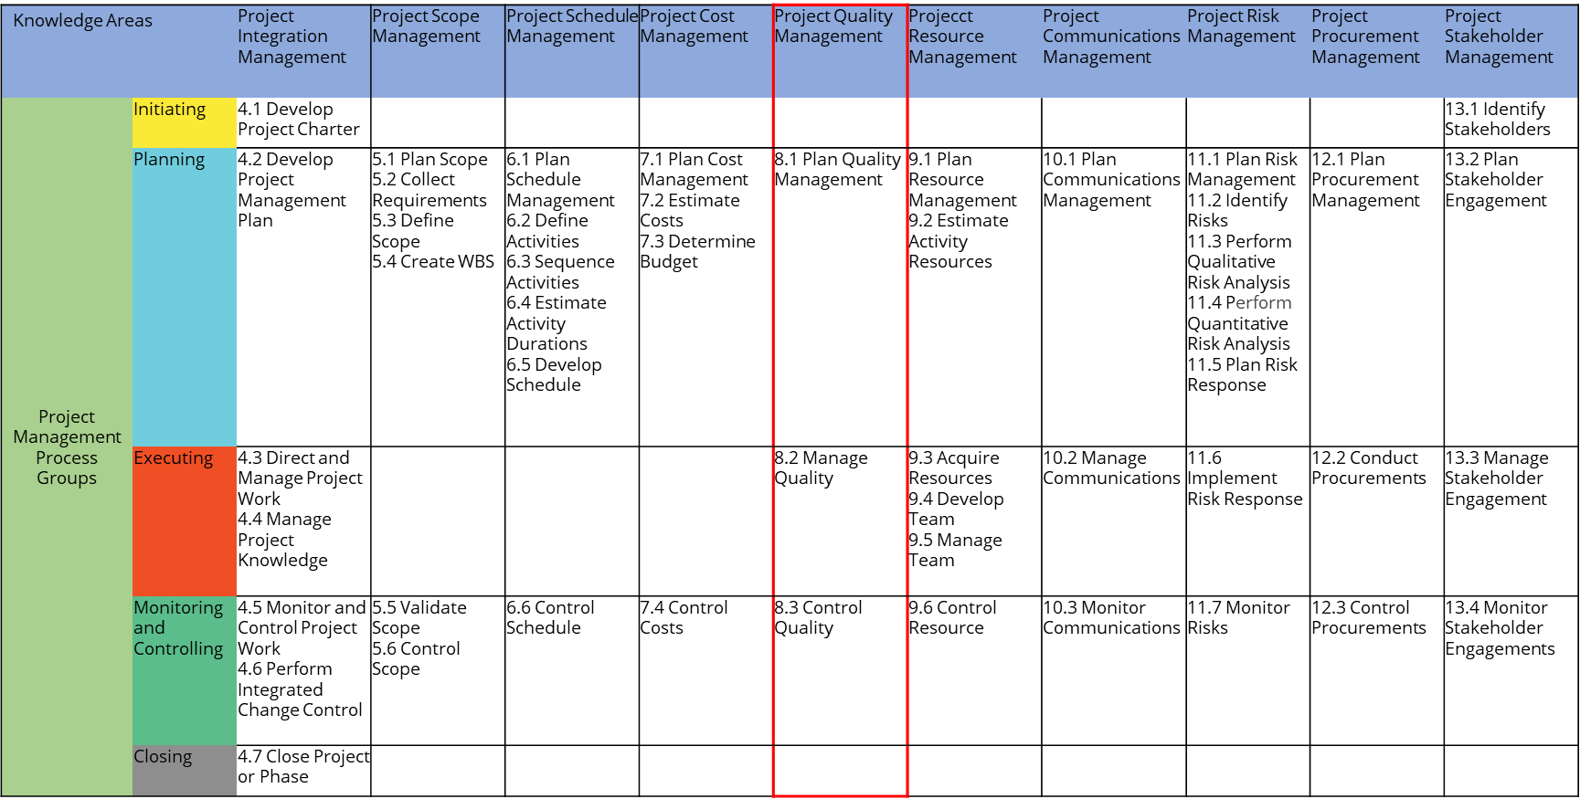

**Plan Quality Management**

“Plan Quality Management is the process of identifying quality requirements and/or standards for the project and its deliverables, and documenting how the project will demonstrate compliance with quality requirements and/or standards.” It is part of the Planning Process Group.

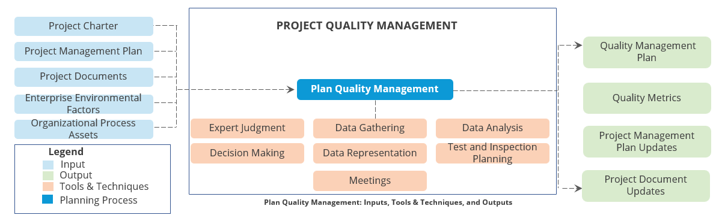

**Manage Quality**

“Manage Quality is the process of translating the quality management plan into executable quality activities that incorporate the organization’s quality policies into the project.” It is part of the Executing Process Group.

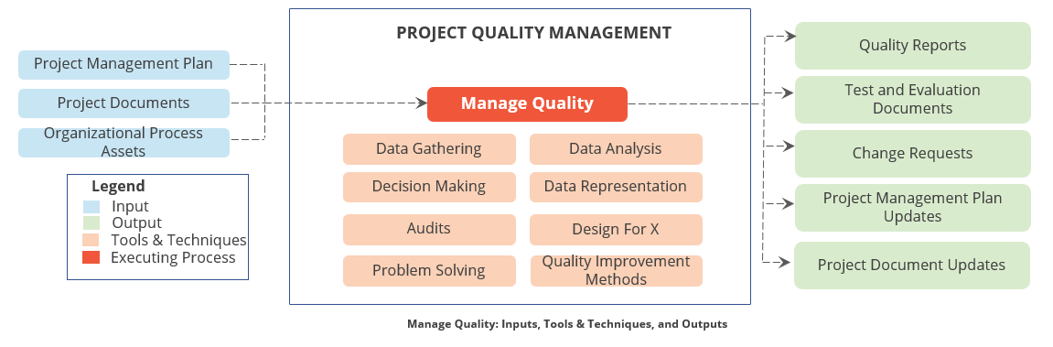

**Control Quality**

“Control Quality is the process of monitoring and recording results of executing the quality management activities to assess performance and ensure the project outputs are complete, correct, and meet customer expectations.” It is part of the Monitoring and Controlling Process Group.

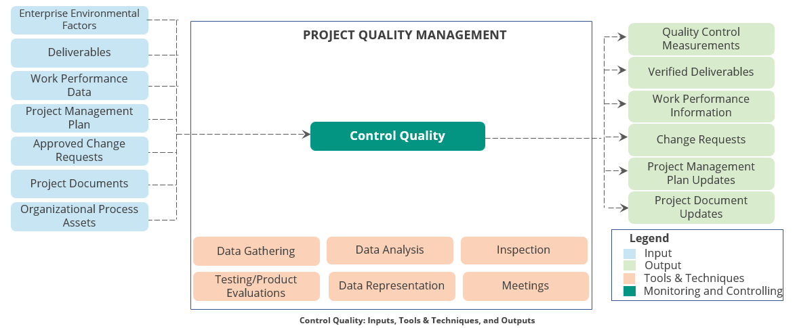

**Quality Tools**

* Control Charts
* Check Sheets
* Cause and Effect Diagram
* Scatter Diagram
* Flowcharting
* Histogram

**Control Charts**

Control charts help to determine if a process is within acceptable limit.

* They are useful to monitor project performance in terms of cost or schedule variance.
* Upper and lower control limits have to be set and the actual schedule variation over time has to be plotted.
* If the values are within the control limits, the project is on track.
* If the schedule variance goes out of these limits, project is out of control and investigations and corrective actions need to be done.

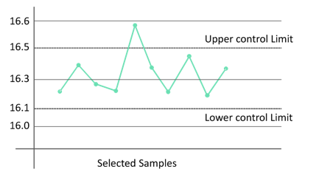

**Cause and Effect Diagram**

Cause and effect diagram is also called the fishbone or Ishikawa diagram.

* It is used in both quality planning and control.
* It is used to organize thoughts or ideas and to identify the root cause of a problem.
* To draw a fishbone diagram, first identify the reasons at a broad level and then try to find specific reasons under each category.

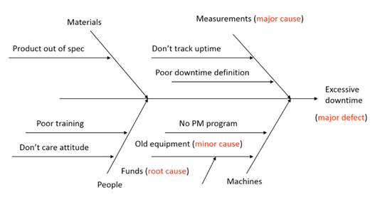

**Flowcharting**

Flowcharts are graphical representations that show how a process or system flows from beginning to end and how the elements interrelate.

* They represent the process and help analyze where the problems occur.
* They are used to identify redundancies and bottlenecks.

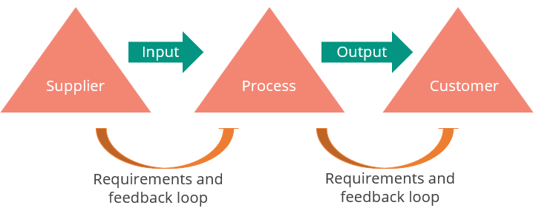

**Histogram**

Histogram is a vertical bar chart showing the frequency of occurrence of a particular variable.

The height of each column represents the relative frequency of the variable.

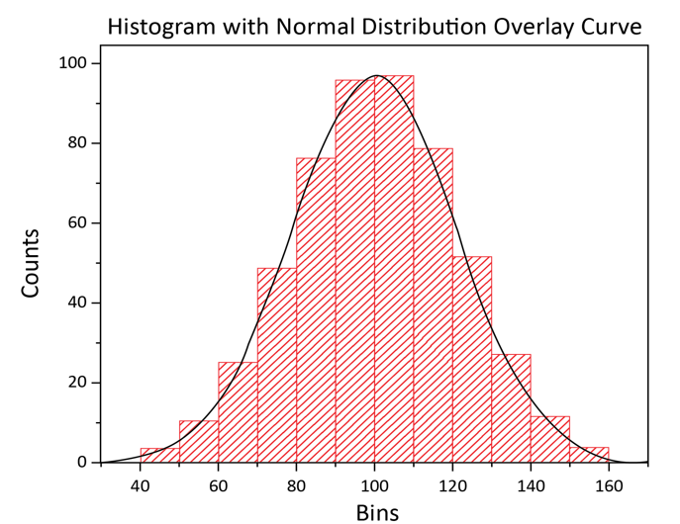

**Check Sheets**

Check sheets, also known as tally sheets, are checklists used for collecting data.

* It ensures that the relevant data or steps of a process are captured and executed.
* It is also useful during inspections.

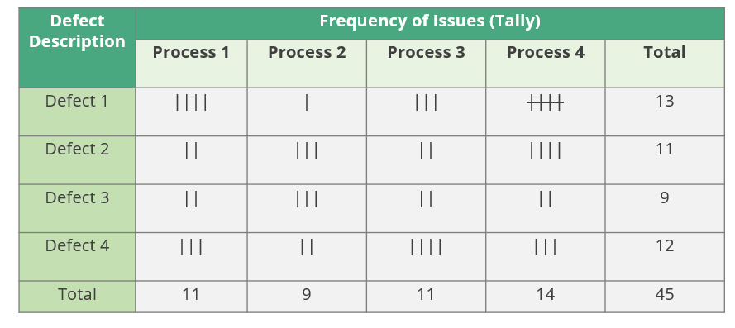

**Scatter Diagram**

Scatter diagram tracks two variables to see if they are correlated or have no relationship.

If the two variables are related, scatter diagrams are used to observe the changes in one variable due to a change in the other.

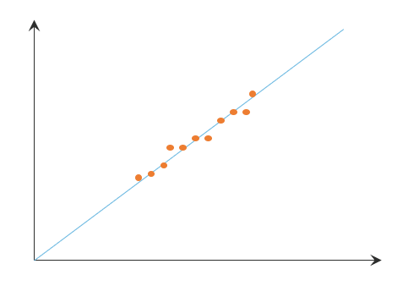

**Six Sigma**

The concept of Six Sigma is used to produce near-perfect products and services consistently.

* If large volume of data is plotted, the graph takes the form of a bell curve, and such distribution is called normal distribution.
* The line corresponding to the top of the bell curve is the median of the data sample.
* Standard deviation or Sigma is used to measure how far the data is from the mean.
* One standard deviation from the mean covers 68% data.
* At Six Sigma, the distribution covers 99.99966% of the data.

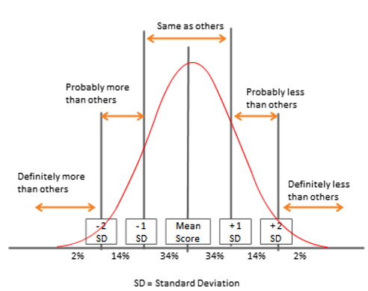

**Project Quality Management Summary**



* A project is said to meet quality expectations when all the project requirements agreed in the beginning of the project are met and the resulting product is usable.
* Quality management includes creating and following policies and procedures that meet the project’s defined quality needs.
* Quality Planning defines the standards, templates, policies, and procedures; Quality Assurance determines if the project is complying with the policies and procedures; and Quality Control measures specific project results against standards.
* Plan Quality Management, Manage Quality, and Control Quality are the three Project Quality Management processes.
* Quality tools are used to plan and achieve the desired levels of quality.
* At Six Sigma level, there would be only three defects out of a million units manufactured.

## 9.Project Resource Management

**Objectives**



* Define Project Resource Management
* Differentiate between functional manager and project manager
* Describe the Project Resource Management processes
* Identify the stages of team formation, powers of project manager, and conflict management techniques
* Explain organization theories

**Define Project Resource Management?**

Project resource management includes the processes to identify, acquire, and manage the resources needed for the successful completion of the project.

* Project team is composed of people with assigned roles and responsibilities for completing the project.
* Physical resources are any tools, equipment, or property necessary for the project.
* Team resources include people (employees and contractors) working together to manage the project effort.

**Functional Manager vs. Project Manager**

The differences between functional and project managers are as follows:-

**Functional Manager**

* Functional manager handles a business function; Example: HR, Engineering, etc.
* Functional managers are subject matter experts.
* Organization structure and the organization’s products define the roles and responsibilities of a functional manager.
* Functional manager is the owner of resources and assigns specific individuals to the project team.

**Project Manager**

* Project managers are accountable and responsible for a project and its quality.
* Project managers are not technical experts.
* Organization’s structure defines the degree of authority of a project manager.
* Project managers need to negotiate with the functional managers to procure project resources.
* Project managers are responsible for product quality and credit the team with project success.

**What are the Key Concepts in Project Resource Management?**

* Project manager should invest suitable effort in acquiring, managing, motivating, and empowering the project team.
* Project manager should be both leader and manager of the project team.
* Project manager should be aware of:-
  + Team environment
  + Geographical locations of the team members
  + Communication among stakeholders
  + Organizational change management
  + Internal and external politics
  + Cultural issues and organizational uniqueness
  + Other factors that may alter project performance

**What are the Trends and Emerging Practices in Project Resource Management**

* **Resource management methods**—Just-in-time (JIT), Kaizen, Total Productive Maintenance (TPM), Theory of constraints (TOC)
* **Emotional intelligence (EI)**—Project manager should invest in personal EI by improving inbound and outbound competencies.
* **Self-organizing teams**—Teams should be able to function in the absence of centralized control.
* **Virtual teams/distributed teams**—Globalization of projects has promoted the need for virtual teams that work on the same project but are not collocated at the same time

**What are the Considerations for Agile/Adaptive Environments?**

* Projects with high variability benefit from team structures that maximize focus and collaboration, such as self-organizing teams with generalizing specialists.
* Collaboration is intended to boost productivity and facilitate accelerated integration of distinct work activities, improve communication, increase knowledge sharing, and provide flexibility of work assignments in addition to other advantages.

**What are the Tailoring Considerations in Project Resource Management?**

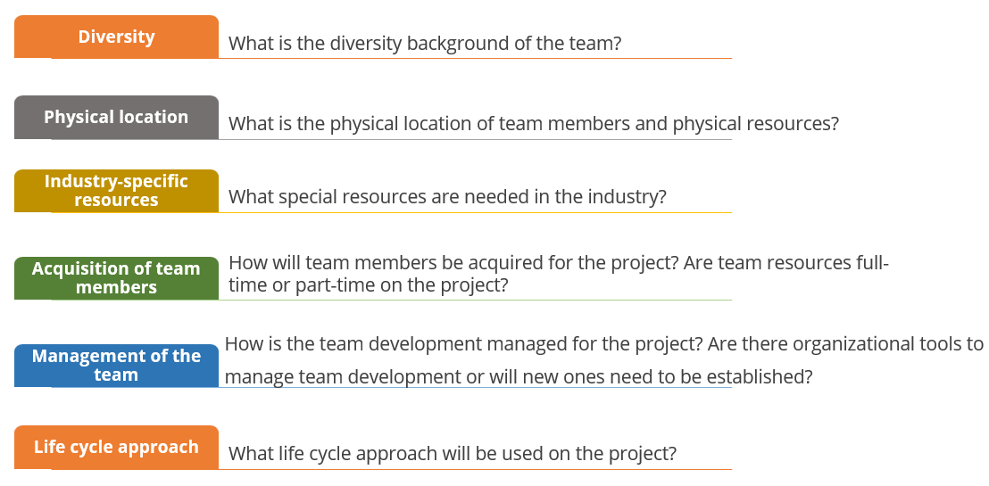

**Project Resource Management Processes**

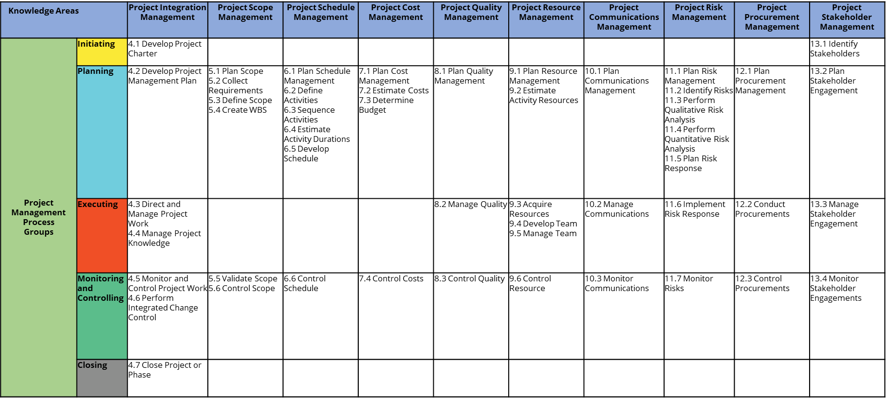

**Plan Resource Management**

“Plan Resource Management is the process of defining how to estimate, acquire, manage, and use team and physical resources.” This process is part of the Planning Process Group.

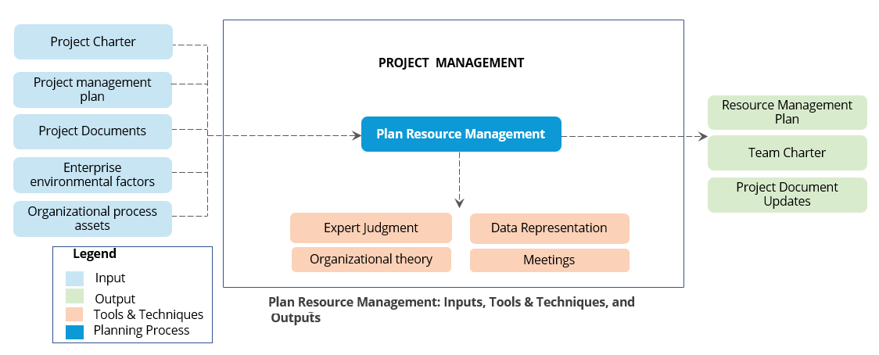

**Organization Charts and Role Descriptions**

A Project manager has to ensure that an organizational chart is prepared for every project to identify the roles and reporting relationships.

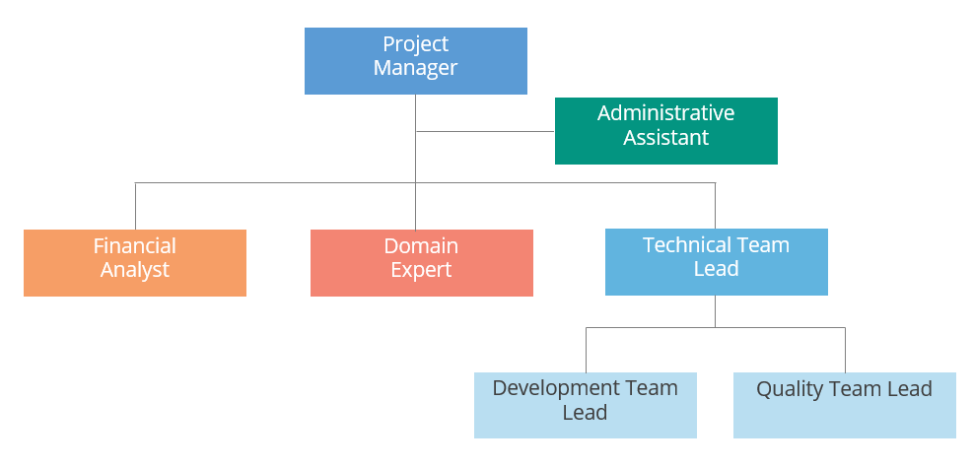

**Responsibility Assignment Matrix**

Responsibility Assignment Matrix (RAM) is used to define project responsibilities among the project team.

|  |  |  |  |  |
| --- | --- | --- | --- | --- |
| **Activity** | **John** | **Kris** | **Sally** | **Ting** |
| Project Plan | A | R | R | R |
| Configuration Management | C | A | R | R |
| Test Plan | C | R | A | R |
| Design | C | I | R | A |
| Team Budget | C | A | R | R |
| Customer Liaison | A | C | R | I |
| Team Building | R | R | A | C |
| Activity | A | R | R | R |

RACI charts are a form of RAM. RACI stands for:-

* Responsible
* Accountable
* Consulted
* Informed

For every project deliverable, RACI charts identify who is responsible, accountable, consulted, and needs to be informed. There can only be one Accountable (A) in each row of a RACI.

**Resource Histogram**

Resource histograms are used to represent the resources required through the life of a project.

* For long term projects, staffing requirements can vary over different project phases
* Based on these estimates, a project manager can develop the resource hiring strategy.

**Time**

**Staff Hours Required**

2013

2014

2015

2016

Q1

Q3

Q2

Q4

Q1

Q3

Q2

Q4

Q1

Q3

Q2

Q4

Q1

Q3

Q2

q

.

**Estimate Activity Resources**

Estimate Activity Resources is the process of estimating team resources and the type and quantities of materials, equipment, and supplies necessary to perform project work.” This process belongs to the Planning Process Group.

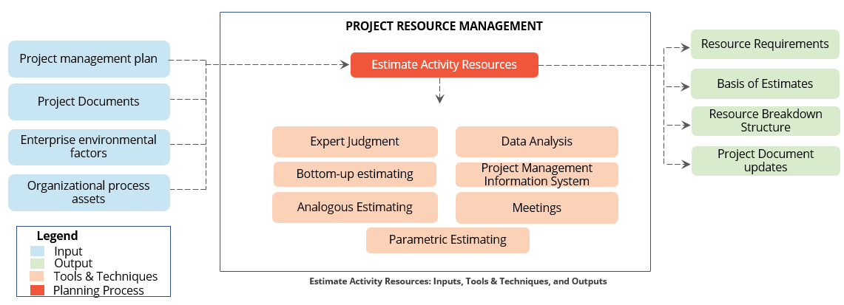

**Acquire Resources**

“Acquire Resources is the process of obtaining team members, facilities, equipment, materials, supplies, and other resources necessary to complete the project work.” This process belongs to the Executing Process Group.

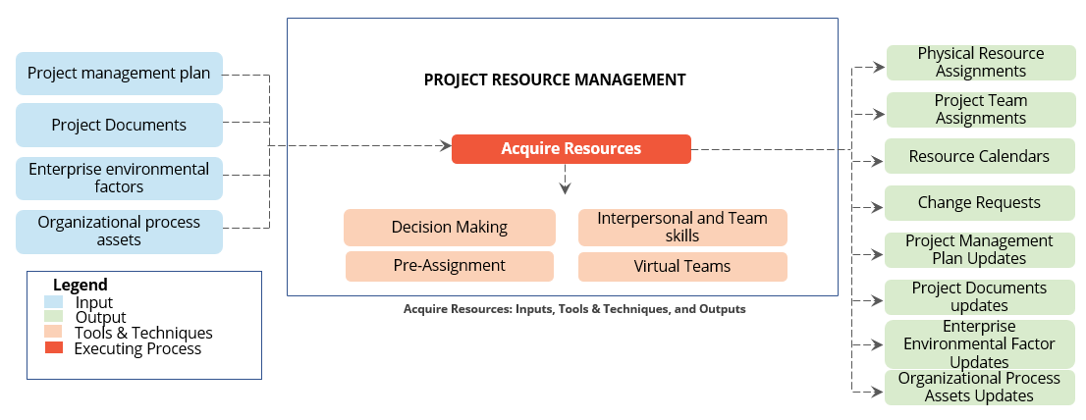

**Develop Team**

“Develop Team is the process of improving competencies, team member interaction, and overall team environment to enhance project performance.” This process belongs to the Executing Process Group.

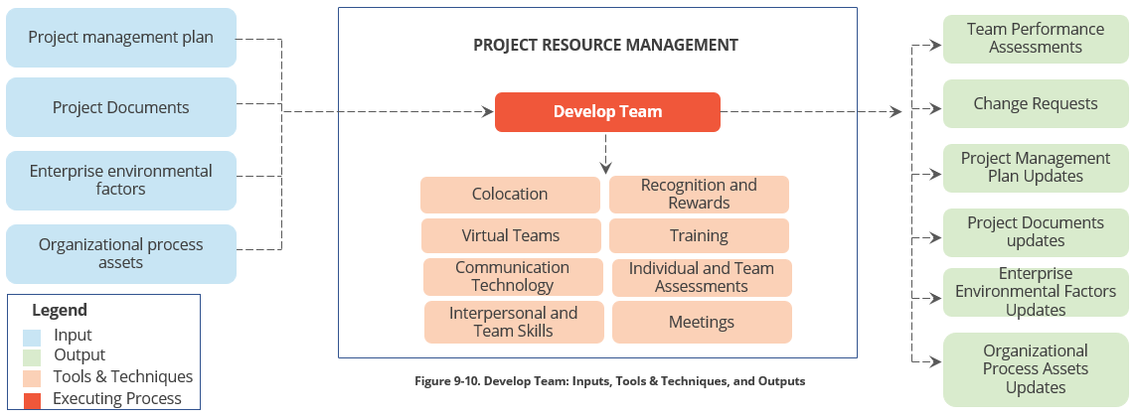

**Manage Team**

“Manage Team is the process of tracking team member performance, providing feedback, resolving issues, and managing team changes to optimize project performance.” This process belongs to the Executing Process Group.

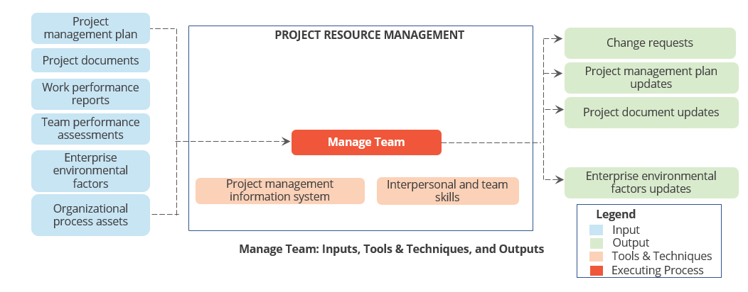

**Control Resources**

“Control resources is the process of ensuring that the physical resources assigned and allocated to the project are available as planned, as well as monitoring the planned versus actual utilization of resources and taking corrective action as necessary.’’ This process belongs to the Monitoring and Controlling Process Group.

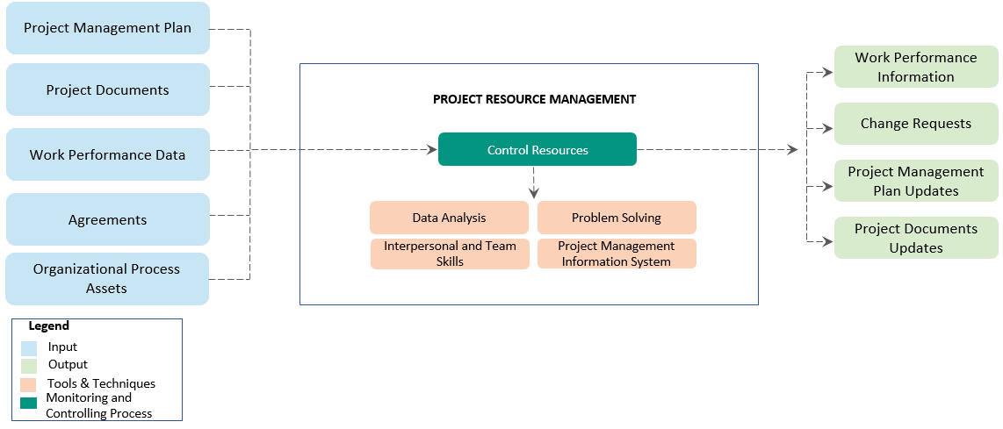

**Team Dynamics**

Dr. Bruce Tuckman’s (1965) Stages of team formation are as follows: -

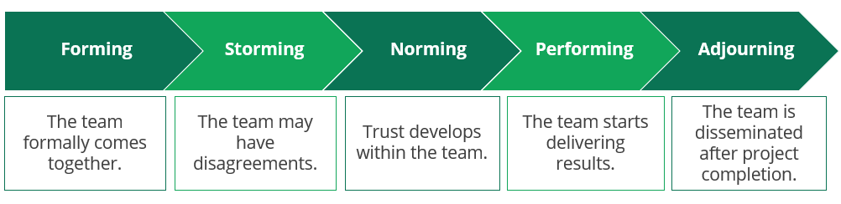

**Conflict Management**

Conflict is an inevitable consequence of organizational interactions. If conflicts are managed well, they can create opportunities for improvement. The sources of conflict are as follows:-

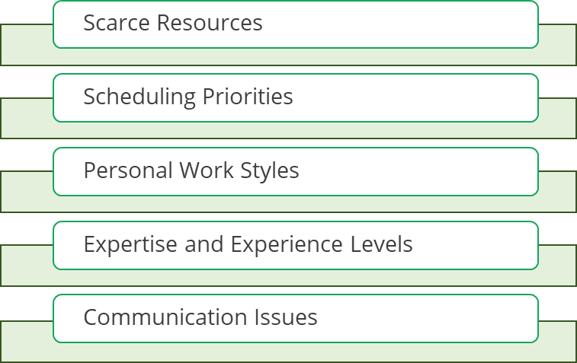

The best way to resolve conflict is to discuss and clarify with the parties involved in it.

A project manager needs to be actively involved in the project processes to minimize and avoid conflicts.

**The following are some measures that a project manager can take to avoid conflicts:**

* Provide all details of the project and keep the team informed of the exact project status.
* Assign the work such that there are no overlapping tasks.
* Motivate the team and ensure everyone gets to work on interesting and challenging assignments.

**Conflict Resolution Techniques**

**The five conflict resolution techniques are as follows:**

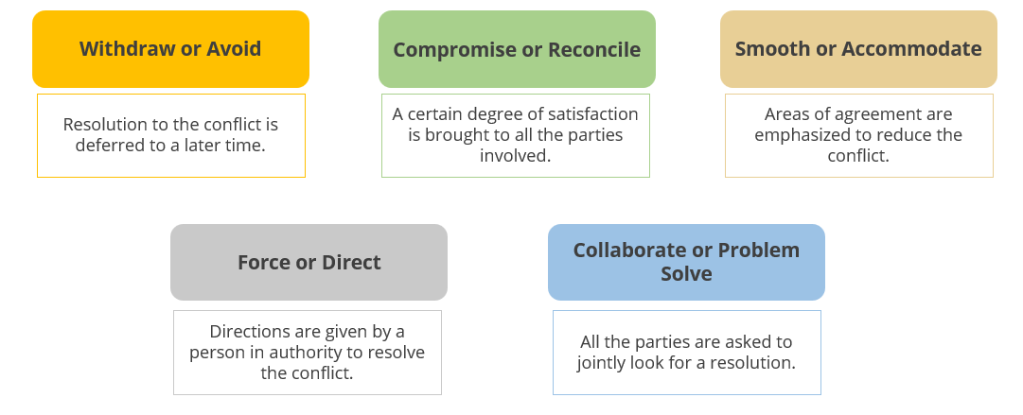

**Powers of the Project Manager**

A project manager is vested with certain powers to facilitate project work from the team members.

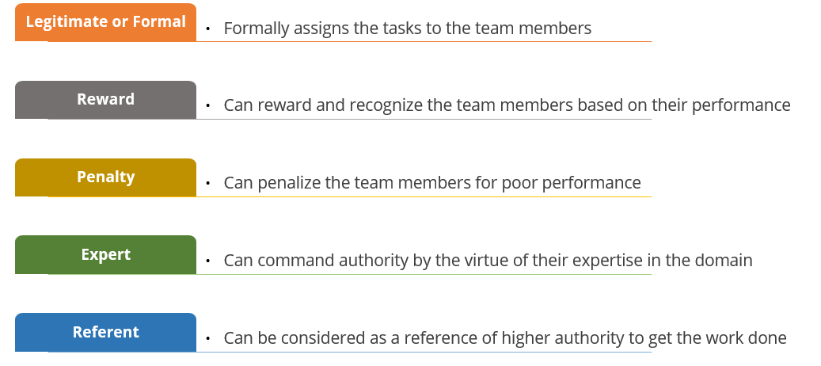

**Organizational Theories**

A project manager needs to know what motivates the team members to design a reward and recognition plan.

**The three popular motivation theories are as follows:**

**McGregor’s theory** indicates that there are two categories of managers, and this classification is based on what the managers think of their team members.

* **Theory X:** Managers who fall under this category believe that their team members need continuous monitoring. Further, they believe that though the team members are capable, they avoid work whenever possible.
* **Theory Y:** Managers under this category believe that their team members can work without supervision as they look forward to achieve something.

According to **Maslow’s Hierarchy** of Needs, people’s needs change as they grow in their career. Maslow’s hierarchy of needs are as follows:

* Physiological: breathing, food, water, sex, sleep, etc.
* Safety: safety of body, employment, resources, morality, family, health, property, etc.
* Social: friendship, family, intimacy, etc.
* Esteem: self-esteem, confidence, achievement, respect, etc.
* Self-actualization: morality, creativity, spontaneity, problem solving, lack of prejudice, acceptance of facts, etc.

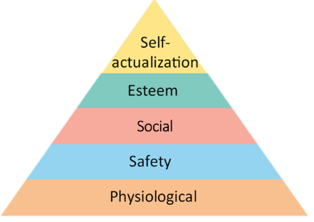

**Herzberg’s theory** classifies factors as follows:

* Hygiene factors: Mandatory factors to motivate the team
  + Example: personal safety, fair compensation, working conditions, etc.
* Motivating agents: Additional factors that motivate people
  + Example: recognition, higher responsibility, etc.

**Project Resource Management Summary**



* Project resource management includes the processes that organize, manage, and lead the project team.
* A functional manager is in charge of a business function and owns the resources; a project manager is responsible for an organization’s projects.
* Plan Resource Management, Estimate Activity Resources, Acquire Resources, Develop Team, Manage Team, and Control Resource are the six Project Resource Management processes.
* Forming, storming, norming, performing, and adjourning are the five stages of team formation.
* Reward and expert are usually the best forms of authority that a project manager can use. Penalty should be resorted to as a last option.
* Organization theories help a project manager to identify what motivates the team members and accordingly design a reward plan.
* A project manager should adopt a leadership style based on the team.

## 10. Project Communication Management

**Objectives**



* Define communication and Project Communications Management
* Identify the key concepts, tailoring, trends, and Agile or adaptive considerations
* Explain the elements of a basic communication model
* Describe the Project Communications Management processes

**Define Communication?**

Communication is a two-way process of transferring information from one entity to another. It is the exchange of information, intended or involuntary.

* Project Managers
* Management
* Others Stakeholders

Project

A project manager spends around 90 percent of time ensuring proper project communication.

**Define Project Communication Management?**

“Project Communications Management includes the processes necessary to ensure that the information needs of the project and its stakeholders are met through development of artifacts and implementation of activities designed to achieve effective information exchange.”

**What are the key concepts for Project Communications Management?**

The types of communication’s: -

* Written: Physical or electronic
* Spoken: Face-to-face or remote
* Formal or informal: Formal papers or social media
* Gestures: Tone and facial expressions
* Media: Pictures or actions
* Choice of words: Words chosen to express an idea

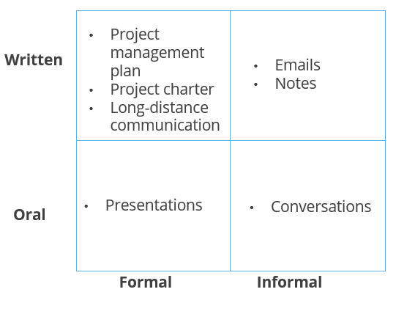

**What are the Trends and Emerging Practices?**

* **Inclusion of stakeholders in project review:** The stakeholder community of each project includes individuals, groups, and organizations that the project team has identified as essential to the successful delivery of project objectives and organizational outcomes.
* **Inclusion of stakeholders in project meetings:** Project meetings should include stakeholders from outside the project and even the organization as appropriate.
* **Increased use of social computing:** Social computing in the form of infrastructure, social media services, and personal devices has changed how organizations and stakeholders communicate.
* **Multifaceted approaches to communication:** The standard communication strategy for project stakeholder communications embraces and selects from all technologies and respects cultural, practical, and personal preferences for language, media, content, and delivery.

**What are the Tailoring Considerations?**

* **Stakeholders:** The project team must consider whether the stakeholders are internal or external or both.
* **Physical location:** The physical location of stakeholders must be considered. The project must consider whether the team isco-located or based in the same geographical area or spread across multiple time zones.
* **Communications technology:** The project team needs to consider the technologies available to develop, record, transmit, retrieve, track, and store communication artifacts. The technologies that are most appropriate and cost effective for communicating need to be considered.
* **Language:** The project team must consider if one or many languages are used. Allowances need to be made to adjust to the complexity of team members from diverse language groups.
* **Knowledge management:** The project team need to consider whether the organization has a formal knowledge management repository and if it is used by the stakeholders

**What are the Considerations for Agile/Adaptive Environments?**

* Communicating evolving and emerging details more frequently and quickly
* Streamlining team member access to information, frequent team checkpoints, and collocating team members as much as possible
* Posting project artifacts in transparent fashion
* Holding regular stakeholder reviews to promote communication with management and stakeholders

**Communication Channels**

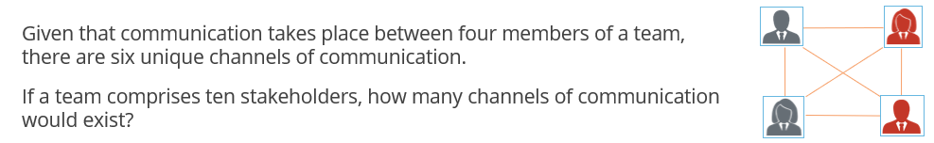

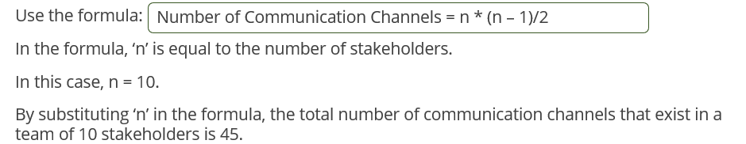



**Basic Communication Model**

The process of communication involves several steps. Given below is a simple communication model: -

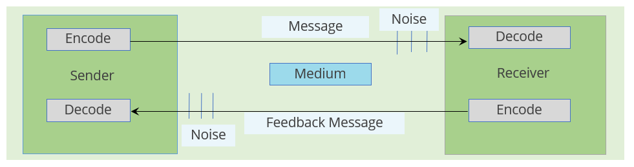

A Japanese tourist calls a hotel in Dubai to book a room. The tourist speaking Japanese is the encoding of the message. Telephone serves as the medium. However, decoding is problematic as the receptionist does not understand Japanese. The same would be true if the receptionist speaks Arabic. However, communication can be streamlined if they communicate in a language comprehensible to both of them.

Analyzing the communication model helps in identifying the communication problems.

* Encoding is the process of translating thoughts or ideas into a language that is understood by others.
* Decoding is the process of translating the message back into meaningful thoughts or ideas.
* Message is the output of encoding.
* Feedback message is the output of encoding.
* Medium is a communication method to convey the message.
* Noise is anything that interferes with the transmission and understanding of the message. Examples include distance and unfamiliar technology.

**Project Communications Management Processes**

|  |  |  |  |  |  |  |  |  |  |  |  |
| --- | --- | --- | --- | --- | --- | --- | --- | --- | --- | --- | --- |
| Knowledge Areas | | Project Integration Management | Project Scope Management | Project Schedule Management | Project Cost Management | Project Quality Management | Projecct Resource Management | Project Communications Management | Project Risk Management | Project Procurement Management | Project Stakeholder Management |
| Project Management Process Groups | Initiating | 4.1 Develop Project Charter |  |  |  |  |  |  |  |  | 13.1 Identify Stakeholders |
| Planning | 4.2 Develop Project Management Plan | 5.1 Plan Scope  5.2 Collect Requirements  5.3 Define Scope 5.4 Create WBS | 6.1 Plan Schedule Management  6.2 Define Activities 6.3 Sequence Activities 6.4 Estimate Activity Durations  6.5 Develop Schedule | 7.1 Plan Cost Management  7.2 Estimate Costs 7.3 Determine Budget | 8.1 Plan Quality Management | 9.1 Plan Resource Management 9.2 Estimate Activity Resources | 10.1 Plan Communications Management | 11.1 Plan Risk Management  11.2 Identify Risks 11.3 Perform Qualitative Risk Analysis 11.4 Perorm Quantitative Risk Analysis  11.5 Plan Risk Response | 12.1 Plan Procurement Management | 13.2 Plan Stakeholder Engagement |
| Executing | 4.3 Direct and Manage Project Work  4.4 Manage Project Knowledge |  |  |  | 8.2 Manage Quality | 9.3 Acquire Resources  9.4 Develop Team  9.5 Manage Team | 10.2 Manage Communications | 11.6 Implement Risk Response | 12.2 Conduct Procurments | 13.3 Manage Stakeholder Engagement |
| Monitoring and Controlling | 4.5 Monitor and Control Project Work  4.6 Perform Integrated Change Control | 5.5 Validate Scope 5.6 Control Scope | 6.6 Control Schedulel | 7.4 Control Costs | 8.3 Control Quality | 9.6 Control Resource | 10.3 Monitor Communications | 11.7 Monitor Risks | 12.3 Control Procurements | 13.4 Monitor Stakeholder Engagements |
| Closing | 4.7 Close Poject or Phase |  |  |  |  |  |  |  |  |  |

**Plan Communications Management**

“Plan Communications Management is the process of developing an appropriate approach and plan for project communications activities based on the information needs of each stakeholder or group, available organizational assets, and the needs of the project.” This belongs to the Planning Process Group.

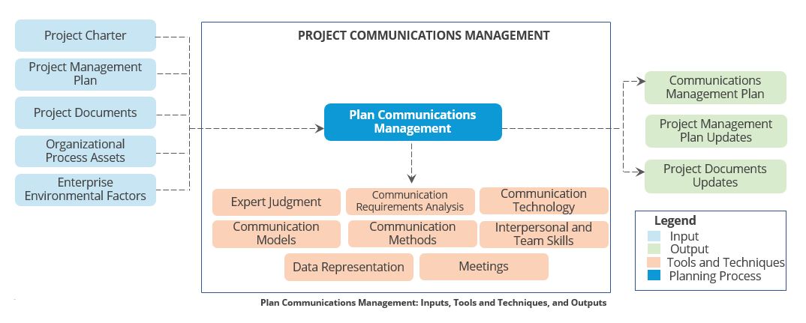

**Manage Communications**

“Manage Communications is the process of ensuring timely and appropriate collection, creation, distribution, storage, retrieval, management, monitoring, and the ultimate disposition of project information.” It belongs to the Executing Process Group.

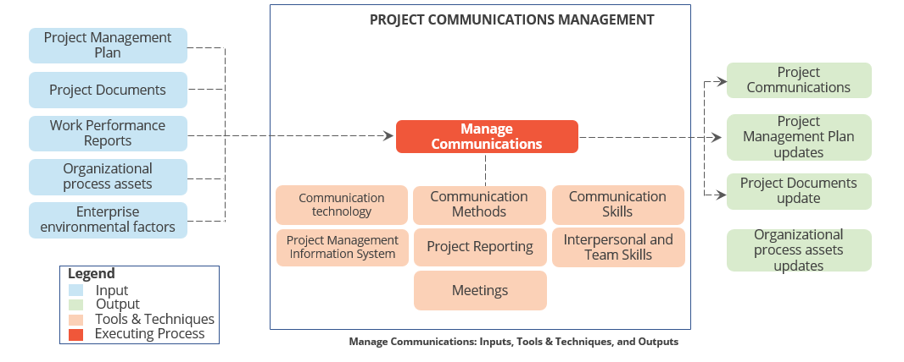

**Monitor Communications**

“Monitor Communications is the process of ensuring the information needs of the project and its stakeholders are met.” It is part of the Monitoring and Controlling Process Group.

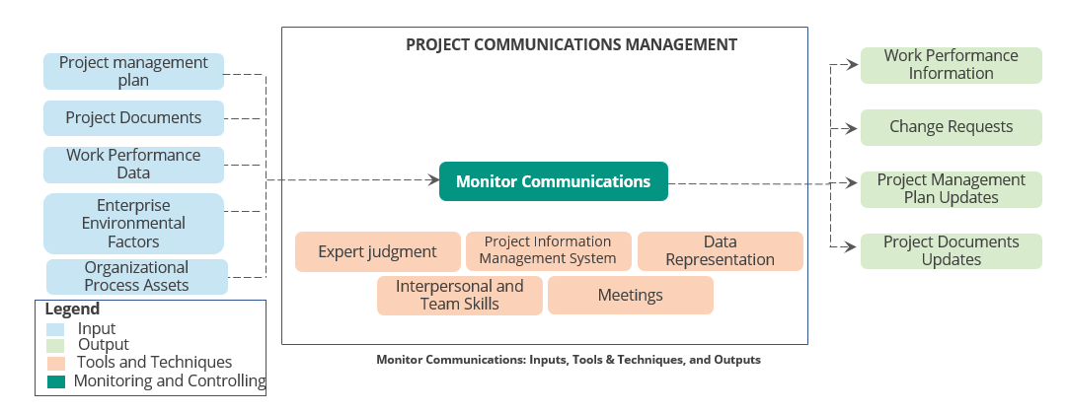

**Project Communication Management Summary**



* Communication is a two-way process of transferring information from one entity to another.
* The four commonly used communication methods are formal written, formal oral, informal written, and informal oral.
* The total number of unique channels of communication can be calculated using the formula n * (n – 1)/2.
* By analyzing the basic communication model, problems in project communication can be identified.
* Project manager is responsible for timely availability of information to all the stakeholders.
* The three Project Communications Management processes are Plan Communications Management, Manage Communications, and Monitor Communications.

## 12. Project Procurement Management

**Objectives**



* Define contract?
* Discuss key concepts, tailoring, trends, agile/adaptive considerations?
* Differentiate between centralized and decentralized contracting?
* Explain the different types of contracts?
* Identify the key terms used in Procurement Management
* Describe the Project Procurement Management processes

**Define Contract?**

A contract is a mutually binding agreement that obligates the seller to provide the specified products, services, or results; obligates the buyer to compensate the seller; and represents a legal relationship that is subject to remedy in the court.

The two parties involved in a contract are the buyer and the seller. A seller provides the goods and services and the buyer buys these for a compensation.

**Characteristics of Contract**

* A contract must be formal and in written form
* A contract must have legal remedies
* Changes to contracts must also be subject to the same checks as the contract itself
* A contract is created and managed by contract managers, also called the procurement managers

**Centralized vs. Decentralized Contracting**

In centralized contracting, a single contract manager handles multiple projects, whereas in decentralized contracting, a contract manager is assigned to a project full time and reports to the project manager.

The advantages and disadvantages of the two methods are as follows:

|  |  |  |
| --- | --- | --- |
| Method | Advantages | Disadvantages |
| **Centralized Contracting** | Increased expertise in contracting  Standardized company practices | Difficult to get contracting help as the contractors may be involved in multiple projects |
| **Decentralized Contracting** | More focus and control on the project  Easier access to contracting experience | Duplication of expertise  Less standardization of contracting practices from one project to another |

**Types of Contracts**

Contracts can be of three types. They are as follows:-

**Cost Reimbursable (CR) or Cost Plus**

This involves payments to the seller for all legitimate actual costs incurred for completed work, plus a fee representing seller profit. It should be used if the scope of work is expected to change significantly during the execution of the contract.

Cost-based contracts can be classified as:

* Cost Plus Fee (CPF) or Cost-Plus Fixed Fee (CPFF)
* Cost Plus Incentive Fee (CPIF)
* Cost Plus Award Fee (CPAF)

**Time and Material (T and M) or Unit Price**

This is a hybrid type of contractual arrangement with aspects of both cost-reimbursable and fixed-price contracts. It is often used for staff augmentation, acquisition of experts, and any outside support when a precise statement of work cannot be quickly prescribed.

**Fixed Price (FP) or Lump Sum**

This involves setting a fixed total price for a defined product, service, or a result to be provided. It should be used when the requirements are well defined and no significant changes to the scope are expected.

Fixed price contracts can be classified as:

* Fixed Price Incentive Fee (FPIF)
* Fixed Price – Economic Price Adjusted (FP – EPA)
* Firm Fixed Price (FFP)

**Types of Contracts: Advantages and Disadvantages**

The advantages and disadvantages of different types of contracts are as follows:-

|  |  |  |
| --- | --- | --- |
| Type of Contracts | Advantages | Disadvantages |
| Cost Reimbursement | Less costly than fixed price because seller does not have to account for the risk  Simple to draft | Requires auditing all the seller invoices and thus increases buyer efforts  Seller has less incentive to control cost and thus these contracts are inefficient, i.e., riskier for the buyer or the project manager |
| Fixed Price | More efficient as the seller has strong incentive to control cost  Requires less effort by buyer to manage contracts as cost risk is with the seller | Seller may underquote initially and later try to make high margins on change requests  Not having a proper Statement of Work (SOW ) can result in seller not providing some of the deliverables |
| Time and Material | Easy to create  Good for resource augmentation assignments, where cost risk is shared by buyer and seller | Seller has no incentive to control costs  Requires monitoring of daily output  Can’t be used in big projects |

**What are the Key Concepts for Project Procurement Management?**

* Project manager need not be a trained expert in procurement management laws and regulations but should be familiar enough with the procurement processes to make intelligent decisions regarding contracts and contractual relationships. The project manager is typically not authorized to sign legal agreements binding the organization; this is reserved for those who have the authority to do so.
* Project manager should understand the culture and local laws when dealing with international contracts.

**Define Project procurement? What are the key concepts?**

Project procurement management includes the processes necessary to purchase or acquire products, services, or results needed from outside the project team.

Project Procurement Management helps in determining the type of contract to be issued and guides in managing the contracts with the sellers.

**Key Concepts for Project Procurement Management**

* Project manager need not be a trained expert in procurement management laws and regulations but should be familiar enough with the procurement processes to make intelligent decisions regarding contracts and contractual relationships. The project manager is typically not authorized to sign legal agreements binding the organization; this is reserved for those who have the authority to do so.
* Project manager should understand the culture and local laws when dealing with international contracts.

**Trends and Emerging Practices in Project Procurement Management**

* **Advances in tools:** Online tools for procurement now give buyers a single point where procurements can be advertised and provide sellers with a single source to find procurement documents and complete them directly online. Information model (BIM) in software tools is used in construction/engineering/infrastructure field**.**
* **More advanced risk management:** An increasing trend in risk management is to write contracts that accurately allocate specific risks to those entities most capable of managing them.
* **Changing contracting processes:** There has been a significant growth in megaprojects in the past several years, particularly in the areas of infrastructure development and engineering projects**.** Multibillion-dollar projects are now common.
* **Logistics and supply chain management:** As many large engineering, construction, and infrastructure projects are done through multiple international contractors, the management of the flow of materials becomes critical to successful completion.
* **Technology and stakeholder relations:** Publicly-funded projects are under increasing scrutiny. Use of Webcams to improve communications and relations is in trend in infrastructure and commercial construction projects.
* **Trial engagement:** Not every seller is well suited for an organization’s environment. Therefore, some projects will engage several candidate sellers for initial deliverables and work products on a paid basis before making the full commitment to a larger portion of the project scope.

**Tailoring Considerations in Project Procurement Management**

* **Complexity of procurement**: Is there one main procurement or are there multiple procurements at different times with different sellers that add to the complexity of the procurements?
* **Physical locations**: Are the buyers and sellers in the same location, or reasonably close, or in different time zones, countries, or continents?
* **Governance and regulatory environment**: Are local laws and regulations regarding procurement activities integrated with the organization’s procurement policies? How does this affect contract auditing requirements?
* **Availability of contractors**: Are there available contractors who are capable of performing the work?

**Considerations for Agile/Adaptive Environment**

* In agile environments, specific sellers may be used to extend the team. This collaborative working relationship can lead to a shared risk procurement model where both the buyer and the seller share the risk and rewards associated with a project.
* Larger projects may use an adaptive approach for some deliverables and a more stable approach for other parts.
* A governing agreement such as master service agreement (MSA) may be used for the overall engagement, with adaptive work being placed in an appendix or supplement.

**Project Procurement Management Processes**

|  |  |  |  |  |  |  |  |  |  |  |  |
| --- | --- | --- | --- | --- | --- | --- | --- | --- | --- | --- | --- |
| Knowledge Areas | | Project Integration Management | Project Scope Management | Project Schedule Management | Project Cost Management | Project Quality Management | Project Resource Management | Project Communications Management | Project Risk Management | Project Procurement Management | Project Stakeholder Management |
| Project Management Process Groups | Initiating | 4.1 Develop Project Charter |  |  |  |  |  |  |  |  | 13.1 Identify Stakeholders |
| Planning | 4.2 Develop Project Management Plan | 5.1 Plan Scope  5.2 Collect Requirements  5.3 Define Scope 5.4 Create WBS | 6.1 Plan Schedule Management  6.2 Define Activities 6.3 Sequence Activities 6.4 Estimate Activity Durations  6.5 Develop Schedule | 7.1 Plan Cost Management  7.2 Estimate Costs 7.3 Determine Budget | 8.1 Plan Quality Management | 9.1 Plan Resource Management 9.2 Estimate Activity Resources | 10.1 Plan Communications Management | 11.1 Plan Risk Management  11.2 Identify Risks 11.3 Perform Qualitative Risk Analysis 11.4 Perform Quantitative Risk Analysis  11.5 Plan Risk Response | 12.1 Plan Procurement Management | 13.2 Plan Stakeholder Engagement |
| Executing | 4.3 Direct and Manage Project Work  4.4 Manage Project Knowledge |  |  |  | 8.2 Manage Quality | 9.3 Acquire Resources  9.4 Develop Team  9.5 Manage Team | 10.2 Manage Communications | 11.6 Implement Risk Response | 12.2 Conduct Procurements | 13.3 Manage Stakeholder Engagement |
| Monitoring and Controlling | 4.5 Monitor and Control Project Work  4.6 Perform Integrated Change Control | 5.5 Validate Scope 5.6 Control Scope | 6.6 Control Schedule | 7.4 Control Costs | 8.3 Control Quality | 9.6 Control Resource | 10.3 Monitor Communications | 11.7 Monitor Risks | 12.3 Control Procurements | 13.4 Monitor Stakeholder Engagements |
| Closing | 4.7 Close Project or Phase |  |  |  |  |  |  |  |  |  |

**Plan Procurement Management**

“Plan Procurement Management is the process of documenting project procurement decisions, specifying the approach, and identifying potential sellers.” It belongs to the Planning Process Group.

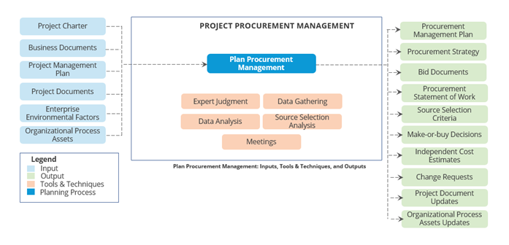

**Conduct Procurements**

“Conduct procurements is the process of obtaining seller responses, selecting a seller, and awarding a contract.” It belongs to the executing process group.

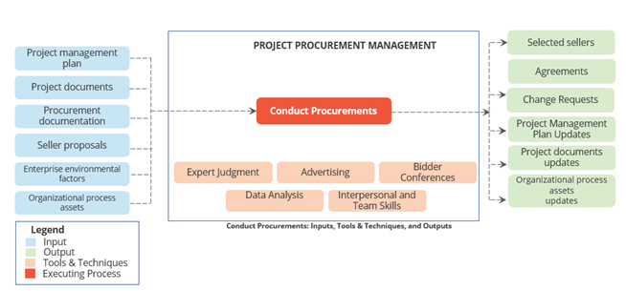

**Control Procurements**

“Control Procurements is the process of managing procurement relationships, monitoring contract performance, and making changes and corrections to contracts as appropriate.” It belongs to the Monitoring and Controlling Process Group.

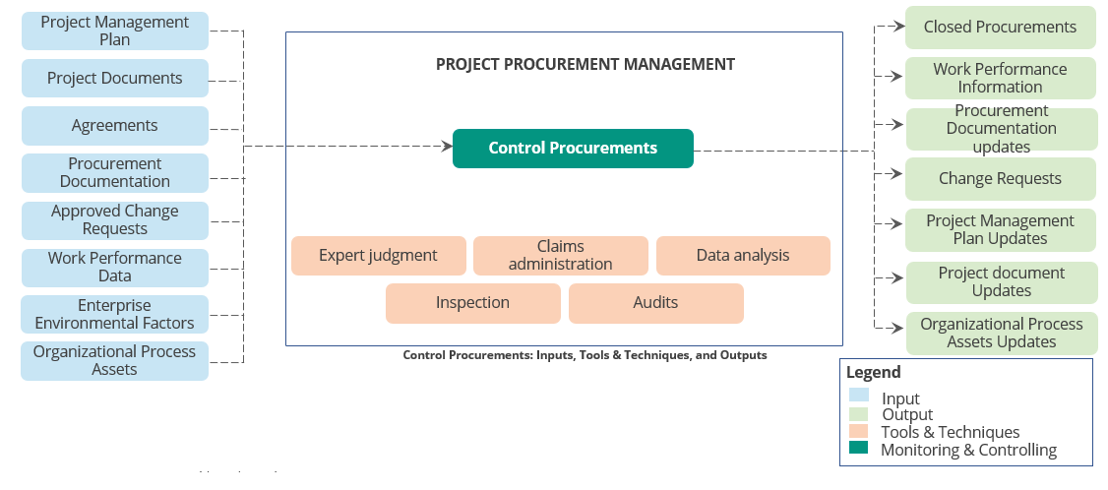

**Project Risk Management Summary**



* A contract is a mutually binding agreement that obligates the seller to provide the specified products, services, or results and obligates the buyer to provide the monetary or other valuable consideration in return.
* In centralized contracting, a single contract manager handles multiple projects, whereas in decentralized contracting, a contract manager is assigned to a project full time and reports to the project manager.
* The three types of contacts are Cost Reimbursable (CR) or Cost Plus, Time and Material (T and M) or Unit Price, and Fixed Price (FP) or Lump Sum.
* Project Procurement Management includes the processes necessary to purchase or acquire products, services, or results needed from outside the project team.
* There are three Project Procurement Management processes. They are Plan Procurement Management, Conduct Procurements, and Control Procurements.

## 11. Project Risk Management

**Objectives**



* Define risk
* Describe the key concepts and tailoring considerations in Project Risk Management
* Learn how to calculate risk
* Identify different categories of risk
* Describe Project Risk Management processes

**Define Risk? Give an example?**

“Risk is an uncertain event or condition that, if it occurs, has a positive or negative effect on one or more of a project’s objectives.”

You are managing a gas pipeline expansion project in Canada. The project funds are allocated in US dollars even though most of the expenses are in Canadian dollars. Exchange fluctuations are a risk to the project budget. Shortly after the project starts, the Canadian dollar depreciates significantly, which contributes to a budget surplus. This is an example of a positive risk.

If a major storm delays the construction of a commercial office tower, the project timelines may be delayed. This is an example of negative risk.

**What is Risk Management?**

Project Risk Management includes the processes of conducting risk management planning, dentification, analysis, response planning, response implementation, and monitoring risk on a project.

The key objective of risk management is to:

* Increase the probability and impact of positive events
* Decrease the probability and impact of negative events

**What are the Project Risk Levels?**

Risk exists at two levels within every project:

* **Individual project risk**– It is an uncertain event or condition that, if it occurs, has a positive or negative effect on one or more project objectives.
* **Overall project risk**– It is the effect of uncertainty on the project as a whole, arising from all sources of uncertainty including individual risks, representing the exposure of stakeholders to the implications of variations in project outcome both positive and negative.

**How would you manage your risks? Tell me how would you handled in your project with example?**

To manage the risks, create one of two strategies: -

1. Mitigation Strategies for risk are that likely to occur, the goal is to minimize the impact of the risk.

2. Contingency Plans are for risks that might not occur but the project team should prepare for that

**How would you calculate your risk? Give an example?**

Risks can be managed only if they are measured quantitatively.

* Risk is measured by assigning a monetary value to it.
* Risk is calculated by multiplying probability and impact of risk.

**Formula: Risk Exposure = Risk Probability * Risk Impact**

Where risk probability is the likelihood that a risk event could happen and risk impact is the effect on the project objectives if a risk event happens

**Example**

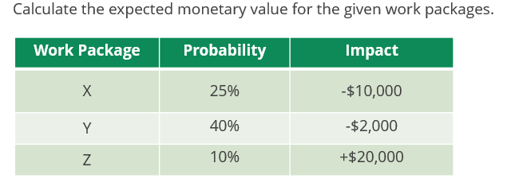

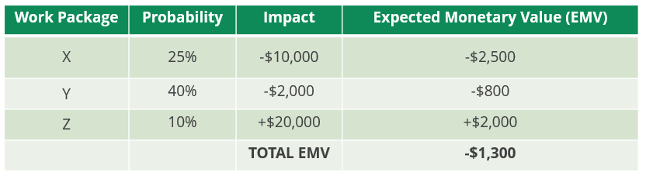

**How would Categorize your Risk?**

Risks can be classified in various ways. One classification of risk is as follows:-

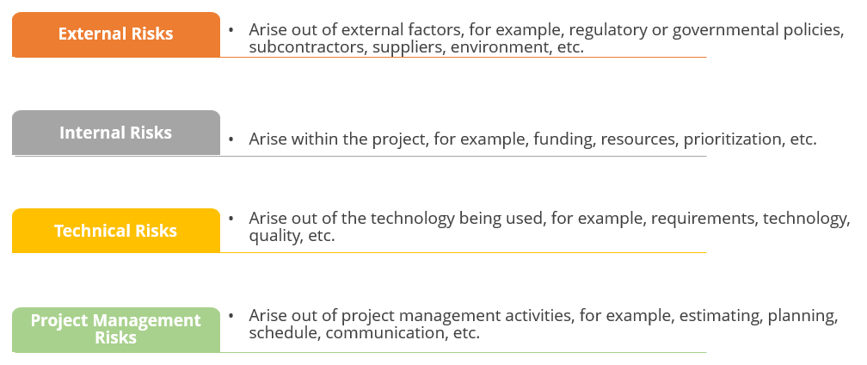

**How Risk Decision Tree works?**

A decision tree is used to analyze risk and its impact on decisions in the face of uncertainties.

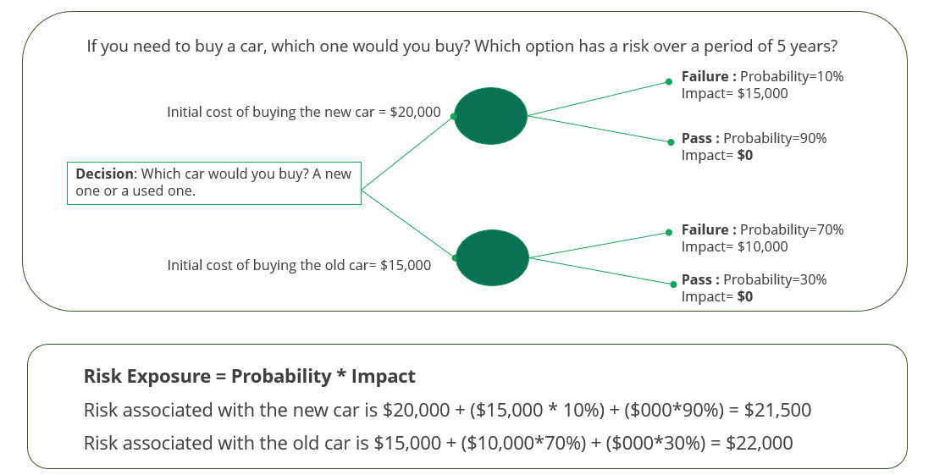

**What is Risk Reserve?**

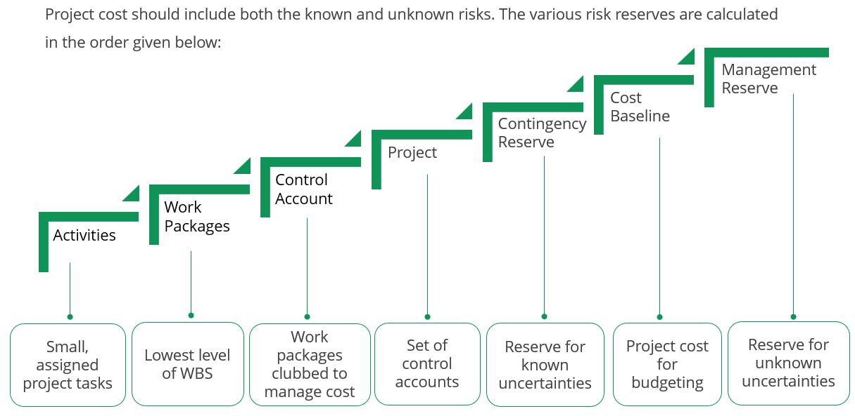

**What are the risks that you handled in your project with example?**

The risks that I handled so far....

1. Time and Cost too optimistic

2. Customer Review and feedback cycle too slow

3. Unexpected Budget cuts, Funding issue

4. Unclear roles and responsibilities

5. Stakeholder input is not sought, or these needs are not properly understood

6. Stakeholder adding/changing requirement after the project has started

7. Poor communication resulting in misunderstandings, quality problems and rework

8.Lack of resource commitment

9.Deliverable not found on time

10. Lack of technology output

11. Unavailability of technology resource on critical time

12. Deployment issue & Execution Phase delay

13. Unexpected resources resignation will impact on project schedule

14. Visa Stamping issue for travel

15. Software, Hardware availability on time

**Project Risk Management Processes**

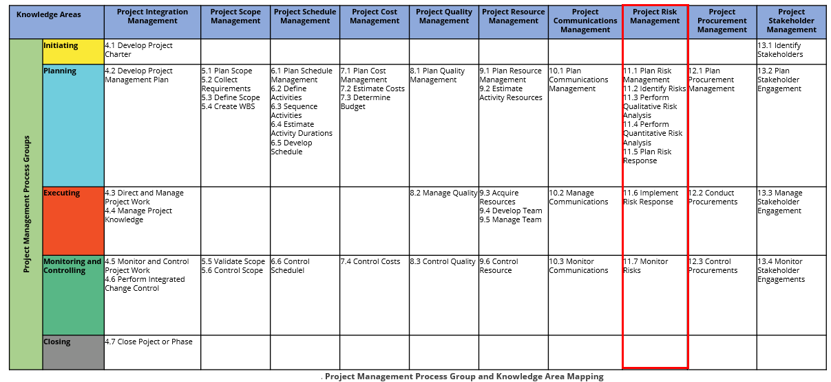

**Plan Risk Management**

“Plan Risk Management is the process of defining how to conduct risk management activities for a project. The key benefit of this process is it ensures that the degree, type, and visibility of risk management are proportionate to both risks and the importance of the project to the organization and other stakeholders.” It is part of the Planning Process Group.

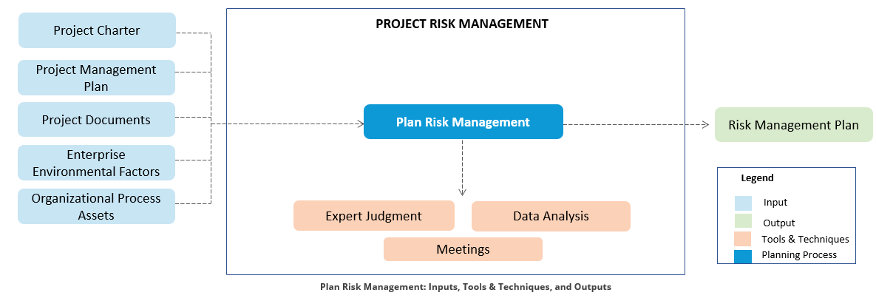

The table given below shows the impact on scope, cost, time, and quality.

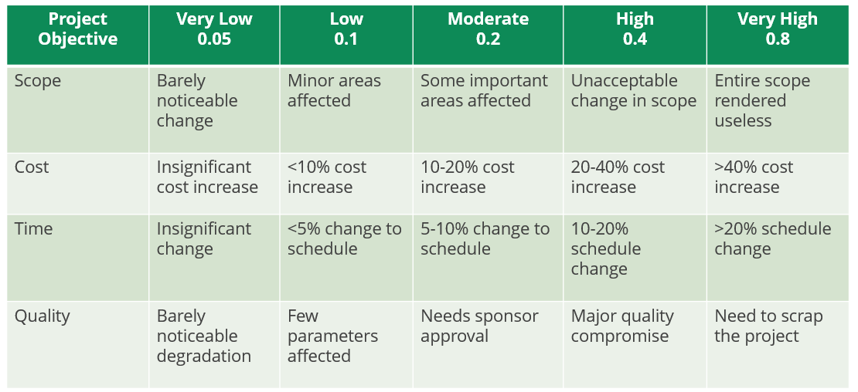

**Identify Risks**

“Identify Risks is the process of identifying individual project risks as well as sources of overall project risk and documenting their characteristics.” It belongs to the Planning Process Group.

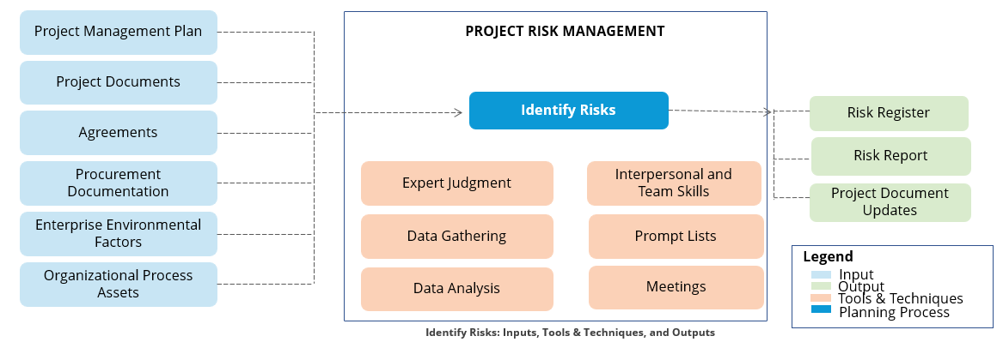

**Perform Qualitative Risk Analysis**

“Perform Qualitative Risk Analysis is the process of prioritizing individual project risks for further analysis or action by assessing their probability of occurrence and impact as well as other characteristics.” This process belongs to the Planning Process Group.

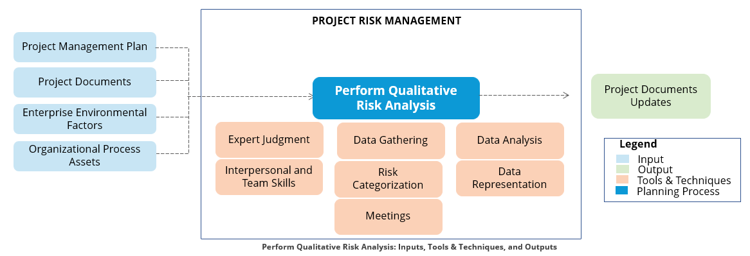

A probability and impact matrix tabulates the probability and impact scales for the opportunities and threats on the project.

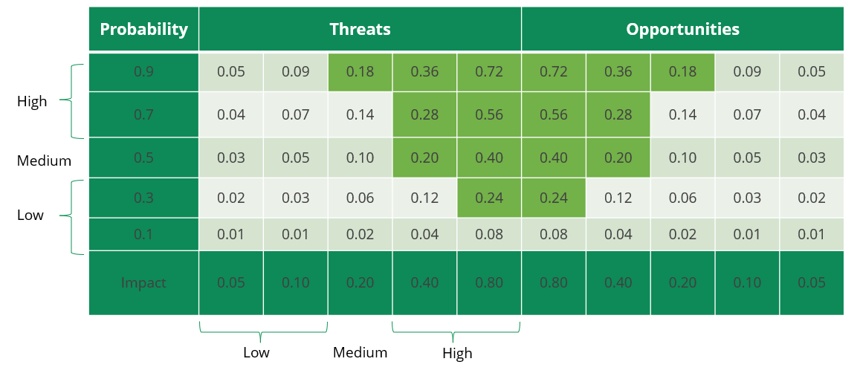

**Perform Quantitative Risk Analysis**

“Perform Quantitative Risk Analysis is the process of numerically analysing the combined effect of identified individual project risks and other sources of uncertainty on overall project objectives.” This is a part of the Planning Process Group.

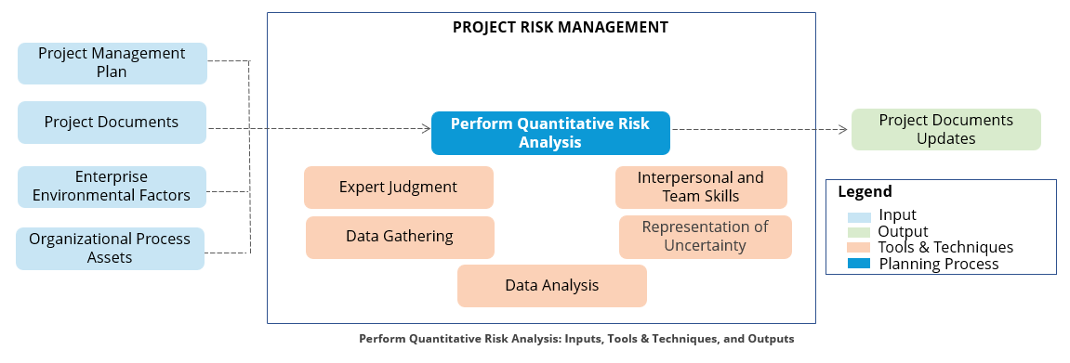

**Plan Risk Responses**

“Plan Risk Responses is the process of developing options, selecting strategies, and agreeing on actions to address overall project risk exposure, as well as to treat individual project risks.” It is part of the Planning Process Group.

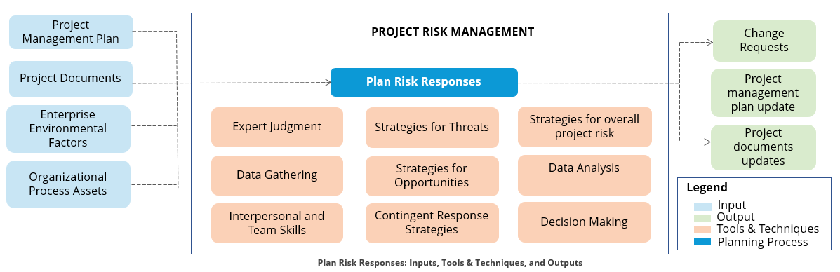

**Positive Risk Responses**

Positive risks have positive effects associated with them and are often called opportunities. There are five response types for positive risks.

**Escalation** is used when the opportunity is outside the scope of the project or when the risk is beyond project manager’s authority. **Example**: Buying a software licence can be useful for other projects and the entire organization.

The **exploit** strategy can be used for high-priority opportunities, where the organization wants to ensure that the opportunity is realized. **Example**: A large software development project has three teams working on different components within the architecture. If one of the teams completes work sooner than scheduled, the project manager can exploit this opportunity by allocating work from the other two teams to it.

**Sharing** involves transferring ownership of an opportunity to a third party so that it shares some of the benefit if the opportunity occurs. **Example**: Your company is bidding for a large engineering project for a hydroelectric dam. As the team reviews the scope of the project, it sees an opportunity to increase its success if it partners with a company that has experience with advanced hydroelectric technology. The positive benefits of this risk are shared with the other company.

The **enhance** strategy is used to increase the probability or impact of an opportunity. **Example**: A construction project that involves building six apartment complexes in different parts of the country is underway. One of the teams is using a new construction design tool that has increased efficiency by 20%. The project manager enhances this result by having the other construction teams use the same tool.

**Accepting** an opportunity acknowledges its existence, but no proactive action is taken. **Example**: A project constructing an overpass in a large city will have a pool of experienced construction workers to draw upon. As the project scope is constrained to the construction of this overpass and there is little opportunity to enhance, share, or exploit the positive effects of this risk, the project manager accepts the risk.

**Negative Risk Responses**

Negative risks have negative effects associated with them and are often called threats. There are five response types for negative risks.

**Escalation** is used when the threat is outside the scope of the project or when the risk is beyond project manager’s authority. **Example**: There may be an increase in the cost, which is beyond the baseline. This requires the attention of the sponsor or program manager.

Risk **avoidance** is when the project teams act to eliminate the threat or protect the project from its impact. **Example**: A project is building a new offshore drilling rig in the Gulf of Mexico. The risk of a hurricane during setup would impact schedule and budget. The project manager avoids this risk by setting up the rig after the hurricane season.

**Transfer** involves shifting ownership of a threat to a third party to manage the risk and to bear the impact if the risk occurs. **Example**: A large commercial office building is under construction. The work location has many flammable materials and there is a risk of fire that could damage/destroy the structure and cause significant budget/schedule impact. The project manager includes fire insurance in the budget during the construction phase until fire prevention equipment is installed.

In risk **mitigation**, action is taken to reduce the probability of occurrence or impact. **Example**: A software development project is transitioning from the Java to .NET programming language. The risk that the developers will not be as familiar with .NET could lead to project schedule delays. The project manager mitigates this risk by providing training to the developers and hiring a .NET developer as a contractor.

Risk **acceptance** acknowledges the existence of a threat, but no proactive action is taken. **Example:** A project manager is concerned that his team does not have access to a printer at their work location. This will require the team to walk down the hall whenever they need a printout. The project manager decides to accept this risk as it has a low impact on his project.

**Implement Risk Response**

“Implement Risk Response is the process of implementing agreed-upon risk response plans. The key benefit of this process is it ensures that agreed-upon risk responses are executed as planned in order to address overall project risk exposure, minimize individual project threats, and maximize overall project opportunities.” It is part of the Executing Process Group.

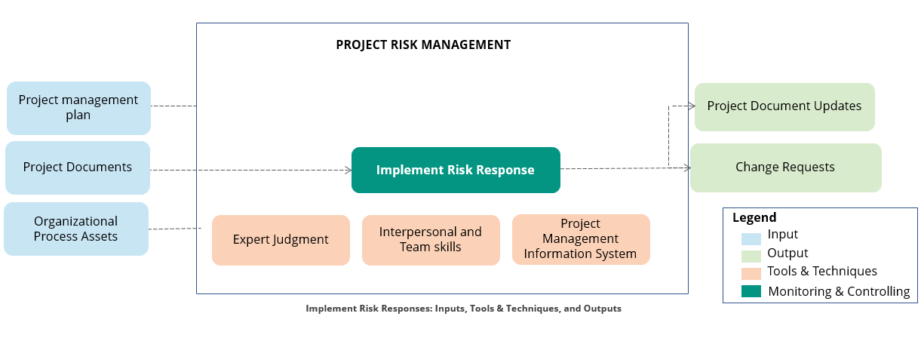

**Monitor Risks**

“Monitor Risks is the process of monitoring the implementation of agreed-upon risk response plans, tracking identified risks, identifying and analyzing new risks, and evaluating risk response effectiveness throughout the project.” It is part of the Monitoring and Controlling Process Group.

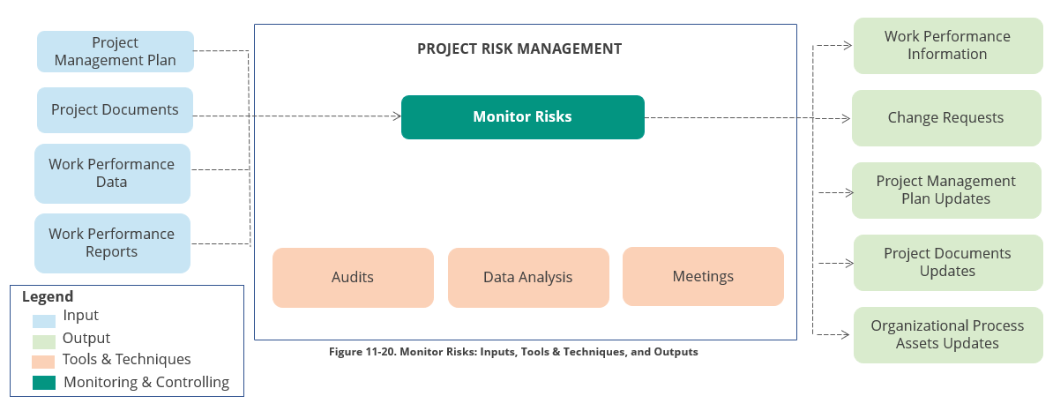

**Project Risk Management Summary**



* Risk is an uncertain event or condition that has a positive or negative effect on a project’s objectives
* Risk is calculated by multiplying probability and impact of risk (Risk Weighting = Probability * Impact)
* Risk can be classified in various ways. Under one category, risks are classified as external, internal, technical, and project management. On the basis of origin, risks can be classified as scope, resource, schedule, cost, and quality risks
* A decision tree is used to analyze risk and its impact on decisions in the face of uncertainties
* The seven Project Risk Management processes are Plan Risk Management, Identify Risks, Perform Qualitative Risk Analysis, Perform Quantitative Risk Analysis, Plan Risk Responses, Implement Risk Responses, and Monitor Risks

## 13. Project Stakeholders Management

**Objectives**



* Define stakeholder
* Discuss key concepts, tailoring, emerging trends and agile/adaptive considerations
* Describe stakeholder classification models and stakeholder engagement assessment matrix
* List the skills needed to manage stakeholders
* Describe the Project Stakeholder Management processes

**Who is Stakeholder?**

An individual, group, or organization who may affect, be affected by, or perceive itself to be affected by a decision, activity, or outcome of a project, program, or portfolio.



* A stakeholder can have a positive or negative impact. Therefore, it is necessary to engage and involve the stakeholders in the project to ensure project success.
* Project Stakeholder Management includes the processes required to identify the people, groups, or organizations that could impact or be impacted by the project, to analyze stakeholder expectations and their impact on the project, and to develop appropriate management strategies for effectively engaging stakeholders in project decisions and execution.

**Examples of stakeholders are as follows: -**

|  |  |
| --- | --- |
| * Project managers * Project team members * Senior management * Sponsors * Customers * End users | * Vendors * People affected by project’s output * Competitors * Social groups * Government and political leadership |

**What are the Key Concepts for Project Stakeholder Management?**

* Use structured way of identifying, prioritizing, and engaging stakeholders.
* Stakeholders can make or break the project success.
* Stakeholder identification should begin immediately after project charter approval and is a continuous journey.

**Share the Trends and Emerging Practices in Project Stakeholder Management?**

* Identify all stakeholders and not just a limited set of stakeholders.
* Ensure all team members are involved in stakeholder engagement activities.
* Review the stakeholder community regularly, often in parallel with reviews of individual project risks.
* Consult with stakeholders who are most affected by the work or outcomes of the project through the concept of co-creation. Co-creation places greater emphasis on including affected stakeholders in the team as partners.
* Capture the value of effective stakeholder engagement, both positive and negative value.

**What are the Tailoring Considerations in Project Management?**

* **Stakeholder diversity:** How many stakeholders are there? How diverse is the culture within the stakeholder community?
* **Complexity of stakeholder relationships:** How complex are the relationships within the stakeholder community?
* **Communications technology:** What communication technology is available? What support mechanisms are in place to ensure the best value is achieved from the technology?

**What are the Considerations for Agile/Adaptive Environment with respect to. Stakeholders?**

* Actively engage and participate with stakeholders.
* Engage stakeholders directly rather than going through layers of management.
* Engage early, be transparent, and build trust to reduce the cost of changes.
* Use postings on public spaces for visibility.

**What are the Classification Models for Stakeholder Analysis?**

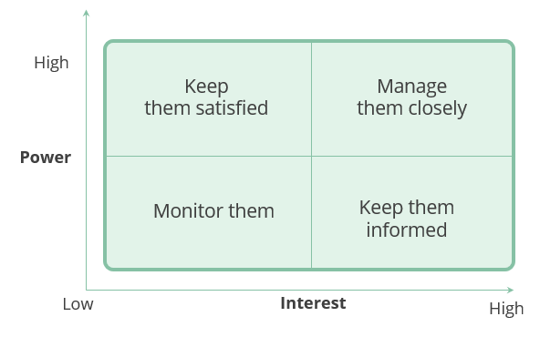

* Stakeholders have power and influence over the project, and the best way to manage each stakeholder is to calibrate a proper classification.
* The power, interest, influence, and impact that stakeholders have on projects can be mapped through power/interest, power/influence, or influence/impact grids, and Salience model.
* A Salience model describes the classes of stakeholders based on their power, urgency, and legitimacy.

**How Stakeholder Engagement Assessment Matrix works?**

Stakeholder engagement assessment matrix helps in visualizing the current and desired states of a stakeholder’s involvement in a project.

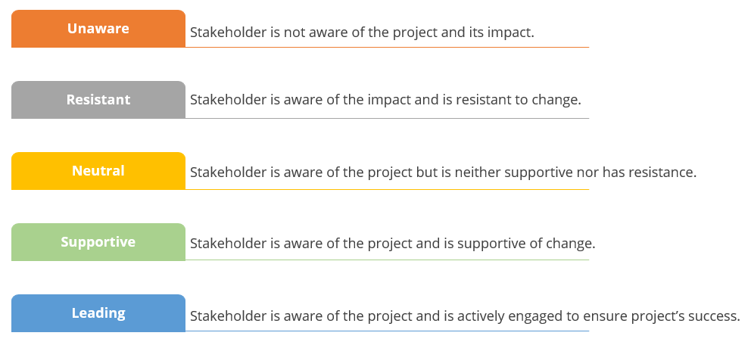

The table given here shows a sample stakeholder engagement assessment matrix:

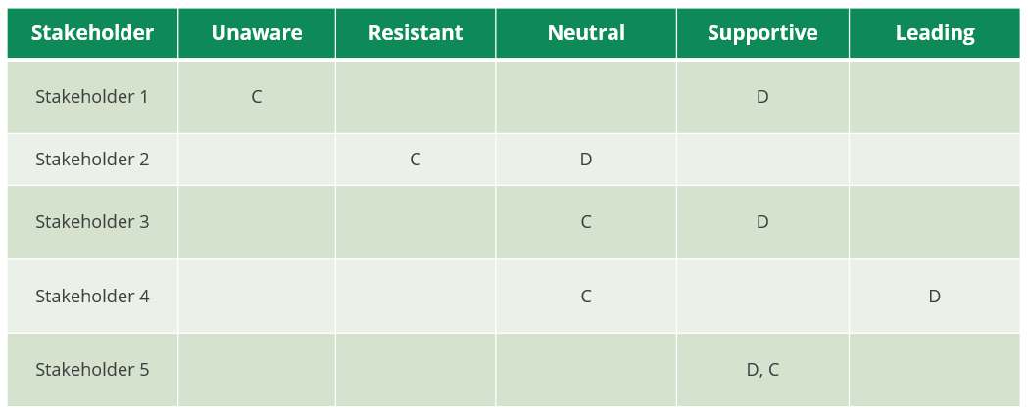

**What are the Skills needed for Stakeholder Management?**

Project managers need to demonstrate the following traits while managing stakeholders: -

**Interpersonal Skills**

The project manager must possess the following interpersonal skills to manage stakeholder:

* Building trust
* Resolving conflict
* Active listening
* Overcoming resistance to change

**Managerial Skills**

The project manager has to use the following managerial skills to accomplish the project objectives:

* Facilitate consensus
* Influence people
* Negotiate agreements
* Modify organizational behavior

**Project Stakeholder Management Processes**

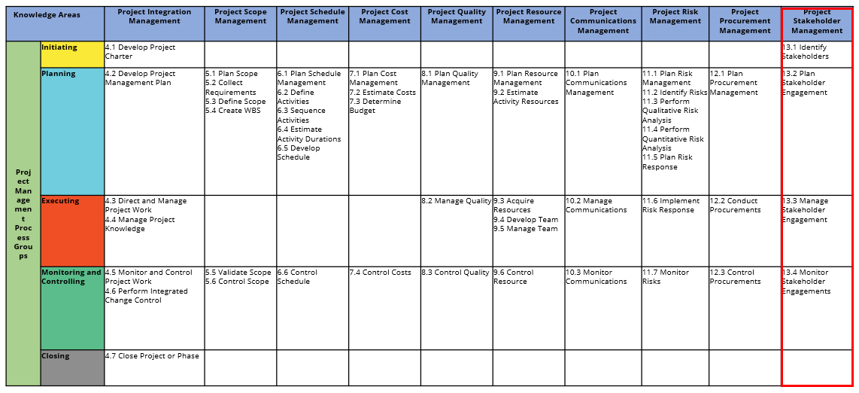

**Identify Stakeholders**

“Identify Stakeholders is the process of identifying project stakeholders regularly and analyzing and documenting relevant information regarding their interests, involvement, interdependencies, influence, and potential impact on project success.” It belongs to the Initiating Process Group.

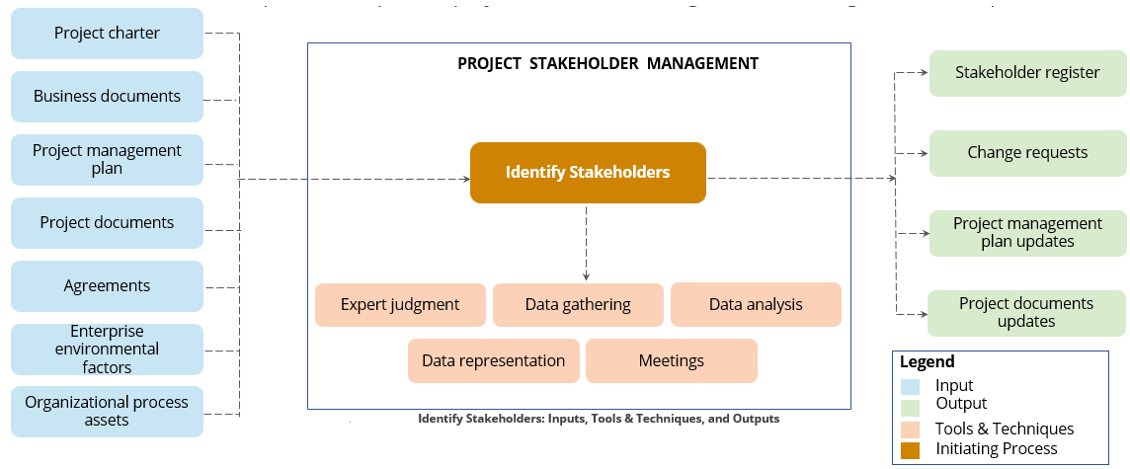

**Plan Stakeholder Engagement**

“Plan Stakeholder Engagement is the process of developing approaches to involve project stakeholders based on their needs, expectations, interests, and potential impact on the project.” It belongs to the Planning Process Group.

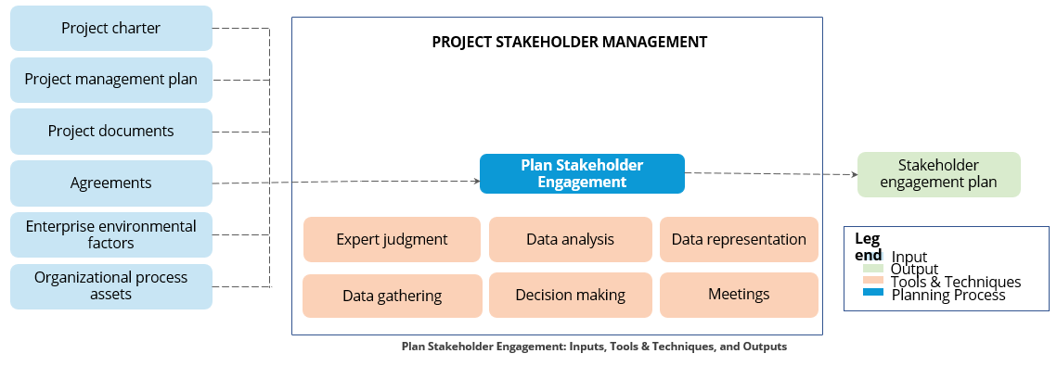

**Manage Stakeholder Engagement**

“Manage Stakeholder Engagement is the process of communicating and working with stakeholders to meet their needs or expectations, address issues as they occur, and foster appropriate stakeholder involvement. It belongs to the Executing Process Group.”

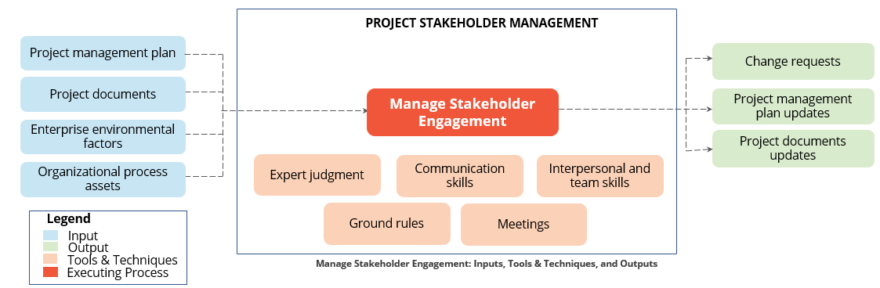

**Monitor Stakeholder Engagement**

“Monitor Stakeholder Engagement is the process of monitoring project stakeholder relationships and tailoring strategies for engaging stakeholders through modification of engagement strategies and plans.” It belongs to the Monitoring and Controlling Process Group.

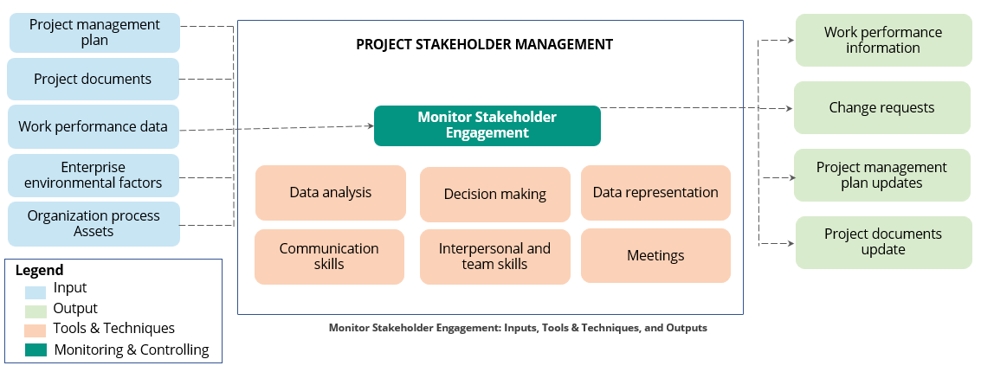

**How would you manage stakeholders?**

* Understand their success criteria
* Provide Weekly Status Reports
* Establish Weekly team meetings and executive steering committees
* Define clear roles and responsibilities

**What are the key components of successful project?**

* Balancing scope, schedule and cost
* Understanding success measures of the client
* Ensuring Quality
* Tracking risks and issues

**How do you measure project success?**

* By validating that my sponsor is satisfied based on the fact that we have met all of the project requirements
* By being able to measure that the project has satisfied all the Key Performance Indicator
* By having all the major stakeholders satisfied that we have met our goals
* By conducting the post project lessons learned to make sure that no anomalies show up there
* By make sure that all the project deliverables are available in online in

**Can you successfully deal with underperforming employees?**

I will find-out the root cause for the underperformance, try to find if the reasons for underperformance is under my control if so, I will handle it heads-on. If not take the necessary steps by involving HR representative of that business unit.

Taking the following steps can help you address workplace underperformance:

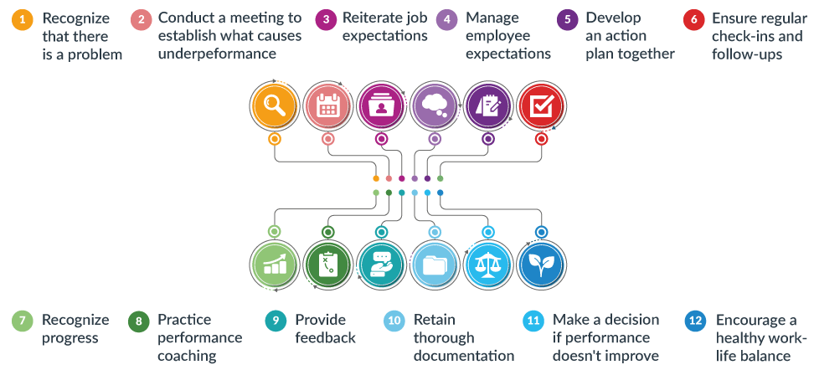

1. Recognize that there is a problem

2. Conduct a meeting and ask questions to establish what causes the employee to underperform

3. Reiterate job expectations

4. Manage employee expectations

5. Develop an action plan together

6. Ensure regular check-ins and follow-ups

7. Recognize progress

8. Practice performance coaching

9. Provide feedback

10. Retain thorough documentation

11. Make a decision if performance doesn’t improve - Reassignment | Move out

12. Encourage a healthy work-life balance

Although dealing with underperformance can be a time-consuming process, most underperforming employees will embrace a collaborative effort that coaches them to do their job better.

**What traits does a good employee need to succeed?**

The top qualities for the best employees are: -

1. Confident. Confident employees make their employer feel confident. ...
2. Sportive Team player
3. Reliable
4. Prepared
5. Organized
6. Good communicator
7. Self-disciplined
8. Flexible
9. Socially intelligent
10. Passionate. Passion, ambition, drive. ...

**Tell me about a time when you had to make a tough business decision that supported your company’s purpose, but may have had a negative, short-term financial impact?**

**People | Technology | Client**

In my recent project, there was a DR setup that I had to implement for a client. The architects of the client suggested go active-active (i.e deployed in two regions). With scalable up-to 100% on each zone but I put my foot down and had several tough conversations from architects to the project management to the senior executives of the client and to my internal technical team and management. My suggestion was to go active-active across three zones. This was slightly on the expensive side. Slightly 15% expensive than the original active-active solution proposed by the client. Finally, I was able to convince them though the client took a hit financially in the short term. There was a major outage on AWS cloud, which made both the originally proposed zones unavailable. As we implemented the solutions across three zones, we were able to move all traffic to the third zone and avoided a major muti hour outage to the client. Thus, saving few million dollars on the SLA penalties.

**If you could work on solving any problem in the world, what one problem would it be?**

I would want to solve the last mile connectivity issues in India.

**How do you motivate your employees in tough times?**

To motivate Employees In Difficult | Tough Times: -

1. Give Them Vision. ...
2. Don't Hide The Target. ...
3. Provide Regular Feedback. ...
4. Make Employees Part Of The Solution. ...
5. Focus On People Development. ...
6. Communicate! ...
7. Don't Overlook The Power Of Praise. ...
8. Build Fun
9. Be Positive

**How do you delegate an important assignment to others while ensuring that it will be completed successfully?**

To Delegate Tasks Effectively:-

1. Choose the right person for the job. ...
2. Explain why you're delegating. ...
3. Provide the right instructions. ...
4. Provide resources and training. ...
5. Delegate responsibility *and* authority. ...
6. Check the work and provide feedback. ...

**How would you go about delivering bad news or a decision that will not be popular?**

When it's time to deliver bad news to employees, follow these steps to ensure you're prepared and confident:

1. Research and prepare
2. Practice
3. Avoid small talk
4. Use direct language
5. Provide context
6. Give time for a response
7. Establish next steps

**When you enter a new workplace with new employees, how would you go about gaining rapport with them?**

To Build Rapport with New Colleagues: -

1. Establish a Common Ground. The first step to building a connection with your new colleagues is identifying common ground. ...
2. Practice Courtesy and Listen to Your Colleagues. ...
3. Be Authentic about Yourself. ...
4. Spend Time with Your New Colleagues. ...
5. Embrace Teamwork and Offer Help

**Describe how you would manage your work week?**

1. Plan Out Your Week Ahead of Time. Laying out a long-term schedule for yourself at the beginning of each work week can help you visually see what tasks lay ahead of you. ...
2. Schedule Tomorrow Today. ...
3. Consider the Times of Day You Work Best. ...
4. Find Tools That Work for You.

**How to handle different personalities at work?**

To effectively engage with different personality types in the workplace: -

1. Know what the differences are and avoid negative labelling. ...
2. Recognize cultural differences. ...
3. See people objectively, not personally. ...
4. Embrace difference: ask questions. ...
5. Look for the common agenda or goal. ...
6. Respect yourself and pick your battles.

**How would you handle a decision that you made that did not have the affect that you were expecting to achieve?**

By doing the root cause analysis, it will help to identify the issues and do course correction at frequent intervals.

**How would you go about disagreeing with your supervisor about a decision that you know is not the right one?**

Tell Me About a Time You Disagreed with Your Boss

1. Choose the right story. ...
2. Admit that you disagreed with your boss. ...
3. Explain what your responsibility was. ...
4. Explain the conflict. ...
5. Explain what action you took to resolve the issue. ...
6. Explain how or why it didn't happen again.

**You are at a point with an employee that it is best to have them leave the organization. How would you go about the conversation?**

**General Procedures**

* Creating your employee resignation checklist in the Project Account as well as in the org. portal
* Inform HR that the employee is resigning
* Make plans for the employee to finalize or transition projects to the other team members
* Distribute employee's work and responsibilities to current employees until a replacement can be found
* Request open headcount to replace the departing employee asap

**5 Ways to Stop a Valued Employee from Quitting**

* Talk It Out
* Show Appreciation
* Offer Support
* Put Career Goals in Reach
* Invest in Employee Retention

**Situation to explain the Non-Billable Position to employees**

I am very sorry to say that your positions is eliminated and I would not be able to accommodate you in other projects as well. The main reason for this client has reduced their headcount, so I forced to take the decisions.

**Project Stakeholder Management Summary**



* Stakeholder is an individual, group, or organization who may affect, be affected by, or perceive itself to be affected by a decision, activity, or outcome of a project.
* The different stakeholder classification models are power/interest, power/influence, or influence/impact grids and Salience model.
* Stakeholder engagement assessment matrix helps in visualizing the current and desired states of a stakeholder’s involvement in a project.
* Project managers need to demonstrate certain interpersonal and managerial skills to manage the stakeholders and accomplish the project objectives successfully.
* The four Project Stakeholder Management processes are Identify Stakeholders, Plan Stakeholder Management, Manage Stakeholder Engagement, and Monitor Stakeholder Engagement.

